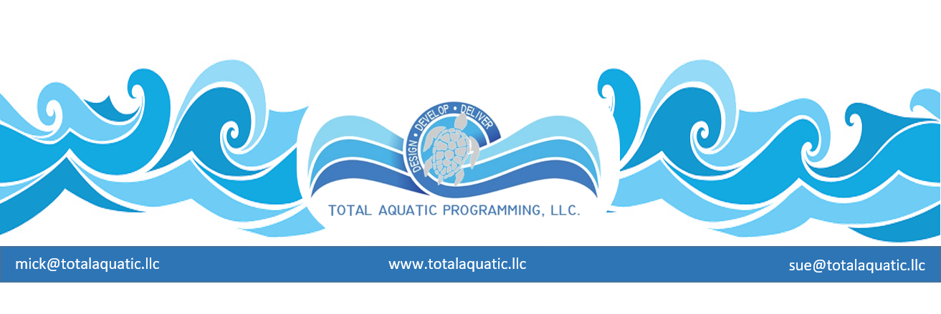
In or Out - Whether visiting a pool on vacation or using the pool as one of your regular health and wellness destinations, you need to be aware of your environment. There is a difference between awareness and paranoia, and this may help you decide what fits your needs and expectations for a pool ….

The Facility….

Aesthetics – If the outside of the pool building – fence – parking lot – is clean and seems to have that ever blowing styrofoam cup or plastic shopping bag removed, this is a good start.

Functionality –
- Does the building layout make sense to “you” and the average user?
- Are all amenities easy to find and use?
- Is the first thing people see inside the main entrance the information desk with a friendly person to greet and help them?
- Are there signs flyers/brochures that are current and nicely displayed on a bulletin board or table in lobby?
- Do the members/user’s areas have controlled access so the general public cannot simply walk into them?
- Are there adequate bathrooms for the general public, members, family changing areas, caregiver and member areas, and wet and dry segregated shower/changing rooms?
- Do the pools have safe and convenient access in the form of stairs, ramps, lifts, etc.?
- Is the facility considered to meet all ADA accessibility codes?
- Are pool decks kept clear of equipment and obstructions? Wheelchairs and walkers need to be stored up against outer walls and out of foot-traffic areas.
- Are staff control points or stations easily accessible to patrons?
- Are there “dry” viewing areas for aquatic activities so guest can watch members without getting wet or walking in/across wet areas?

The shower rooms do not have to be “country club” quality but they do have to be clean and smell/feel fresh. Under SMELLS we include:

- Chlorine odors
• Cleaning odors
• Bathroom and locker odors
• Health club odors
• Food odors

Under FEELS we include:

- Various room temperatures in different
zones of the building
• Air flow or breezes people can feel
• Humidity
• How are entrances and fresh air coming into building handled?
• How is noise control and reduction handled?

Showers need soap dispensers filled and safely installed with no slick spots under them on floors. Bathrooms need paper dispensers that are filled and appropriately positioned. Mirrors need to be clean and not cracked. All doors need to be rust free. Lockers (if available) need to be clean and rust free. Benches need to be safe and clean and there should be no wet towels lying around.

Lights need to be functional and bright enough so users and staff can see. Hi-glare areas on water surface need to be identified and staff needs to address this safety issue.
- Lighting in public areas should be adequate and meet codes. T-3 and T-8 florescent lights and LED lights are the new energy efficient recommendations. Indirect lighting is also popular.
- Lighting in the pool should have at least 2 phases separately controlled. Daily programming requires 30 to 50 ft. candles at deck level. Event lighting (swim meets or large classes or workshops) needs 75 to 100 ft. candles. Therefore, banks of lights should be on separate switches/breakers so daily operations are on one bank of switches and event lighting on another that can be added to daily lighting requirements.
- EXIT lights should be operational
- If a bulb is out it needs to be replaced immediately not “when someone can get to it”.

Safety
- All electrical outlets need to have GFI’s - like the ones in your motel rooms next to the bathroom sink. There is an extra small button that clicks out when something is not right with the plug-in or thing being plugged in.
- Are there SHARPS disposal containers in bathrooms?
- The decks and walk-ways in the shower rooms around the pool need to be unobstructed and not have large cracks as toe stubbers.
- Any tile or trim needs to be well maintained and grout between tiles needs to be smooth without black things growing.
- The water must be clear and not smell like chlorine. The clear water test is …. “Can you see a quarter on the bottom of pool and tell whether it is heads or tails?
- The pool gutters or skimmers (the things around the top edge of pool perimeter that get the water back to the filter room for treatment) need to be clear of leaves and Band-Aids and other things that belong in a garbage can.
- Has dirt and silt and other “stuff” been removed from the bottom of pool?
- Do the pool bottom and walls seem to have a brightly colored clean surface, or do they show wear and bare spots? Are there green or black spots or streaks (algae) on the pool bottom or walls?
- Are pool signs easy to read and understandable and posted where people can see them?

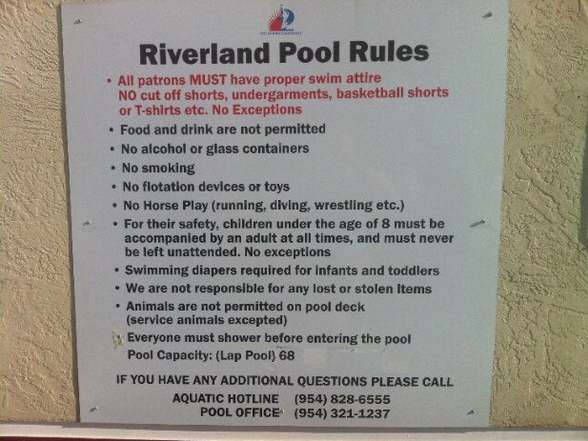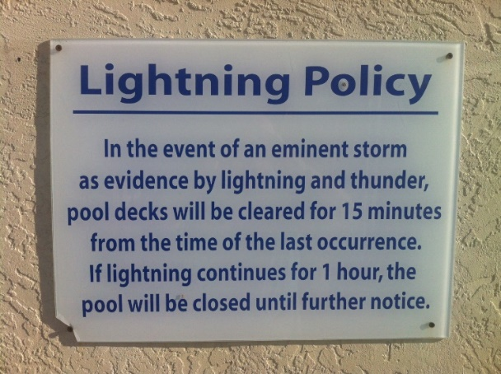

- Are their garbage cans with liners conveniently places in all area of facility? Clocks?
- Is safety equipment like ring buoys and poles hung on walls in sight?
- Is the pools bad weather policy posted? Is the emergency action plan written on the wall or were you advised of it when you first entered?
- Is there a phone to call 911 within view?

Non-public areas – The safety and comfort of the staff is just as important as that of the members or patrons. The staff will be in the facility many more hours per day/week than any member. Here are some of the things that need to be considered:
- Staff bathrooms and changing areas need to be segregated from the public. At least 2 are needed (Men’s and Women’s) and they should include a bathroom – showers – and lockers with changing area.
- Staff break rooms are suggested. This should include a couch, table and chairs, microwave, coffee maker, refrigerator, computer station with internet access, first aid station, TV, emergency radio, etc.
- Staff should have access to a washer and dryer in the facility.

Specialty areas – These are areas that only properly trained people should be in. They need to be marked “DO NOT ENTER” and/or “STAFF ONLY” with locked doors. These areas include….

- HVAC and building operational equipment rooms
- Electrical rooms
- Sprinkler system rooms
- Computer router rooms
- Storage rooms for cleaning equipment and cleaning chemicals
- Pool equipment and filter rooms
- Pool chemical treatment rooms
- Record storage areas and private offices
- Staff dressing rooms

The Staff – Are the staff certifications displayed where the public can view them? Do the people who work there seem knowledgeable and responsive and happy to see you? Is this a guarded facility or, like many motel pools, a “swim at your own risk” pool.

The Participants – Talk to others who look like they belong there and ask them how they like it. Customer satisfaction is a daily challenge for any facility and if the regulars are happy then kudos to the staff.

Common Sense advice ….

- If it is storming or lightning around an outdoor pool – get out of water and stay away from fences and any metal poles. If an indoor pool – check with the facility staff for their procedures.
- If there is an electrical cord in sight (drop-cord) stay away from it and ask an employee why it is near the pool.
- If the pool is covered or has any sort of cleaning device/machine in it – stay away from pool.
- If the water is even a little bit cloudy – don’t go in the pool.
- If the water smells like chlorine (especially in indoor pools) don’t go in the pool and calmly exit building.
- If the water is green – even if clear – don’t go in the pool.
- If the water level is obviously below its normal operational level – ask why before getting in.
- If others are complaining about eyes burning or skin itching – don’t go in the pool.
- If you have an open sore or have had diarrhea in the past week – don’t you go in the pool – it is dangerous for both you and others.
- If it doesn’t seem right, it’s probably wrong – use common sense.

