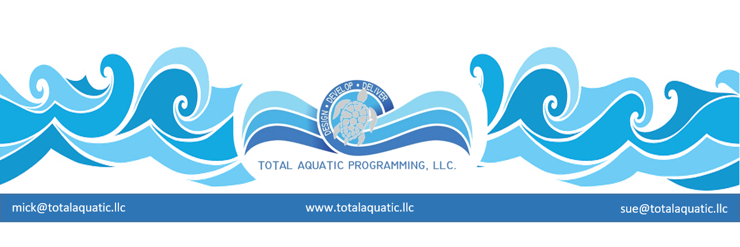
The BENEFITS of Inclusion and Sustainability for facilities

Inclusion and Sustainability are more than just a words. They need to become a daily action item and mindset that have working parts. If any part is deficient, the plan fails. As with any successful plan, it’s the people that make things work rather than the building they work in. If as much time and effort was spent on the staff preparation and education as went into the facility planning and building, all would be better off. This is the job and vision of the people leader, sometimes called manager sometimes called director.

What do leaders need to constantly “focus on” to promote program success and a community that benefits from aquatics?

A “leader” is anyone who oversees anything that involves more than themselves. They do not have to be a president, upper level director, or have an important sounding title to manage or lead. Coaches manage swimmers and parents and staff. Learn to Swim instructors manage children and adults and co-staff. If you want to give yourself and your programs the best chance for success and longevity, learn not only to lead/manage, but also make a constant effort to understand what works and what doesn’t. The only way success can be reproduced is if you track the steps taken to reach your end goal.

Inclusion, Motivation and Tracking are critical, and you can never quit learning how to do them better. Categorizing helps both the leader and their team clarify what is being tracked and how it impacts the total plan. There is no BEST WAY since all managers are unique, but here’s one way that works:

There are 3 main areas each with 2 sub-areas - of aquatic leadership and inclusion importance:

- The Facility
    - Aesthetics
    - Safety
- Staff
- Certification
- Style
- Participants
  - Satisfaction
  - Goals

The FACILITY: It really doesn’t matter whether you are renting a facility or own your own, the same principles still apply.
- The facility must be clean, and attractive. Everything from the parking lot to the reception area to the shower rooms to the pool itself has to say welcome to our facility and we care about both the facility and all the patrons.
- Risk management is, and always has been, super-important. However, it is receiving more public attention than ever before. You must have a “plan” and make everyone aware. The days of winging it are gone. There are great nationally recognized firms that specialize in helping your development and implement your plan. For more information contact snelson@usaswimming.org

Things to consider about the facility:
- Is it ADA accessible in all areas?
- Is the proper signage displayed in the appropriate areas and are they in language that all of your patrons can understand?
- Are the rooms located where they can be easily found and are, they labeled so everyone knows what the room is used for?
- Do pictures and notices and signs throughout the facility encourage inclusion for all ages, genders, ethnicities/cultures, etc.

The STAFF: You can never spend enough time and resources on staff training and support. Teamwork has become a catchphrase, but it is so important.
- Staff training and certification benefits everyone. The certification needs to be relevant and from a reputable organization. There is much more to aquatics than just first aid and CPR. Once certifications are achieved, all clientele need to be made aware that the staff is among the best in the country.
- Each staff member must be conscious of their personal style. How do they appear and relate to others? No one should ever think their “style” is proficient. Improvement is something that just doesn’t happen, it is caused. Staff motivation and a concerted effort to be better than last week is critical.

Things to consider about the staff:
- Do you have an effective mix of age and gender and culture of staff?
- Is training and certification ongoing and do you listen to staff about some of their specific interest for continuing education?
- How many in-house seminars or workshops do you host each year?
- Do any of your staff speak more than one language that would help in your programming and inclusion efforts?
- Does your staff dress professionally in logoed apparel?

The PARTICIPANTS: These are the people who write the checks (customers). Without them the business fails. Many customer service businesses fail because the staff did not recognize what it took to keep people happy, healthy, and coming back day after day.
- Customer satisfaction is a daily challenge that must be discussed, analyzed, and tracked. Customer comment cards should be available at the front desk. Periodically the staff needs to talk with the participants and see how they feel the staff are doing.
- Do all the participants feel welcome and have goals? Have they been taught goal getting? Have you discussed their personal plan and the benchmarks they will use along the way? People quit because they feel they are wasting their time, or they don’t belong.

Things to consider about participants:
- Do all programs have different price points along with options?
- For programs, has “time of day” or “day of offering” been considered to include the most possible participants?
- Is the participant’s safety of upmost importance?
- Are programs offered for all ages and stages of participants?
- Is there a plan so a portion of every income dollar is set aside for program financial assistance?
- Is there a grant application plan to secure outside dollars for financial assistance?
- Is there a plan to engage local businesses in sponsorships and advertising to help participants that have financial assistance needs?

We are in the SERVICE BUSINESS. "Aim to please!" Remember the code word A I M.

- Appreciated = always make people feel their efforts are appreciated. Don’t forget staff and customers are both equally important. Always be inclusive.

- Important = make someone feel important whenever possible. This applies to both clients, co-workers, acquaintances. Always be inclusive.

- More = give people more that they expect and more than they have paid for.
Quantities of Quality! Always be inclusive.

Every facility has a better chance of success and survival with Total Aquatic Programming. Every program has a very important place in the culture of success. It is very difficult to have one program functioning with one plan, delivery method, and staffing philosophy while another program works an entirely different way. Aquatic programming has way too many commonalities for us all not to take advantage of the above points and collaboratively make the business a sustainable success.

The two main parts of any successful business plan are:
- Managing expenses
- Increasing income

Income and program pricing must be based on Value Received Pricing
For information on VRP. Email sue@totalaquatic.llc

Expenses need to be evaluated quarterly.
- Do you cover the pools at night?
- Do you use the best pool chemicals?
- Is the HVAC system checked twice a year (or more) for operational pumps, condensers, vents, and filters?
- Are cleaning supplies the highest quality at best price?
- Have contract services been evaluated and comparative bids collected?
- Do you have a capital improvements budget that has income every 2 weeks just like an employee?

And finally, do you really know your community?

A very common request of TAP is for us to provide the facts and figures that prove a community can build and/or sustain a specific size of facility or offer a specific aquatic program that will be successful. The demographics of Miami Florida vary greatly from those of Seattle Washington but on paper, the raw numbers look similar. The needs of each community will be based on what exist there now and what national trends they are not currently fulfilling. The delivery system of the actual programs plays as important of a part as the size and type of facility and where it is located.

You can pay for a formal Feasibility Study from Counsilman Hunsaker that will give you a wealth of information about your community and the surrounding areas, but first you should know the basics and do some research on your own.
- A market analysis can be performed to document the needs and identify the “target market” and core service offerings for programming.
- You can analyze the major direct and indirect competitors and compare against the activities and programs identified in the market analysis above.
- Interviews with key stakeholders and potential participants to document their needs and other issues.
- Examine the demographics of the area. Trends will be documented based on growth of community, median age of adults, median household income, ethnic and cultural trends, and frequency of participation by each demographic characteristic. These figures will drive the revenue projections
- Identify the recommended core program markets based on the input and analysis performed during this task. The outcome of this task will be used to establish a concept development plan including financial performance and partnership/management alternatives.

