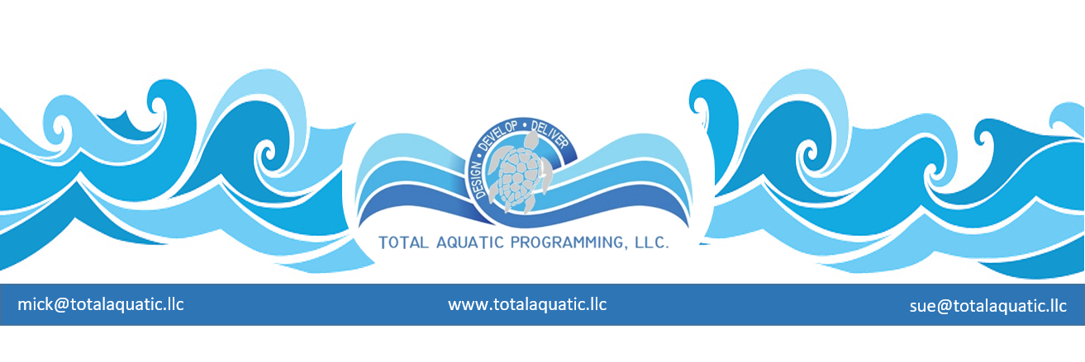

Is it really “NEW”?

Facts: We definitely need more pools in this country. Pools are being decommissioned because of cost to repair and cost to operate. The population base is rapidly growing. The baby-boomers are here. We need aquatic facilities and recreation centers that fulfill new needs.

Many “new” projects are being planned by schools and municipalities. Because they have a “due diligence” responsibility, they all want to know “who can I call to talk to about the ideal facility and how it is operating?” The partial answer is that you can’t call them because they are not there – YET. The pioneers and entrepreneurs are out there but are involved in the planning and design stages so their “successful model” will not be online for a few years.

Many consulting and design firms who are contracted to offer advice for type and size of facility are looking at what has been done in the past and how it needs to be modified for the future. This is not the only information you should depend on. A large number of solutions and plans we have reviewed are simply face-lifted relics of days gone by or rely on aquatic fad-based gimmicks. .
In the 1990’s there were examples of Fortune 100 companies who were ready to go out of business. Now in 2020, some of them are credited with being cutting edge and futuristic in their product development and service. How did this happen?
- They looked for ideas outside their normal focus.

- They built products and services based on their predicting the needs of their potential customers.
  - Basic designs do not always have to come from architects, engineers, marketers, or consultants. They can come from anywhere – within or from outside the organization.
  - The main premises are the product or service must be:
    - Functional
    - Energy efficient
    - Programmable and user friendly
    - Sustainable
    - Economically feasible
    - Esthetically pleasing

- Most people can only advise you to duplicate what already has been successful to some point. Have the audacity to think about what will be “needed” before considering what is wanted. Even the end user may not have figured this part out yet. Disney makes this an art-form.

- If you are afraid to stumble and fall – don’t enter the race. It is hard to get to the future one step at a time. You have to be willing to takes leaps of faith. A successful project is a conglomeration of mistakes that have been corrected and never repeated. Apple makes this an art-form.

- Learn from available information that can be looked at differently. Develop products and services that define new categories and markets rather than products that compete in existing markets. Sony makes this an art-form.

If you hang your hopes solely on frilly curvy leisure pools – I have some racquet ball courts you also may be interested in.

