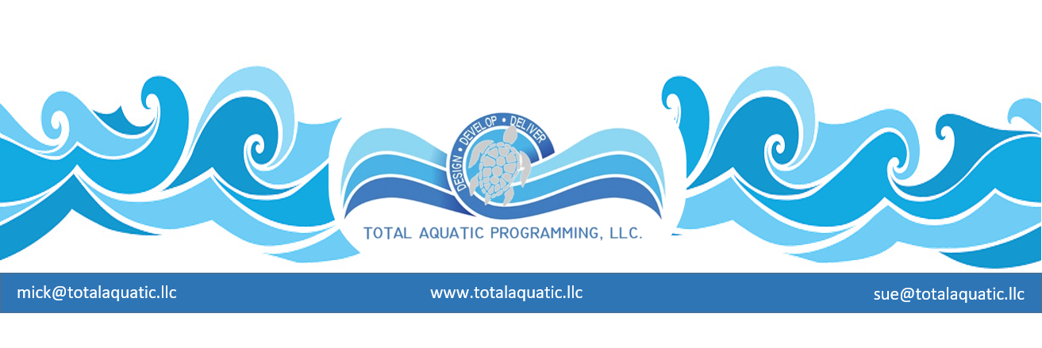
It is all about PERSPECTIVE Protect the Rectangle Pool WANTS VS NEEDS
What is someone trying to sell, what is their product? You can always tell from an aquatic article what professional is writing the article. They tend to direct the article toward the consumer’s wants. Aquatic recreation field has been making their case for the themed water park for well over 15 years.
If one is in the recreation field, you will want to hear about the themed water park that can make you money. If you are in the sport of swimming you want to know more about the components of the pool, and will it be fast. If you are in the fitness and therapy world you want to know if the design of the pool will meet the needs of the community who want to focus on exercise and preventive health care. But many forget that pools are needed first and foremost to be able to teach children how to swim for safety and fitness.
Years ago, pools all followed a business model that basically provided services at a very low cost to the public pools. This practice has been around for many years draining most of the city’s budgets. Now cities (city councils) are making the statement that pools are “money losers”. The rectangle pool is being closed across the United States in a very epidemic manner.
The basic rectangle pool has taken a back seat to the water park themed scheme because we have been told pools cannot make money. The aquatic industry did not embrace the basic business practices that make businesses successful. One practice is you provide a service you get paid, the better the service the more the community will pay. TAP calls this “Valued Receiving Pricing”.
Understanding the “Valued Received Pricing” practice one can research each of the 4 Aquatic Pillars to develop a sustaining aquatic center for their community. The 4 Pillars are (1) Learn to Swim Pillar (2) Aquatic Fitness Pillar (3) Aquatic Therapy Pillar (4) Competitive/Community Pillar. Each one of these pillars has components that offer value because you have certified or licensed professional providing the programs for all ages.
The next practice is called “Optional Programming supports Community Programming”. We have to understand “someone has to pay.” Implementing this practice will allow all levels of society to have access to the aquatic center. Aquatic optional programming would include offering services to the community that address their needs. This is accomplished by providing Aquatic Personal Training for the person who wants that one on one attention. This of course would be at a higher fee than some of the other community programs. One supports the other with all paying their own way and keeping the doors open and sustainable.
Sue Nelsons - Aquatic Program Specialist - perspective is SAFETY, FITNESS AND WELLNESS. “My selling points are every child NEEDS to learn to swim to be able to participate in the recreational water parks or water skiing, rafting, surfing. One NEEDS to learn how to swim to have an Aquatic Career, such as swim instructor, swim coach, lifeguard and first responders and aquatic physical therapist. It is also important to know how to swim to be a city fireman or policeman and to enter the military. The list goes on, but we do not hear about the NEEDS we hear about the WANTS for aquatic recreation. “
If we are to protect the future of the rectangle pool(s) we NEED to be marketing the safety and health benefits aquatic programming. Learn how to develop an Aquatic Health Club that serves all ages and stages of the community. While it is true that aquatic “play features” are an initial draw for a destination type facility, the rectangles should not be eliminated. A truly valuable community aquatic center should always include at least 2 rectangular style pools with different water temperatures for teaching swimming, aquatic rehab, aquatic exercise both vertical and horizontal, and healthy activities like lap swimming. Any recreational features that will then be included can be used by patrons who are safer and better prepared to enjoy them. Day pass admission dollars for water fun is not as predictable as service-based fees for aquatic programming but both have their place in many business plans.
How do we pass along the values of the rectangle pool? We inform our community and all levels of city government, so everyone understands the value of aquatic centers for health, safety and wellness.
Want to learn more how to save a pool or build functional and sustainable pools reach out to
Total Aquatic Programming.LLC
Website: www.totalaquatic.llc
Emails: sue@totalaquatic.llc

