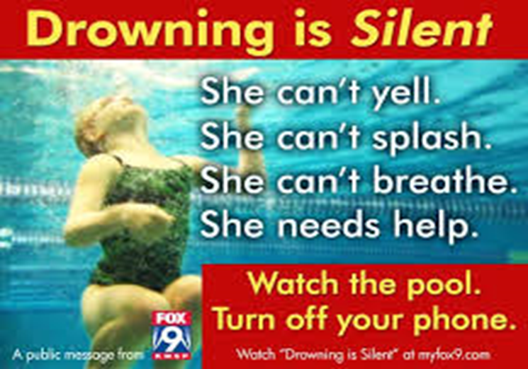 **

Summer is here but not at all what we anticipated. 500 plus public pools are not opening this summer and the little pop-up or inflatable backyard pools are selling out as fast as stores can get them ordered.

This has the potential to be a real hazard for children and their parents who are responsible to watch their kids at all times. The stats are there. We have tracked drownings for the past 12 years and keep our numbers updated monthly – [www.totalaquatic.llc](http://www.totalaquatic.llc) Drownings TAB.

We have categorized our tracking into age brackets:

* 4 years and younger,
* 5 years through 12 years,
* teenagers (13-19),
* adults (20 and older).

We record actual ages so we can refine information if ever needed. We also track Male and Female Hispanic and African American ethnic groups. Other tracking includes situations: Fishing, Autos, Emotional Reaction, Grandparents involved, Rip currents, Life jackets not worn, Guards present, Alcohol (drugs) involved, Flooding, unsafe pool ladders, and more…..

Our focus for this article is the backyard pools and how we can be safer. We refer to these reminders as the 5L’s:

Lessons - Locks – Latches – Ladders – Life Vest

67% of pool drownings are at homes. Over ½ of those are in above ground pools with unsafe ladders. Almost all the drownings could have been prevented with Locks Latches and Safety Ladders (and fences)

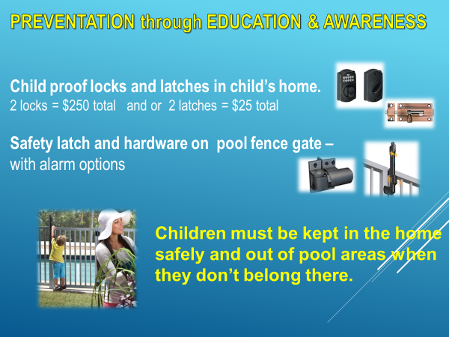

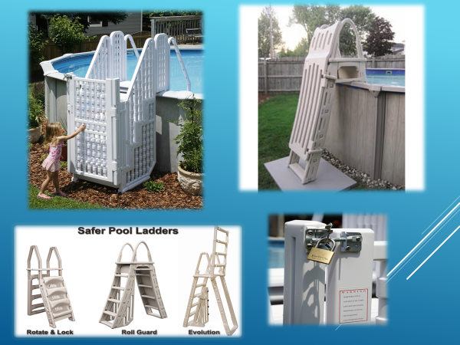

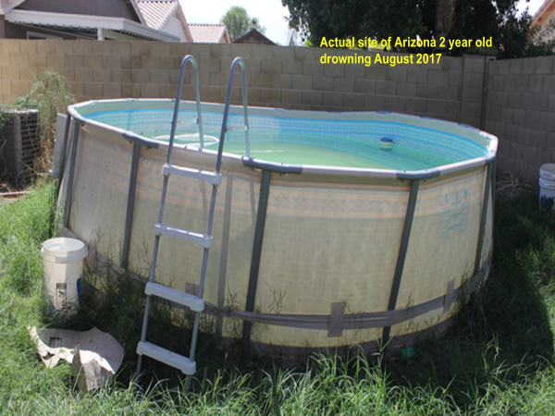

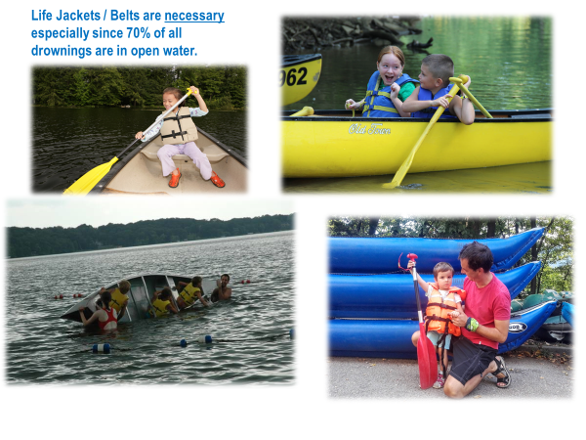

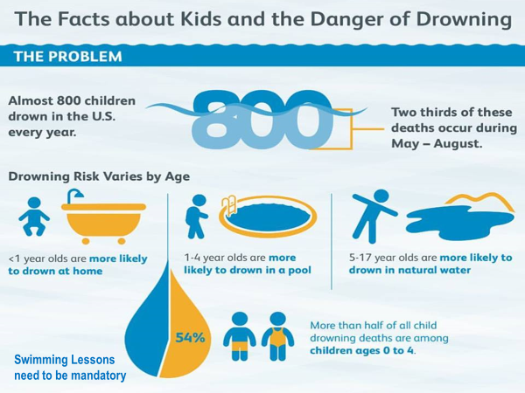

So here is your “walk-about check list”…..

First - swim lessons for toddlers are important. But even after lessons, we all must be vigilant in watching children every minute. Your home pool and the neighbors pool and the pond close by, are all potential dangers to our children. All children should know how to swim as early as possible but no later than the 2nd grade. There are resources available for those who can not afford lessons.

### [Make a Splash - USA Swimming](https://www.usaswimmingfoundation.org/home/make-a-splash/make-a-splash)

www.usaswimmingfoundation.org/home/make-a-splash

The USA Swimming Foundation's Make a Splash initiative is a national child-focused water safety campaign which aims to provide the opportunity for every child in America to learn how to swim.

Second: do the adults and all members of the household know how to swim and know CPR? It is a family effort and responsibility to offer a safe environment around the pool.

Third: Making the house safer. Every way to exit the house and enter the pool area must be safeguarded. These include but are not limited to…..

* A safety fence around the entire pool that children cannot climb or get through. The gate to the fence should have a motion and open/close sound alarm.

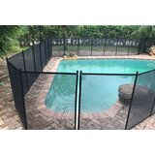

* The pool itself should have an alarm that sounds when the water is agitated by anyone entering it.
* Ladders to above ground pools must be SAFETY LADDERS with the steps capable of being blocked off and locked.

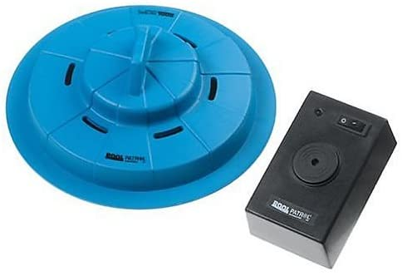

* If an inground pool, check all points of entry from surrounding decks. Controlled entry is important.
* House doors. All need secondary latches – hooks – or locks that are high enough that children can’t reach them. Kids do climb and stand on chairs. Be especially aware of doggie doors. They cannot have direct access to pool area.

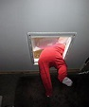

* Have signs posted about never swimming without someone watching. Also, basic pool rules like no glass containers, no breath holding, etc. are a good idea.
* Close circuit tv cameras and monitor are extremely affordable. They are a great additional safeguard but cannot replace personal supervision.
* Never leave any pool toys or equipment floating in pool. It is a temptation for a child to try to get to it.
* When more than one person is in the pool, like during a cookout or yard party, the water-watcher system (with wrist bands) should be activated.
* Constantly talk safety and vigilance with family members and visitors. You usually don’t get a second chance to prevent an accident.

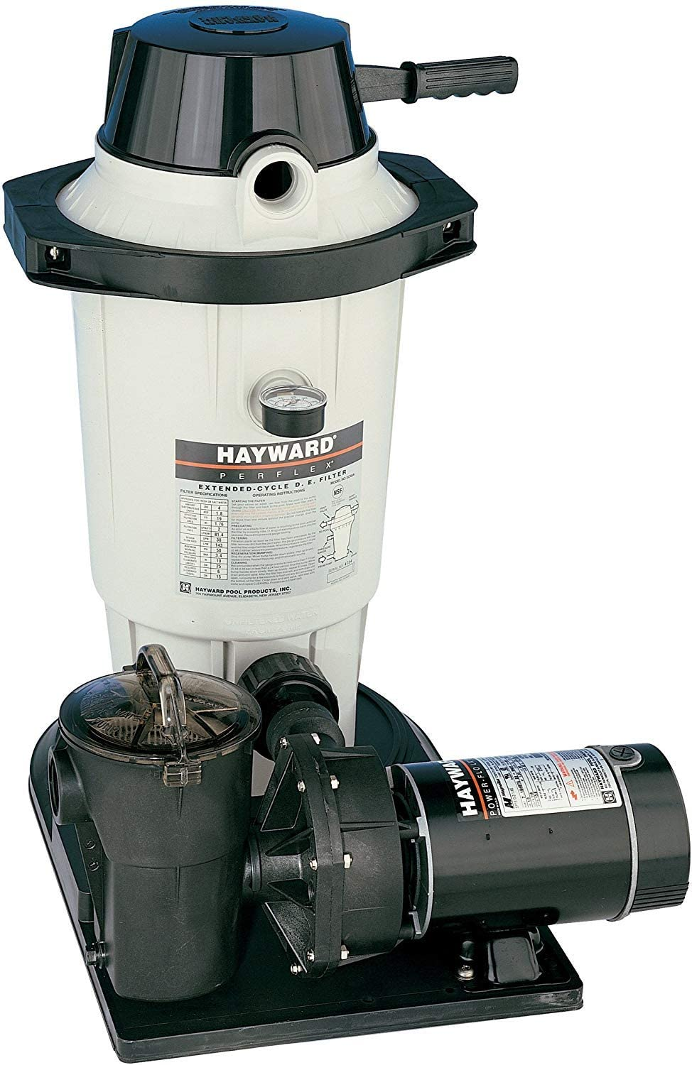

Additional info…..

* The pump and filter that come with most above ground inexpensive pools are undersized and will not work well. The cartridge filter and plastic pump will not handle keeping the pool water safe and clean. These parts can be replaced with better ones but cost more than the pool itself. For more info on sizing system and pricing, email [mick@totalaquatic.llc](mailto:mick@totalaquatic.llc) Circulation and treatment of the pool water is of primary importance.
* Do not use a drop cord to plug in the pump. Every year people are electrocuted in home pools. The electrical service needs to be hardwired and have a GFI circuit breaker to plug into. Use heavy enough wire so if you decide to get a pump and filter that does the job, the wiring can handle the ¾ HP 120V 20amp pump.
* The types of pool chemicals used are critical. There are dozens of viruses and bacteria that chlorine kills or deactivates so the Chlorine and pH levels are of upmost importance. Do not shock pool. Do not use calcium based chemicals or silver based algaecides. Best to use 1” sodium based tablets in the skimmer or floater. Adjust pH; to increase pH use soda ash – to decrease pH use sodium bisulfate. Ideal ranges are Chlorine 2.0 to 3.0 and pH 7.4.
* Test water at least once a day. Do not use test strips, they are not accurate. Use a Taylor TechNologies - K-2006 Complete Pool Water Test Kit

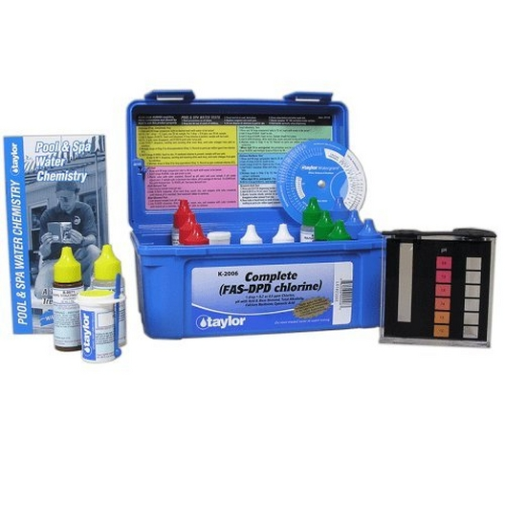

Mick & Sue Nelson [sue@totalaquatic.llc](mailto:sue@totalaquatic.llc) [mick@totalaquatic.llc](mailto:mick@totalaquatic.llc) [www.totalaquatic.llc](http://www.totalaquatic.llc)