Looking for Pools to use ?
In this unpredictable economy many “new pool projects” have been put on the “back burner”. Delaying decisions because of economic uncertainty does not help our immediate need for more pools. Currently pools are being closed at the rate of 1 per week in this country. Two of the main reasons for closure are:
- The pool needs upgrades and maintenance repairs and there is no money set aside for this.
- The pool is costing us too much to operate because we have not modernized our program offerings and pricing.
Many of the pools built during the 1960’s are no longer repairable. The cost to replace the iron pipe underground with PVC and then do interior tank work on the pool itself prices out about the same as a new pool. So the dilemma is all based around dollars that can be committed to a community asset like a pool.
In the Northern half of our country, there are very few outdoor pools that operate year round. This is not only hard on the pool equipment but also hard on the community. One solution is to take a really close look at every pool that sits vacant and unused in the winter. Ask yourself these questions:
- What if this pool was indoors, heated, and staffed professionally to offer Total Aquatic Programming services to the surrounding community?
- What if this pool became self-sustaining and profitable?
Many of these pools are owned by cities/municipalities or home owners associations. When these owners do a “cost of doing business” analysis they may not be pleased with the “red ink” involved with the pool budget. Yes, a pool is one of the most valuable community service centers. Yes it is where our kids have the opportunity to learn to be safe in and around the water. Yes it can be a tremendous asset to adults who can exercise in water but not on land. Yes – Yes – Yes ! But why does it have to be such a drain on the budget? (pun intended)
The short answer is: It doesn’t have to be a budget liability.
Every aspect of the way the pool is currently operated needs to be reviewed. A popular solution that many cities/owners have explored is to get out of the pool business by partnering with entities that can professionally operate the pool. The city still owns the land and the pool and through the partnership or “arrangement/agreement” can take credit for the community service offered (for a fee) to its citizens.
We started off by identifying $ as the hurdle we have to get over, so back to the point. As an example, let’s take the typical 75’ long x 42’ wide outdoor pool you will find in hundreds of communities across the USA.
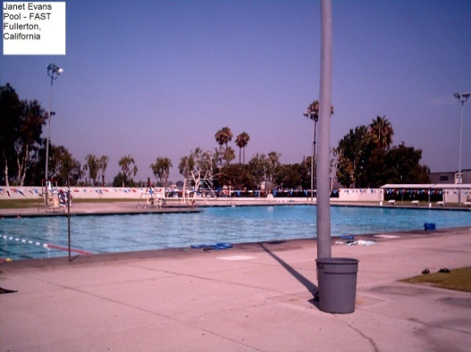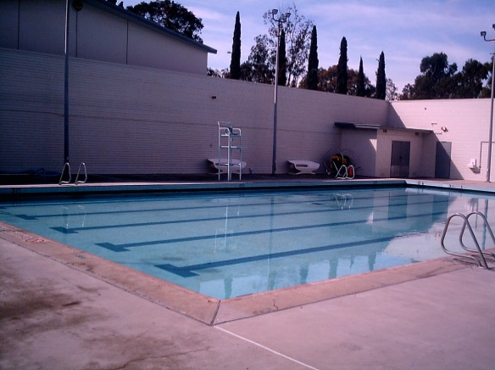
It is used 4 to 5 months during the summer and then is drained and sits there for the remainder of the year. What if this could be made accessible year round for a very reasonable investment?
The solution is an Architectural Membrane building that is removable in total or in part for the summer months, and in place for the colder months. We are not talking about a bubble or air-dome that can be prohibitively expensive to purchase and operate, instead we are suggesting a hard clad building with steel beams and doors and windows.
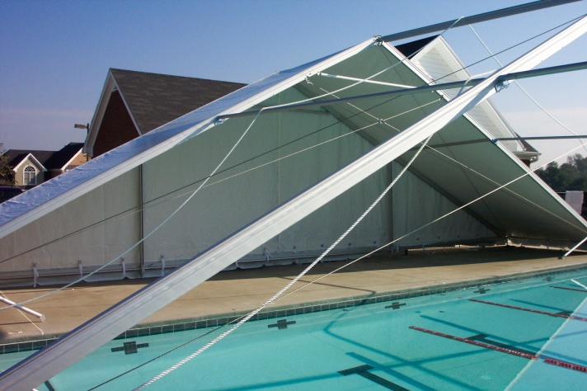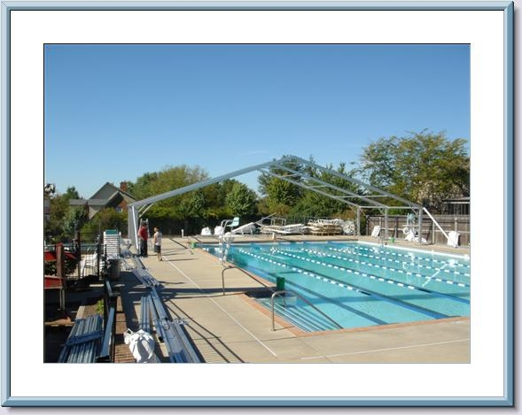
The aluminum beams are bolted together and lifted into place.
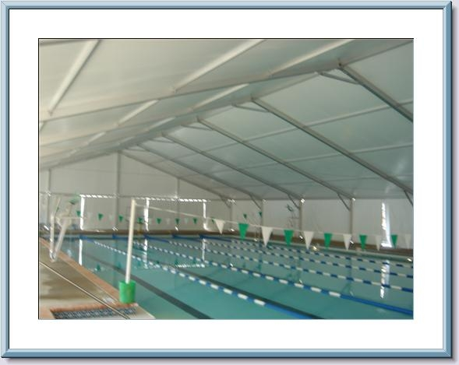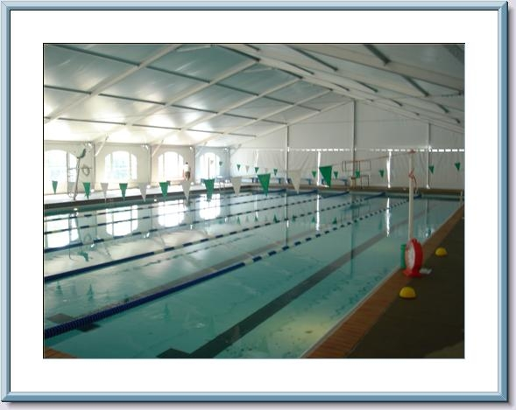
The membrane is installed and you have a building up or down in 1 to 2 days.
These buildings have 70 mph wind (and up) factors and can be double lined for added insulation. They cost less to operate than an air inflated structure and can be run at negative pressure like natatoriums need to operate. This means more air is exhausted than taken into building so it is easier to control the air quality and humidity.
Cost is very attractive. Each pool site will have its own nuances but “rule of thumb” for basic budgeting is $20 per square foot for the building installed. An added advantage is since this building goes up and down each season, it is classified as a piece of equipment. Therefore it qualifies for a lease to own financing option.
So rather than be required to have hundreds of thousands of dollars equity to build a new pool, you now need a good business plan and the first and last month’s lease payment and you are in business. The most recent club that ventured into this type of pool partnership was looking at $3,000,000 to build their own 25 yard training pool. They found an existing 25 yard pool and purchased the Architectural membrane building for $150,000.00. BIG difference.
When approaching the “pool owners” you have to have a plan.
- What’s in it for the current owner
- What’s in it for you
  - Be honest
  - Don’t embellish
  - Don’t hide facts or exaggerate
If this is going to be advantageous to both parties, each needs to bring something important to the table.
Some things you may want to investigate if you are dealing with a city:
- Will they lease you the existing pool and allow you to manage it year round? This way they are out of the pool business and in the “look what our community has” business
  - Can the lease include all utilities and insurance since cities pay preferred rates for utilities and insurance?
  - Can you afford to also pay the city 5% of your gross income – or –
  - Offer reduced rates for citizen access during special hours – or
  - Offer reduced rates for swim lessons to children on the reduced fee lunch program
- OR - Can the city/owner lease you the pool for $1 a year and let you run it like your own private business? This may not be something the owner is interested in but why not start down this road and see where it leads?

- OR - Can the city purchase the new up and down building and get bond rates for the loan? Will they then include the pay back for their bond loan in your lease? This way you only have one lease payment at a very attractive rate rather than a lease for the pool and land payable to the city then another lease payment for the building financing.

Listed below is an excerpt from discussions from an actual city on a similar situation. Just think PVC building rather than solar panels. You can get some insight on the cities thought process…..
Bond question considers quality of life upgrades Alamogordo Daily News
By Elva K. Österreich Associate News Editor
The question in the March 10 general obligation bond is concerned with the quality of Alamogordians' lives. The quality of life question will take care of a number of issues that have been on the city's planning slate for several years, and will also help draw commerce and tourism into the city……..
* Solar heating panels for the recreation center pool will cost $150,000. "These will help offset heating costs," Schmittle said. "Last year, the bill was $81,000. The panels may reduce the bill by 40 percent as the pool is heated year-round. Eventually it could pay for itself." * Creating a "sprayground" for small children at the site of the old Washington Park pool will cost $1 million. The project would fill in the old pool and add equipment to the site. "I think that could be a tourist draw," Schmittle said. McNeil said the city could use the existing building and locker room facilities for "sprayground" access. The old pool equipment is not usable and it would be too expensive to operate two pools when the existing Olympic-size pool at the recreation center rarely exceeds capacity.
* Paving the parking lots at Kid's Kingdom and the Family Recreation Center will cost $85,000.
* A therapy pool at the senior center will cost $500,000. "The need for this was brought up at public hearings," Schmittle said. "It would have warmer water in it and be used for fitness." …..
The total of all the quality of life projects bring the third bond question to $3.13 million. "We think they are all good projects," Schmittle said. "We feel that improving the quality of life for citizens is important," McNeil said. "It also gives us the ability to attract new business and individuals to our town. Companies look at these things." The cost of the bonds to individuals depends on the dollar amount of the questions that pass. The city will pay off an existing property tax bond this year and most of the funding for the G.O. bonds can come from extending the tax used to pay those bonds. Contact Elva Österreich at eosterreich@alamogordonews.com.
Summary
So start thinking about how you may be able to use a pool that is already there but not operated or programmed year round.
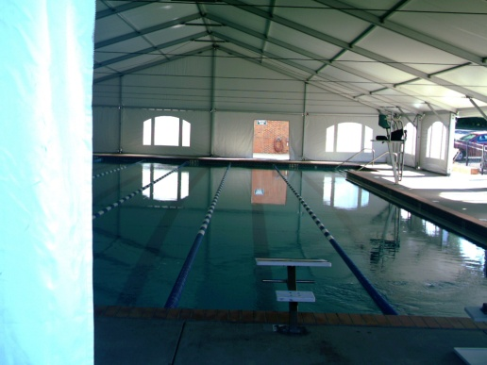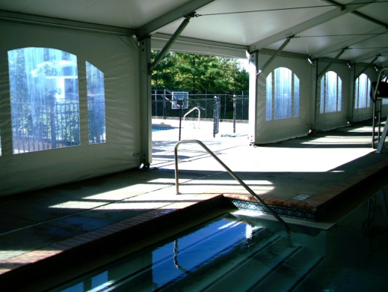
Financed amount $150,000
- A 3% interest rate bond payment through the city for $150,000 loan payable in 10 years would cost $1449 per month
- The same loan at 7% business loan rate for 10 years would cost $1742 per month
- The same amount on a 7 year lease would cost approximately $2490 per month
This does not address equity or down payments.
After the process has been completed a couple of very important things need to become daily routine.
- Even though the pool is now indoors, it (they) must be covered every night. This saves up to 40% on water heat and chemicals plus allows the building to “dry out” overnight. Moisture is hard on any building so the more consistently we remove it, the healthier the building and the budget is.
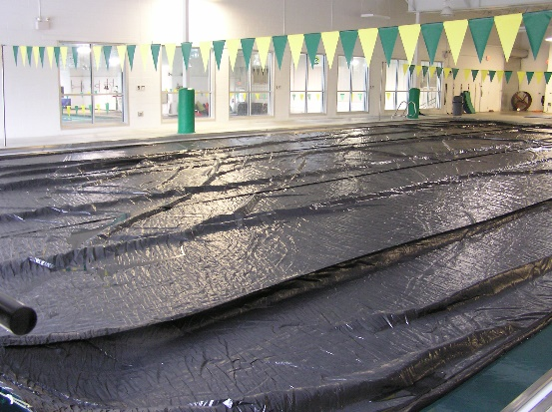
More information on covers is available from mnelson@usaswimming.org
- All natatoriums (pool buildings) need to be run under “negative pressure”. This means more air is being exhausted than is being brought in. After the pools are covered leave the natatorium exhaust fans run over night. On buildings without dehumidification systems, this will help the building dry out every night. This greatly extends the life of the building and enhances the air quality the following day. Unless you have a high end HVAC system the exhaust fans should run 24/7. A two speed fan motor is also a good idea.
AND – some great advice from Coach Mike Stromberg who actually covered an HOA pool with a SERG building that the swim team owns. This was a partnership that benefited both the Falfin’s USA Swim Club in Colorado Springs and the Wolf Ranch HOA.

Things to do:
1) Do a pool inventory of all the HOA swim pools in the area and identify who manages the pool for the HOA.
2) Rank the pools according to the best fit for your program and how it helps your team’s growth goals.
3) Spend some time meeting with members of the HOA and find out what they think of think and their expectations.
4) Draft up a proposal for each HOA off your discussions - tailor your proposal. You will be surprise they will all be similar, but each one will have separate concerns.
What you – the swim club - bring to the table
1) Manage the pool after the HOA closure until there next season.
2) Your club will be responsibility for operation and utilities when the pool is covered
a) We requested a 3 year operation and utilities agreement and we would responsible for $$ above that average.
3) The HOA may have an open swim time on Saturday or Sunday afternoons.
4) Ne aware you may have the expense of buying and installing a pool heater and pool covers.

What we got in return.
- Total usage of the pool from 6:00am until 10:00pm for practice and programming when the building is up.
- We also program and manage the HOA swim lessons in the summer.
- We also run a summer swim team.
- We use the pool in the summer for practice from 6:00-9:00am then iy is open to HOA for the rest of the day.
Coach - Mike Stromberg mkstromberg@gmail.com

