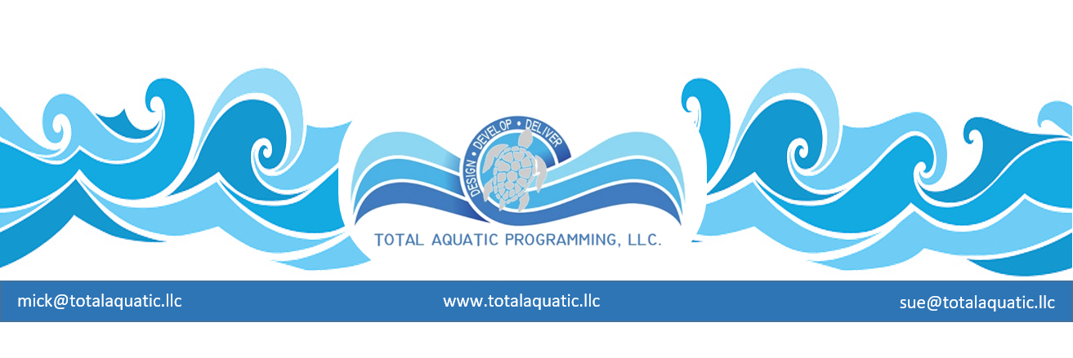
The evolution and change of program planning ….
If you are planning to introduce Total Aquatic Programming (New Programs) to your facility and have addressed the Temperature Access and Depth issues, then your next step is the Who What When Where How and Why. There is a huge difference between a New facility START UP and an Existing facility NEW PROGRAM introduction. Each has its advantages and challenges. Both need to have a great advanced MARKETING PLAN that educates and excites customers.
One of the advantages for the NEW facility is that there are no current members so no built-in expectations or preconceived notions of program quality. A full menu of 4 Pillars Aquatic Programming can be offered with different levels of service for each program. This will not be overwhelming if marketed and presented properly.
The Existing facility has an advantage of staff reputation and existing programming effectiveness (hopefully) and needs to introduce New Programs gradually into the schedule. Too many new programs created at the same time can confuse customers. From your list of potential New Programs pick the top 1 or 2 that have the best chance for immediate success. One successful strategy for program introduction is:
- New Program name and very brief explanation 3 months prior to first day of program
  - Flyers at existing facility available to current members
  - Bulletin boards with flyer in prominent place
  - Web site banner on Home Page
  - Flyers or ads in community places that are appropriate
  - Staff orientation so each one of them understands the program and can promote
- New Program name and more detailed explanation 6 weeks prior to first day of program
  - Early registration options at existing facility
  - Web site with registration options listed and active
  - Staff meetings to track and evaluate program sign-up
  - TV or Radio adds if appropriate
- New Program name and more detailed explanation 2 weeks prior to first day of program
  - Notice that registration options are now limited so “sign up now”
  - Web site focus on new program
  - Last week staff push to sell program
For more information about aquatic programming or to get an electronic copy of the Aquatic Programming Manual please contact sue@totalaquatic.llc

