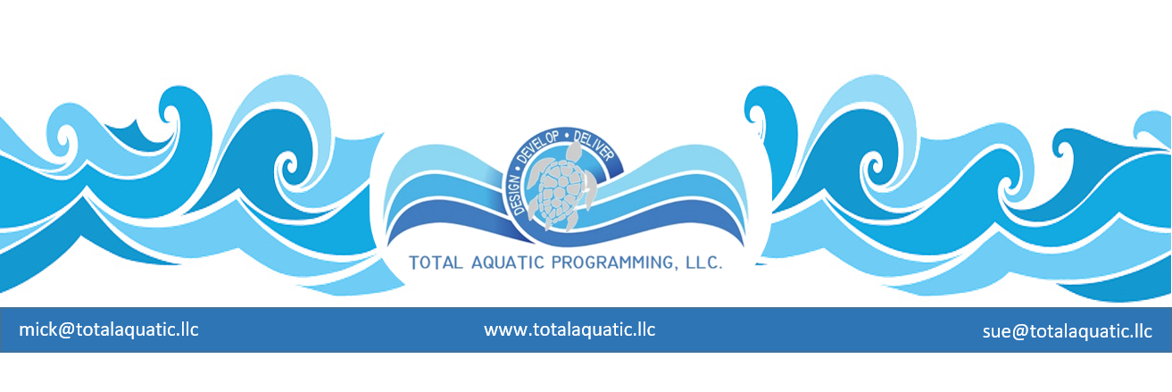

The BENEFITS of the OSS principal for aquatic facilities.

The One-Stop-Shop has become prevalent in almost every facet of business culture. From gas stations and travel marts to pharmacies and big box stores. The first shopping mall was the Country Club Plaza, opened by the J.C. Nichols Company near Kansas City, Missouri in 1922. It wasn't enclosed and eventually was the impetus for the term “strip mall”. The first enclosed mall was Southdale, opened in 1956 in Edina, Minnesota (near Minneapolis). When people were exposed to the convenience of buying multiple items on the “shopping list” in stores that were located just a few steps from each other, that convenience become a necessity. The dry cleaners profited by being close to the nail salon that profited from being next to the sandwich shop. Shared parking and marketing became a formula for success.

We mention this because Total Aquatic Programming (TAP) offers a tremendous advantage for the financial sustainability of an aquatic facility. Think of each aquatic program as a separate business that can benefit by being in the same place as other similar programs.

- Learn to Swim
- Aquatic Therapy & Rehab
- Adult CAAP membership-based programs
- Recreation swimming
- Masters Swimming
- USA Swim Team
- High School Team
- Parties and special events
- Swim meets

Each one of these programs has the potential for cross-over membership and participation when people can actually see the programs taking place. The parent who brings their child to a learn to swim class can see the swim team getting ready for, or actually practicing. They can also see adults participating in a healthy lifestyle aquatic activity in a socially interactive and fun setting.

This is the main principle for the Total Aquatic Programming facility and the 4 Pillars of aquatic programming.
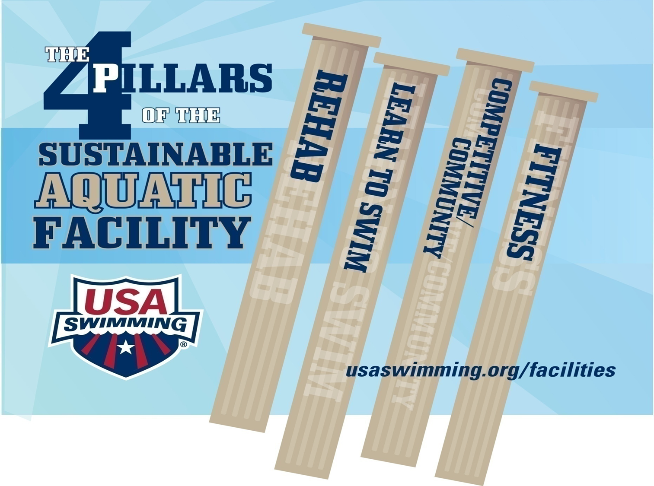
There are also tremendous benefits for cross-training staff and developing professional aquatic careers. It is more economically effective to operate one Total Aquatic Programming facility with 10 staff members than 2 different facilities that need 20+ staff members.

Operational cost can also be decreased. A savings of over 40% in utilities and other direct operational cost can be realized by having all programs under one roof rather than in multiple locations.

We realize that the practical cannot always be balanced with the ideal. If there are already pools at 2 or more locations in a community, you do the best with what is in place until a new model can be considered.
The following are slides form our Regional Build and Program a Pool Conferences:

Sharing staff and their expertise in various aquatic programs…..
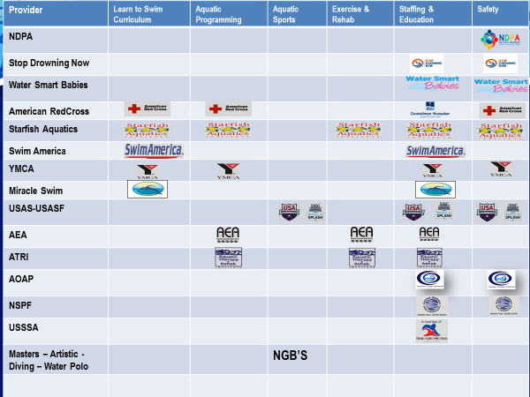

All programs and pools within sight of each other. Each pool has the ideal Temperature, Access, and Depths, this is known as TAD

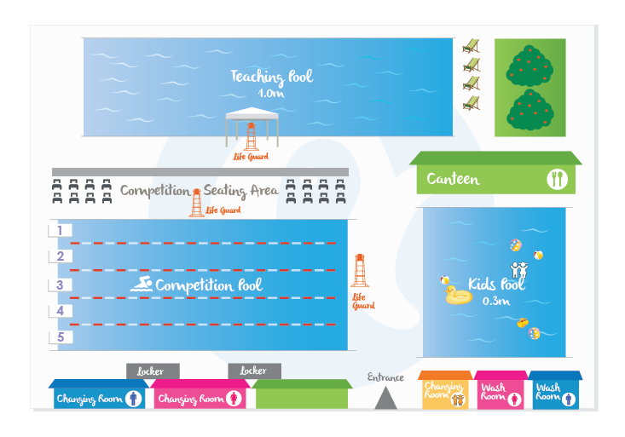

Rather than have too many staff, devote resources to having professionally trained and certified staff that are fairly compensated which encourages “aquatic careers”.

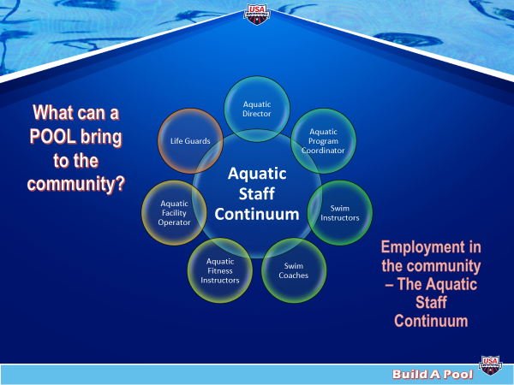

Programming Precedes Design. Always multiple pools on separate filter systems with ideal program water temperature, access and depths.

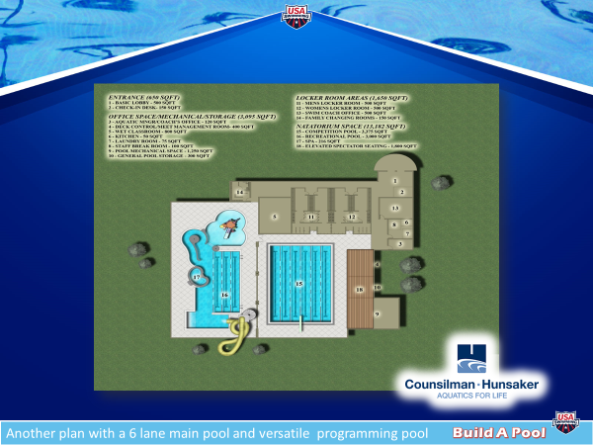

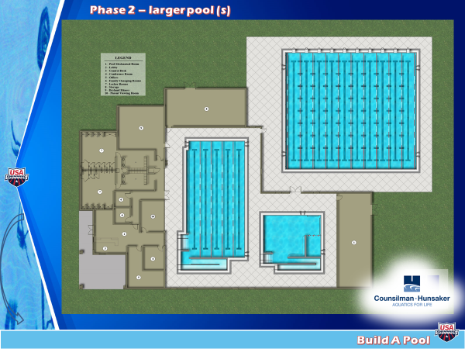

A banlanced business plan that recovers all operational cost plus 10%.

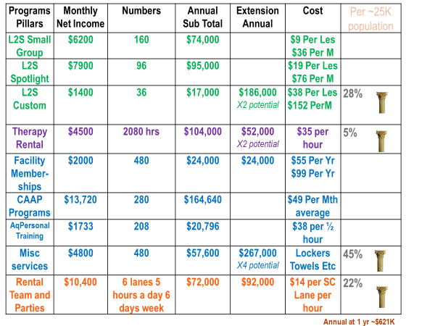

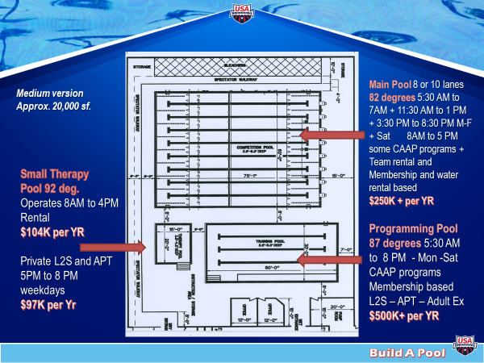

The Aquatic Facility One-Stop Shop model has come of age. Don’t limit your creativity by only looking at what has been done in the past.

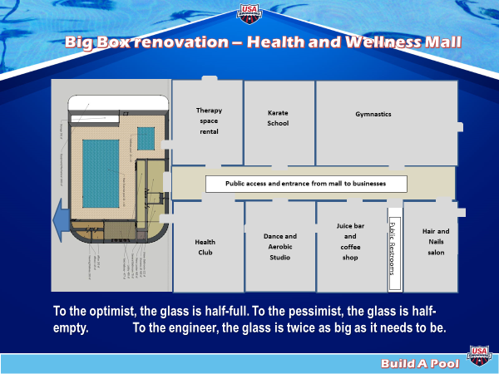

SUPPORTING INFORMATION

The FACILITY: It really doesn’t matter whether you are renting a facility or own your own, the same principles still apply.
- The facility must be clean and attractive. Everything from the parking lot to the reception area to the shower rooms to the pool itself has to say, “welcome to our facility” and we care about both the facility and all the patrons.
- Risk management is, and always has been, super-important. However, it is receiving more public attention than ever before. You need to have a “plan” and make everyone aware. The days of winging it are gone. There are great nationally recognized firms that specialize in helping you develop and implement your plan. For more information contact mick@totalaquatic.llc

Things to consider about the facility:
- Is it ADA accessible in all areas?
- Is the proper signage displayed in the appropriate areas and are they in language that all patrons can understand?
- Are the rooms located where they can be easily found and are, they labeled so everyone knows what the room is used for?
- Do pictures and notices and signs throughout the facility encourage inclusion for all ages, genders, ethnicities/cultures, etc.

The STAFF: You can never spend enough time and resources on staff training and support. Teamwork has become a catchphrase, but it is so important.
- Staff training and certification benefits everyone. The certification needs to be relevant and from a reputable organization. There is much more to aquatics than just first aid and CPR. Once certifications are achieved, all clientele need to be made aware that the staff is among the best in the country.
- Each staff member must be conscious of their personal style. How do they appear and relate to others? No one should ever think their “style” is proficient. Improvement is something that just doesn’t happen, it is caused. Staff motivation and a concerted effort to be better than last week is critical.

Things to consider about the staff:
- Do you have an effective mix of age and gender and culture of staff?
- Is training and certification ongoing and do you listen to staff about some of their specific interest for continuing education?
- How many in-house seminars or workshops do you host each year?
- Do any of your staff speak more than one language that would help in your programming and inclusion efforts?
- Does your staff dress professionally in logoed apparel?

The PARTICIPANTS: These are the people who write the checks (customers). Without them the business does not succeed. Many customer service businesses fail because the staff did not recognize what it took to keep people happy, healthy, and coming back day after day.
- Customer satisfaction is a daily challenge that must be discussed, analyzed, and tracked. Customer comment cards should be available at the front desk. Periodically the staff needs to talk with the participants and see how they feel the staff are doing.
- Do all the participants feel welcome and have goals? Have they been taught goal getting? Have you discussed their personal plan and the benchmarks they will use along the way? People quit because they feel they are wasting their time, or they don’t belong.

Things to consider about participants:
- Do all programs have different price points along with options?
- For programs, has “time of day” or “day of offering” been considered to include the most possible participants? CAAP programming.
- Is the participant’s safety of upmost importance?
- Are programs offered for all ages and stages of participants?
- Is there a plan so a portion of every income dollar is set aside for program financial assistance?
- Is there a grant application plan to secure outside dollars for financial assistance?
- Is there a plan to engage local businesses in sponsorships and advertising to help participants that have financial assistance needs?

Every facility has a better chance of success and survival with Total Aquatic Programming. Every program has a very important place in the culture of success. It is very difficult to have one program functioning with one plan, delivery method, and staffing philosophy while another program works an entirely different way. Aquatic programming has way too many commonalities for us all not to take advantage of the above points and collaboratively make the business a sustainable success.

The two main parts of any successful business plan are:
- Managing expenses
- Increasing income

Income and program pricing must be based on Value Received Pricing.
E-mail sue@totalaquatic.llc for information on VRP.

Expenses need to be evaluated quarterly.

- Do you cover the pools at night?
- Do you use the best pool chemicals?
- Is the HVAC system checked twice a year (or more) for operational pumps, condensers, vents, and filters?
- Are cleaning supplies the highest quality (no ammonia or nitrogen) at best price?
- Have contract services been evaluated and comparative bids collected?
- Do you have a capital improvements budget that has income every 2 weeks just like an employee?

And finally, do you really know your community?

A very common request of TAP is for us to provide the facts and figures that prove a community can build and/or sustain a specific size of facility or offer a specific aquatic program that will be successful. The demographics of Miami Florida vary greatly from those of Seattle Washington but on paper, the raw numbers look similar. The needs of each community will be based on what exist there now and what national trends they are not currently fulfilling. The delivery system of the actual programs plays as important of a part as the size and type of facility and where it is located.

You can pay for a formal Feasibility Study that will give you a wealth of information about your community and the surrounding areas, but first you should know the basics and do some research on your own.
- A market analysis can be performed to document the needs and identify the “target market” and core service offerings for programming.
- You can analyze the major direct and indirect competitors and compare against the activities and programs identified in the market analysis above.
- Interviews with key stakeholders and potential participants to document their needs and other issues.
- Examine the demographics of the area. Trends will be documented based on growth of community, median age of adults, median household income, ethnic and cultural trends, and frequency of participation by each demographic characteristic. These figures will drive the revenue projections
- Identify the recommended core program markets based on the input and analysis performed during this task. The outcome of this task will be used to establish a concept development plan including financial performance and partnership/management alternatives.
- Attend a USA Swimming Regional Build & Program a Pool Conference. There are 6 per year – schedule is at www.usaswimming.org/buildapool

