“P” in the Pool

We don’t swim in your toilet – please don’t pee in our pool.

This was a popular sign displayed at many pools in the 1970’s and 80’s. What happened to that message? It needs to come back, stronger than ever with the advent of municipalities going to chloramination of drinking water rather than chlorination. To make a very long explanation short, it is not chlorine that makes the pool air smell bad, it is chloramines.

During the past few months, alerts hit the internet claiming that sixty three percent of people surveyed were not aware they could get sick encountering contaminated water. One in five people admit they failed to get out of the pool before having to urinate. “When it comes to peeing, a survey of 1,000 adults finds 78 percent are convinced their fellow swimmers are the guilty parties”. The survey has a margin of error of 3 percent. Only 35 percent say they shower before entering a pool. Even though our main goal is to improve air quality we need to mention that not showering further contributes to the bacteria and other dirty stuff, like sweat, getting into the pool. That dirty pool water can lead to recreational water illnesses including diarrhea, respiratory illness, and ear and skin infections. Just 36 percent of those surveyed say the quality of the pool water is something they think about when they go to the pool. And think about this: some kids actually drink from the pool. This is a very dangerous practice.

Why is the issue of peeing in the pool so important? What has come to the forefront recently is that peeing in the pool may be one of the main causes for “bad air quality” in indoor natatoriums. Since urine has a high ammonia content, a few people peeing in a 25-yard pool can tremendously affect the chloramine level. This directly affects the air quality in the pool room. Then we read on the web how bad chlorine is for people with asthma. This is a sensationalistic “the sky is falling” approach to a problem that can be helped. Stop peeing in the pool and start taking showers before going in the water and it will be surprising how fast air and water quality improves.

The introduction of full body suits compounded the problem. Maybe the rule change outlawing full body suits will help, but old habits are hard to change. Swimmers do not want to struggle peeling off their overly tight suits and then struggle getting them back on. They pee in the main pool during warm-ups and they use the warm-up pool as a toilet in between events. I recently was on deck at a USA Swimming Sectional Meet that had good air quality on the first day of meet then very questionable air quality on the second day, and unhealthy/dangerous air quality on the third day. My eyes started to water within 10 minutes of entering the pool room. At that same meet I personally heard many swimmers joking about peeing in the warm-down pool. One of the misconceptions amongst swimmers is that one-person peeing will not affect a large pool. They do not realize the problem they are creating.

We talked about this increasingly serious situation at many of the United States Aquatic Sports Conventions during the annual coaches meeting and specialty Facilities presentations. Over 150 coaches were in attendance. They were all asked to preach “get out and use the bathroom” to their swimmers both in practices and during meets. This is the first line of defense against this problem. After the meeting I heard all sorts of comments. One that stuck with me was: “If I let my kids out of practice to go to the bathroom, I’ll never get any set done right!” My reply was simply: “How will you get sets done right without a swimming pool?”

That’s where this is heading! Pools that have bad air quality are mandated to spend $30,000 or more to upgrade their water treatment equipment. Some pools (average rate of about 2 per week) respond by closing their pools doors permanently. Even upgraded water treatment systems with ultra-violet systems cannot adequately handle the problems occurring in the tank between filter cycles.

Let’s debunk an urban legend: – there is no chemical to add to the water that turns the water red (or some other color) when someone pees. If you can invent such a chemical, please let us know so we can buy stock in your product.

Problems that have the simplest solutions seem to be the most challenging. Think about this: we know the causes of lung cancer, but people still smoke. We know a major cause of high chloramine levels in pools that cause air and water quality issues, but……

Here is what you can do:
- Sit your swimmers down (more than once) and impress upon them the importance of not peeing in the pool. Not a passing comment or casual mention of the fact or a joke, but real a statement that gets the swimmers’ attention and gets the point across.

- Make sure there is signage in more than one prominent location (including locker rooms and lobbies) stressing the importance of not peeing in the pool. BIG – BOLD – LETTERS. Not cutesy signs – WARNING SIGNS.

- Help make every coach, athlete, parent, official and volunteer aware of the seriousness of this problem.

Please take appropriate action immediately. Our pools thank you and your swimmers will thank you!

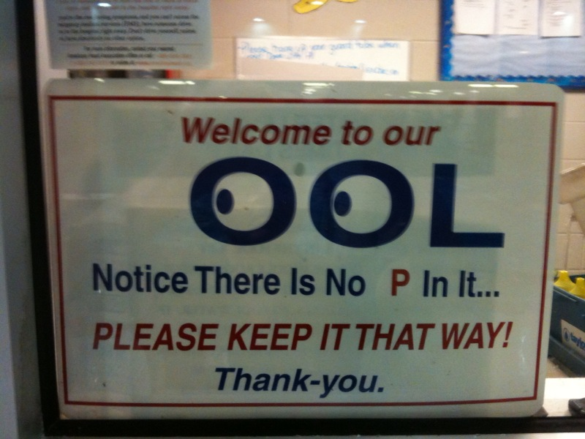

- News results for peeing in pools
What's in the pool?‎ - 6 days ago
"If you are looking for any real-life or personal anecdotes, I can say that it's probably way more than one in five people who pee in pools – it's just that ...
Philadelphia Inquirer - 13 related articles »
- snopes.com: Urine Revealing Pool Chemical
Jul 21, 2007 ... Can a chemical be added to swimming pools that will reveal the presence ... called "Wee-Wee See" is used to catch a pool-peeing perpetrator. ...
www.snopes.com/science/poolpiss.asp - Similar pages
- Do You Pee in the Pool? | Poll, Swimming, pool | FitSugar ...
In light of the start of swim season, a bit of news caught my eye — in a recent survey, one in five Americans admitted to peeing in the pool ...
www.fitsugar.com/3162791 - 126k - Cached - Similar pages
- Peeing in the Public Pool: One in Five People Do It | Rodale News
May 20, 2009 ... So if too many people are peeing in the pool or diving in while sweaty, that could mean less chlorine's available to wipe out nasty critters ...
www.rodale.com/pool-peeing-survey - 31k - Cached - Similar pages
- 1 in 5 Americans Admits Peeing in Pool
Jack8274, on 05/15/2009, -5/+1So if the 1/5 is actually lying about peeing in the pool, then only 3/5 of Americans pee in pool. It's not that many. ...
digg.com/health/1_in_5_Americans_Admits_Peeing_in_Pool - 75k - Cached - Similar pages
- The problem of peeing in pools … - snopes.com
11 posts - 8 authors - Last post: Jun 27, 2007
She really believed that if someone peed in the pool they'd have to close it for the day and refill it? Oh boy. ...
message.snopes.com/showthread.php?t=11290 - 66k - Cached - Similar pages
- Peeing In The Pool? It's More Common Then You Think | ChattahBox ...
US (ChattahBox) – You may want to think twice before doing that cannonball. As it turns out, 1 in 5 Americans admit to peeing in swimming pools, ...
chattahbox.com/curiosity/2009/05/15/peeing-in-the-pool-its-more-common-then-you-think/ - 23k - Cached - Similar pages
- Gross Alert: 1 in 5 Americans Pees in the Pool | NBC Chicago
As you head to the public pool this weekend to relieve yourself of the sweltering heat, just remember -- someone near you is probably relieving themselves ...
www.nbcchicago.com/health/tips_info/Do-You-Pee-in-the-Pool.html - 99k - Cached - Similar pages
- 1 in 5 Admit to Peeing in Pools
"I've never peed in the pool before," said one swimmer earlier Monday but ... 1 in 5 Admit to Peeing in Pools. It's summer time and that means people will ...
nwahomepage.com/content/fulltext_news?cid=91901 - 59k - Cached - Similar pages
- How can you pee in the pool without getting caught? - Yahoo! Answers
I saw another girl's question about peeing at the …
answers.yahoo.com/question/index?qid=20080526120729AAFq7xf - 67k - Cached - Similar pages
- Gross Alert: 1 in 5 Americans Pees in the Pool | NBC New York
May 17, 2009 ... One in five Americans pees in the public pool, according to the survey conducted by the Water Quality & Health Council. ...
www.nbcnewyork.com/news/weird/Do-You-Pee-in-the-Pool.html - 102k

