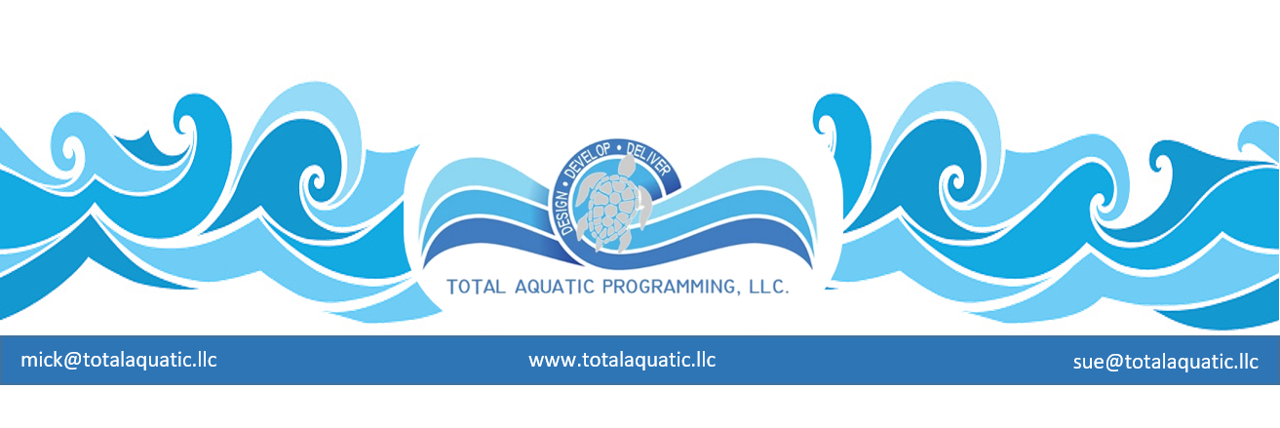
Partnerships and Mergers

Partnerships and mergers are defined as relationships between two or more people or organizations that are involved in similar activities. These involve working together for a common purpose and sharing in the risk and profits of such a project.

Many times, partnerships are formed out of necessity and/or passion. The whole becomes real when considering the sum of its parts. The USA Swimming club is usually in search of a partner for the development of a new aquatic facility. Seldom does a single club have the resources to sustain a project on their own. These “seekers” are usually volunteers with a passion for swimming based on their child’s current or previous involvement. Passion makes us feel but seldom helps us see clearly, therefore, planning and great advisors are paramount. F. Shulz said: “Passion acts as a wind to propel our vessel, our reason is the pilot that steers her; without the winds she would not move; without the pilot she would be lost.” We are dependent on the USA Swim club(s) to supply the pilot for the project.

Understand than much of the time, the partners considered will bring more to the table than the single club. If they are a partner worth having, they will figure this out quickly, so the clubs must be prepared to assign values to what they bring. This can be done by creating a list!

First what does each club bring to the table:

- Competitive swimming business, experience, and know how
- Learn to swim business
- Other aquatic programming expertise
- Economic impact for swim meets and other events
- Community presence for water safety for children
- Health and wellness through aquatics for the community
- Fundraising through a 501.c.3 not for profit corporation
- Equity
- Special business or project expertise from the club’s members
- More …. what else?

Second what is needed from each partner?

- Real estate and development
- Investment capital
- Professional services
- Building assistance
- Preferred utility rates
- Marketing
- Membership base potential
- Extended programming options
- Operational subsidies
- More …… what else?

The type of partner will be determined by what is needed. This is where the cliché “leave no stone unturned” has true meaning. There is simply no standard model. Partnerships that may have merit are:

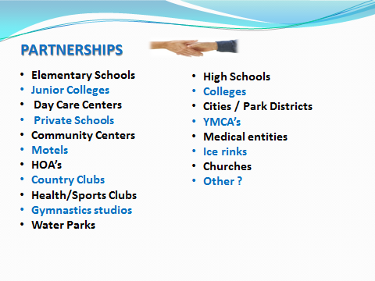
With each type of partner comes a unique arrangement that can be negotiated so both the club(s) and the partner benefit. Not every partnership explored will be a “good fit and competitive swimming may not be the only focus of a partnership. It will be important to the club and to the business plan, but it’s only one pillar in the project plan. We talk allot about the 4 pillars of aquatics and we use that metaphor because it takes 4 pillars to effectively hold up a roof. Our pillars of Total Aquatic Programming are:

- Community/Competitive
- Learn to Swim – Water Safety
- Aquatic Exercise
- Aquatic Therapy/Rehab

Since programming precedes design, the club needs to see where they fit and then solicit partnerships for the balance of the plan. With each partner considered comes the hard fact that the club will give something up when compared to an outright ownership. This is where patience and clear vision play an important role. We have seen partnerships of desperation that do not work very well for very long. It does not accomplish much if the USA Club needs water time after school for practice for their 250 swimmers and the additional 75, they have on waiting list, yet they partner with a high school or college that needs the pool from 3PM to 6PM every evening. It does not help the programming potential if the club partners with a business that is skeptical about having kids in the facility during prime business hours. Partners have to understand and respect each other’s priorities from the very first step. This is something that cannot be “worked out” later. Remember the passion and clouded vision thing we talked about earlier.
Partners can be beneficial. Many times, partners are necessary for the project to be real.
- Pick wisely.
- Negotiate truthfully.
- Have patience.
Don’t be afraid to walk away from the table and start the process over again if things can’t be worked out for both parties’ mutual benefit. We have seen many projects where the search for partners lasted more than 2 years. It is worth it to get it right the first time.
Attitude and Accomplishments are important to any partnership. When attitudes are positive, and accomplishments are recognized there is a greater chance the partnership will flourish. Successful sustainable partnerships are not easy.

The level of commitment of both partners will probably be different and that is OK if each entity understands this from the outset. One thing that is easy to lose sight of is that a school or business or club is every changing entity that is made up of individuals that are constantly turning over. ABC swim club that partnered with XYZ school in 2002 will probably both have substantially different make-ups (people) in 2008. Unless attitude is part of the culture and accomplishments are constantly reinforced, sustainability is questionable. ABC and XYZ must be committed to each other’s success.

.
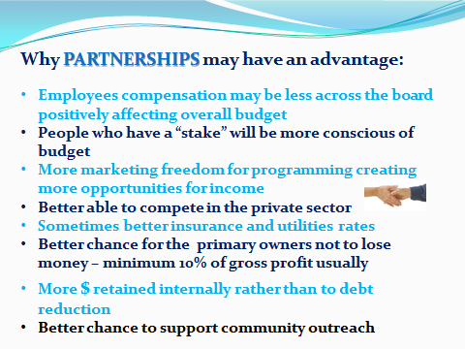
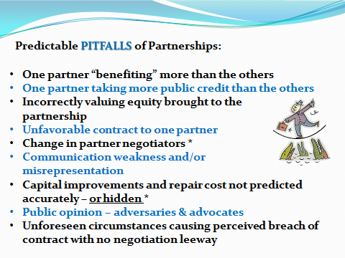

Partnership goals:

- Create opportunities for clients and employees
- Problem solve fairly with innovation
- Understand management and staffing model
- Communicate effectively and frequently
- Reward and acknowledge clients and employees

Things to consider:
Other successful models you can ask for information from:

- History
- Planning
- Proposal & Staffing
- Operation
- Challenges
- Events
- Communication & Partnerships

Others Business Plan that have helped them create a “proven” sustainable facility:

- Examples
- Projected Programming and Expenses
- Contract: Agreements with Club Teams and other renters
- Business Plan: Value Received Pricing understanding and implementation

Resources & Partnerships

- USA Swimming
- LSC (Facilities, rental & Programming Fees)
- Make A Splash Partnership
- Water Safety & community plans
- Community Partnerships – other NGB’s

Risk Management
Things that make the premiums higher
- Diving boards – 1 & 3 meter and platforms
- Water slides and play features
- Unsupervised areas such as splash pad

Things that help the premiums stay lower

- A good written policy and procedures manual
- Formal risk management program – e.g. Starfish Aquatics system
- Staff certifications and in-services
- Record keeping
- Reduce Risk & Liability (Introduced resources, SAI and PHTA
- Aquatic Risk Management
- Emergency Response Planning
- Aquatic Facility Audits

