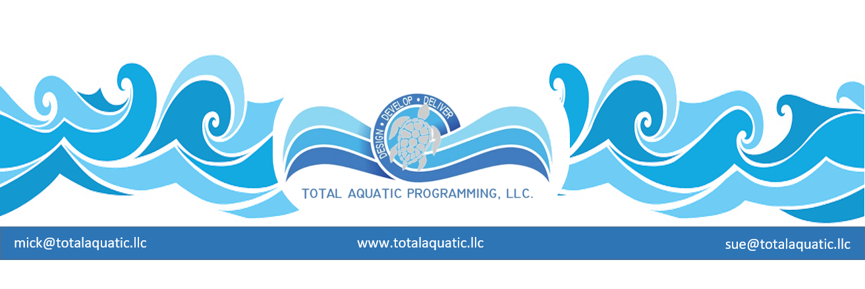

PHASING – one plan to tackle the improbable.

“There is no great achievement that is not the result of patient working and planning.” – J.G. Holland

If building a pool was easy, they would be as plentiful as Starbucks. Imagine a pool in every neighborhood that gave swim lessons to children, water exercise and wellness opportunities for adults, and a place to train for swimmer’s youth and adult alike. We started approaching that model with some of the national health club chains until they realized they knew nothing about aquatics and the pool was the most expensive part of the building to both construct and then to maintain and operate. Rather than change their paradigm, they simply cut the pools out of their plan. That of course is “one answer” to their dilemma, but none to ours. Without the franchise model we are on our own. We rely on the YMCA – some of the more progressive health clubs – schools – universities – cities – the list goes on.

USA Swimming clubs are the most prevalent water renters in the country. Out of their 3200+ clubs, over 2800 rent water. With a solid, long term, water rental agreement and great community minded people involved on both sides, this is a very practical solution to our needed pool time. However, the ongoing challenge is “growth potential”.

The four pillars of aquatics are experiencing growth in popularity.

- LEARN TO SWIM - More parents are realizing the importance of their child learning how to swim no later than the 3rd grade; much earlier in, most cases. The necessity for this skill transcends ethnicity and social economic status. Being safe in and around the water ranks right up there in importance with learning to walk.
- AQUATIC EXERCISE - The baby boomers are here and want places to do low impact aerobic exercise that leaves them pain free – exercise machines simply don’t cut it – water does.
- REHAB - Aquatic rehab/therapy is here to stay and the clients love it – better outcomes with less pain
- COMPETITIVE SWIMMING - The community aspect of competitive swimming may be the fastest growing population of all. Starting with our young elementary school children the aquatic sports offer something for everyone for the rest of their life. It is truly the only “lifelong lifestyle” activity.

Because swim clubs across the country are aware of these facts, they are looking to partner with other community minded entities in an effort to upgrade existing facilities or create new functional and sustainable aquatic facilities. This is absolutely the best way to begin. However, the one thing that seems to be extremely common and unfortunately predictable across the country, is the ability for a group of passionate people to get off track from their original goal thus expanding the scope of the project from the “difficult” right on past the improbable landing squarely at the impossible. This is not-so-affectionately called “scope creep”. It is very unlikely that a “committee” or “project focus group” can back up and start over when the project hits the proverbial money wall.

Many times, community projects that do get the municipalities or park districts interest must be bonded which can take 2 years or more. 75% of the time the project is not designed well or presented to the voters properly, so the bond gets defeated. By this time 4 years of project planning, feasibility studies, and bond development have gone by. Many of the people who held a government office when this all started are now termed out and many of the original project volunteers have been replaced. It may be a decade or more before this topic will be revisited. This cycle of failure is typical. It can be stopped but it takes a well-prepared local leader who understands what is needed and how to turn adversaries into advocates. These volunteers are rare indeed.

At the first sign of “scope creep”, the local leader must have a plan prepared. It is not if it will happen, it is more likely when it will happen, so just realize it will be part of the planning process.

Typical scenarios are:

- Other aquatic sports wanting to be serviced by expanded your original facility design. E.G. Syncro – Water Polo – Masters – Diving – etc. These activities have special needs for custom design. This adds expense to the project – including cost to build and cost to operate. What do they bring to the table for capital construction cost and programming income opportunities? Not theoretical but contractually.
- The older populations wanting warm water opportunities for them to exercise. If it has nothing for them, they will automatically vote it down. This takes planning and politicking. This may be the most inexpensive consideration or addition to any facilities plan, and it has very good income potential
- The younger generations want a place to play. Some studies show water parks make money and the city looks good if they can showcase a recreation facility for their citizens. The jury is still out on this one. Water parks are the highest dollar per square foot to build and operate. They seem to have a “newness or novelty” factor that wears out quickly. Places like Six Flags and Disney constantly have to keep adding new attractions to bring people back again. Why do people think water slides are any different?
If they can be an affordable and logically planned “add on” then go for it. When they become the focus for the facility, we think the project is headed down the wrong path. If the dense population warrants a water park, then it will probably also be able to support a separate facility dedicated to the 4 pillars of aquatics.
- The mega-meet pool is always discussed. “We want to be the center for swimming in our state”. “Look at all the money we can make holding meets”. This has some merit but usually gets way out of proportion quickly. It is true meets add to the economic development of a community, but many of the figures we have seen in planned presentations are drastically inflated.
- Meets have an income potential but that is not their primary focus. Meets usually have a facility cleaning and repair budget for each event hosted that barely allows the facility to break even. So before jumping on the “we want to host the mega-meet” band wagon, understand what it takes to host an event.
- Another factor to consider is how to pay for the daily operational cost for the spectator area. Many projects want seating for 2,000 + people, but that area must be heated and treated 24/7. The last 2 major university pool projects had to cut their proposed spectator seating almost in half because of cost to build and operate.
- Most clubs would love to have one of their pools be an indoor 50-meter facility for their swimmers to train in. Whether this is practical or not can be decided by a feasibility analysis based on demographics in conjunction with a well-developed business plan. What the project has to be ready to do is to evaluate the business plan and be prepared to scale the facility back to what will be practical and sustainable. Many times, the information says “you can’t build as big as you thought” yet the planners belligerently plod on towards the impossible.

This is when “phasing” can save a project. Phasing simply is building the most important part of a project first and making it a success before attempting the next step. Going back to the Starbucks example – it started with one Seattle coffee shop – expanded to 7 – changed names and then developed according to the business plan and the market demand. This is a successful model to follow. First the project must decide what is the “prime directive”.

- Is it to teach children how to swim?
- Is it a training facility for a growing team?
- Is it a family center for the community?

This must be addressed so phase priorities can be established.

There are as many plans as there are projects, but one example of phasing is listed below:

Prime Directive: “Teach children how to swim.

Phase 1. Build a 20’ x 60’ learn to swim pool with ramped entry for zero depth capability. The pool will be 4’ constant depth. It will be indoors with 3 x shower and dressing rooms; 1 for male, 1 for female, 1 one unisex.
The building will have 2 offices, 1 meeting room, small viewing area, mechanical room, storage room, and a reception area/lobby.
- Pool cost estimate = $350,000
- Building cost estimate = $1,500,000

Building has to be designed for expansion (adding on to). Cost does not include permitting, land, parking, utilities access, or design cost. After a 3-year successful swim school business is operated with supporting financial records……

Phase 2. Build an outdoor competitive community pool of the appropriate size. Add new shower rooms for team and public access. Design new pool so existing indoor pool, offices, meeting room is accessible. Deck is designed so outdoor pool can be converted to indoor pool and spectator areas added.
- 25-yard x 25-meter pool cost estimate = $915,000
- Additional shower room and decks cost estimate = $700,000
OR
- 25-yard x 50-meter pool cost estimate = $3,200,000
- Additional shower room and decks cost estimate= $950,000

Phase 3. Cover outdoor pool and add necessary areas for supporting programs as per business plan.
- SEC PVC convertible structure cost estimate = $350,000 to $600,000 depending on size of pool
- Universal Architectural membrane structure cost estimate = $650,000 to $990,000 depending on size of pool
- Steel building cost estimate = $2.3 million to $4.5 million depending on size of pool.

Phase 4. Fill in your plan details – you get the idea.

Phasing may not be the preferred method because of the time it takes to get from part 1 to part 4 – but many times it is the only method that will work.

