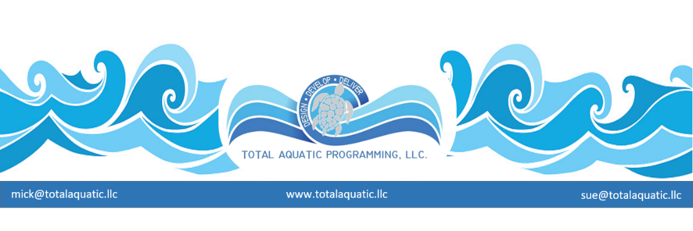
We always stress the importance of multiple pools in the same facility. Our Ideal Pools publication deals with TAD (Temperature Access Depth) and the importance of these principles to community programming. In this article we want to move from concepts to reality when considering facility design.

Programming precedes Design. This is a ‘Prime Directive”.
That is about the last clear-cut principle we will refer to. From this point forward every decision we make will have proportionate affects for the long-range success of the facility.

Design the small and necessary first and leave the large and flexible until later. Many projects are prime examples of what happens when too little money collides with to grandiose of plan. All aquatic facilities should have the following amenities included in the initial planning. Some of the more important considerations:

1. Shower room space and design – right at code minimums then a liberal amount of
deck rinse shower stations.
2. Unisex dressing and changing areas (minimum 1 / recommend 2) ADA compliant
with sink, stool, shower, 4 x locker rooms.
3. Unobstructed deck areas that will allow both wheelchairs to pass and people to
walk comfortably from place to place.
4. Easily accessible pump and equipment and storage rooms.
5. Safety controlled and monitored access points and offices.
6. Supporting land specific areas such as concessions, exercise area, retail rental
area, viewing areas and lobby, meeting room, computer equipment areas,
entrance way.

The Pools are listed in order of community service and income potential:

1. Therapy/Rehab pool – minimums -
Temperature range from 89 to 95 degrees.
Access – permanent steps in pool with railing
Depth – 42” to 52” – skimmer pools can have flat bottom and water level can be adjusted within a 5” range up or down.
Minimum size: 12’ x 15’ - 4’ wide decks –
Better size – 15’ x 20’ – 5’ wide decks –
Ideal size – 2 pools – split filter system – 12’ x 20’ – appropriate decks

2. Teaching/Exercise pool –
Temperature range from 84 to 89 degrees.
Access – permanent ramp in pool with railing – steps are an option or addition.
Depth – 48” to 72” – skimmer pools can have gradual slope to bottom and water level
can be adjusted within a 5” range up or down.
Minimum size: 20’ wide x 50’ long-5’ wide decks –
Better size – 30’ wide x 60’ long– 6’ wide decks –
Ideal size – 45’ wide x 75’ long – appropriate decks

3. Community/Competitive pool –
Temperature range from 78 to 84 degrees.
Access – outside steps alongside and ladders
Depth – 48” to 96” – state codes may affect shallow end design.
Minimum size: size 75’ long x 45’ wide– 10’ wide decks -
Better size – 75’ long x 67’ wide – 12’ wide decks –
Ideal size – 82’ long x 75’ wide – appropriate decks

Each pool must be on its own separate filter and circulation system.
Pools can share common deck area for conservation of square footage deck area.
Spectator seating – observation area - is one of those things that will be budget driven.

The deeper water the Community/Competitive pool has, the larger the Teaching/Continuum pool must be. For example, if the Better Size Community/Competitive pool is selected and it has all 7’ water, the Ideal size Teaching/Continuum pool needs to be selected to handle proper programming alternatives.

Somewhere along the line we became convinced that the only “fast” water is “deep” water. Neither empirical or antidotal evidence proves this concept. “Fast” conditions are created by proper gutter design along with correctly size surge tanks, proper lane line design, and most importantly fast swimmers participating. Everything we have seen as far research leads us to believe that 4’ deep water is just as fast as 6’ deep water. Those that think a 7’ deep tank is automatically “faster” than a 4’ deep to 7’ deep tank, have aways to go to convince our department (and a few of the current research projects) that this is a provable axiom.

With this in mind, it is programming and financial suicide to design an all deep Community/Competitive 82-degree pool. It will not be used for the community it serves between the hours of 8AM to 3PM because the water is too deep and too cold. This is one of the main reasons many facilities are struggling to stay open; too much of the wrong kind of water.

There are some states that require unusual deep water to dive from starting blocks. How they came to their conclusions was – in our opinion – not by a defendable scientific study. It was more by crisis policy making without considering how seemingly solving one problem can create other more serious ones. This is something that has to be handled through proper methods and educational material.
For the time being we would only ask if diving from both ends so we can conduct a few “short distance” relays is worth giving up community health, wellness, and safety opportunities?
If the answer is YES, then those representing competitive swimming in the community are truly a special interest group and they will always be struggling for the support they need for success.

