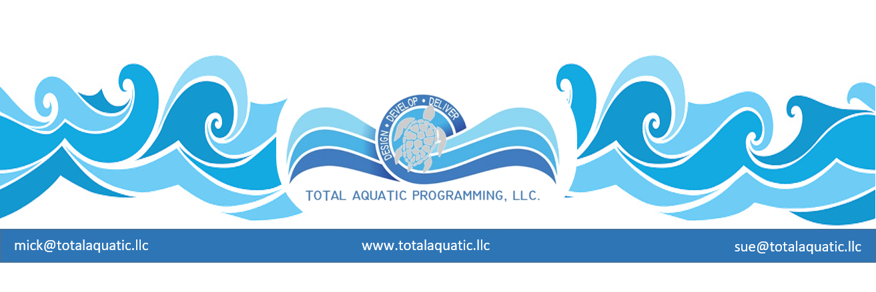
Pool sizes

Programming precedes design therefore the “size” of pool must match the programming needs. Three main things need to be considered when considering size.

- Length
- Width
- Depth

Therapy pools are usually the smallest and depth considerations are of primary importance. There really is no “standard” for length and width. Cross programming opportunities for therapy pools also need to be considered. Therapy is usually conducted 7 hours a day e.g.8AM to 4PM so, if designed appropriately, the pool can be used for additional community programming such as:

- Learn to Swim
- Aquatic Personal Training
- Adult exercise
- Stroke technique classes

The length and width of the pool need to be designed to accommodate stairs (with 4” to 6” risers) and a ramp if possible.

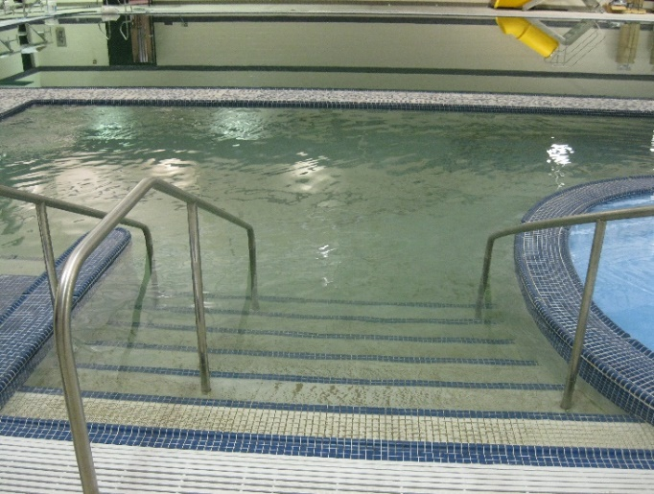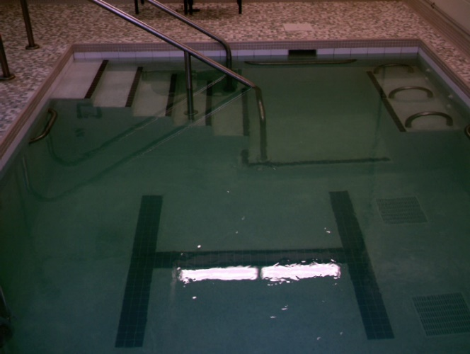

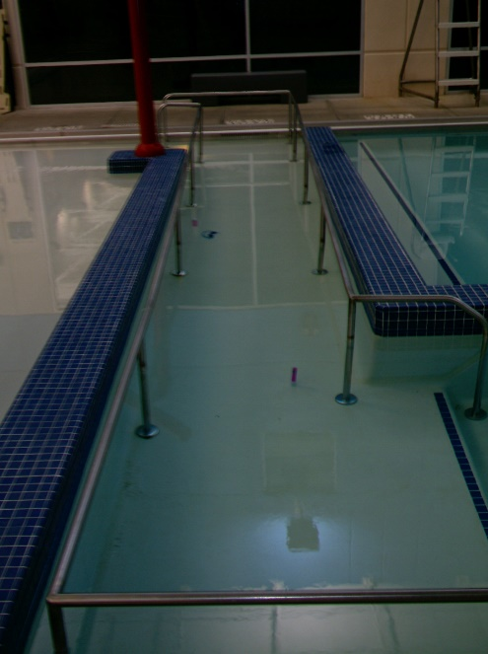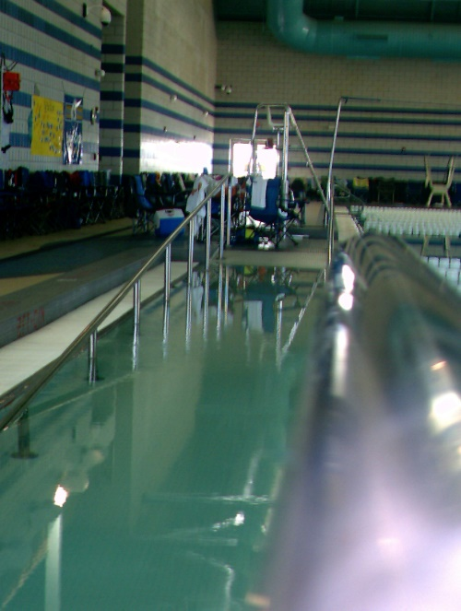
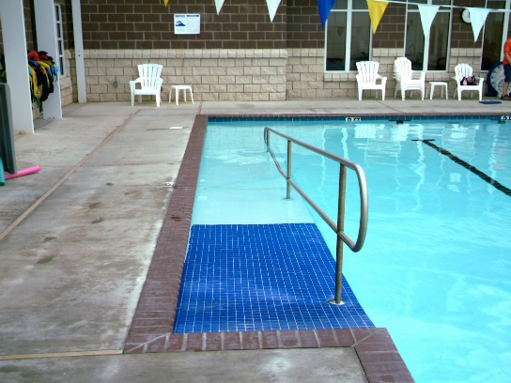
Ramps require more pool length than stairs but offer the advantage of “zero depth” and aquatic wheelchair entry.

For a ramp the pool needs to be approximately 40’ long or more or a switchback design for the ramp can be considered.

Ramps add cost to the construction budget but are extremely important for Total Aquatic Programming.

There is no “ideal” size but a very popular size for a therapy pool would be 40’ long x 16’ wide with ramp and stairs. Depth ranging from 3’6” to 6’. A non-ramped rehab pool can be as small as 15’ x 20’ with a slightly sloped bottom from 40” to 48” deep. Stairs only for entry.

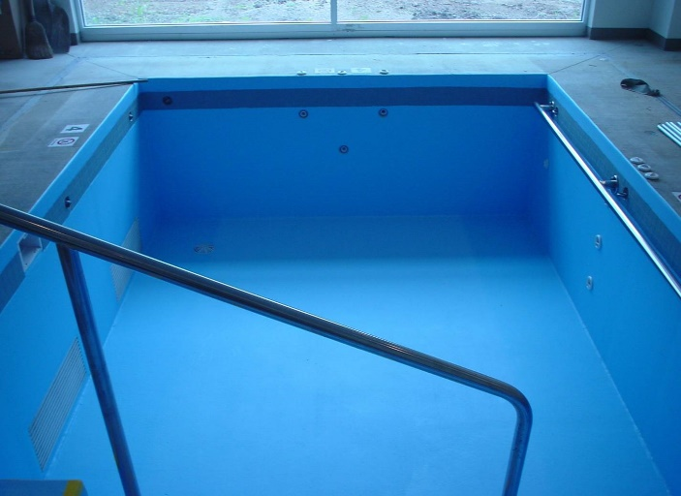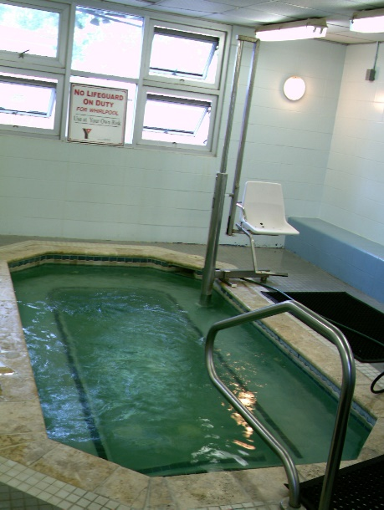

Learn to Swim pools offer the most options for sizing. Learn to Swim can be conducted in a therapy pool or an Olympic size pool. Pool depths can be from 3’ to 4’ deep and if deeper portable platforms can be used.

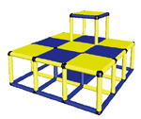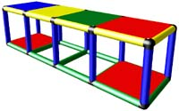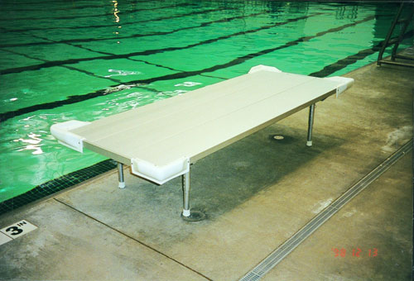

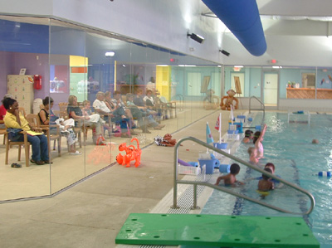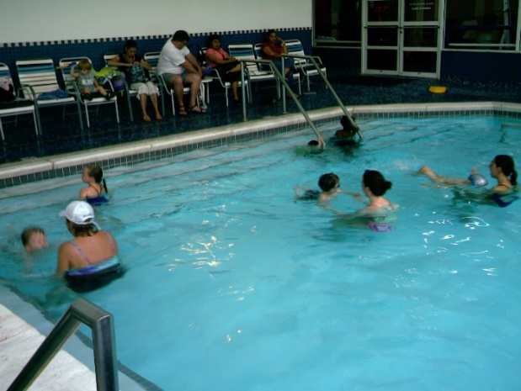

Depending on the “class structure” and programming design, a dedicated Learn to Swim pool can be 14’ x 28’ up to 20’ x 40’ and larger. Learn to Swim can also be conducted in a single lane of a larger pool at the same time other programming is going on.

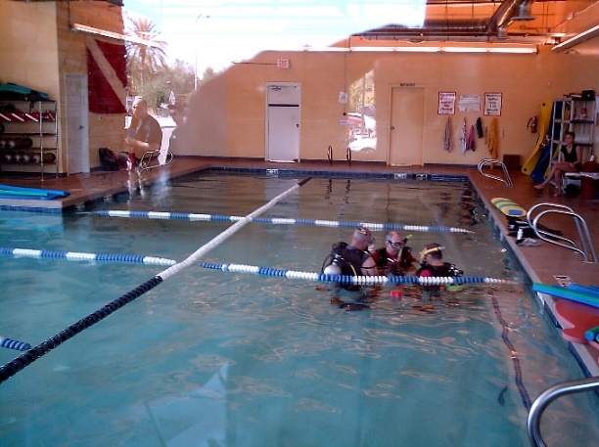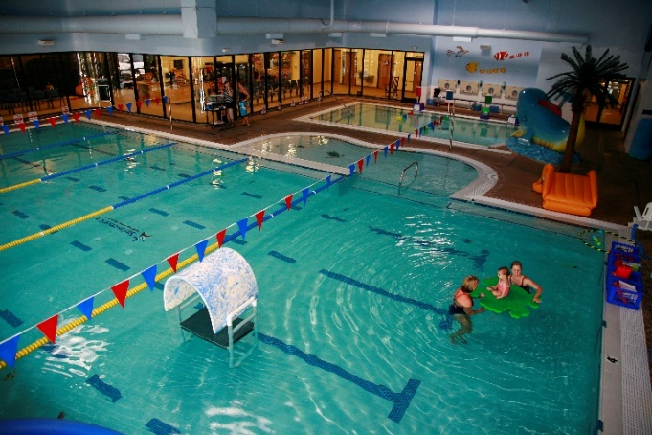

Adult Exercise – Similar to Learn to Swim, the size of the pool is not as important as the depth of the pool. The ideal depth is from 40” to 48”. This allows for water walking, Ai Chi, stationary routines, and even floatation assisted exercises. If a pool is to be dedicated for adult exercise, then it should have a ramp and stairs and be 40’ to 75’ long and 28’ to 45’ wide.

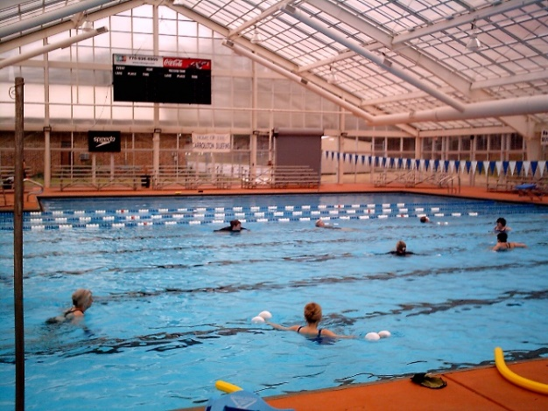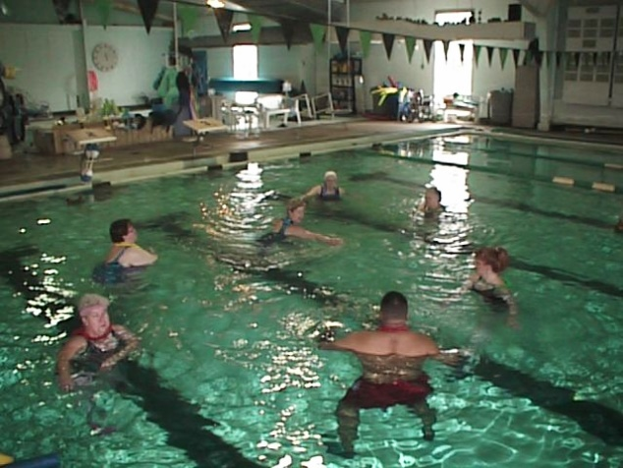

Community/Competitive Pools – have probably the largest selection to choose from. The size of the pool will be decided by budget, community size, and swim team(s) usage. The minimum size should be a pool that is 45’ wide x 75’ 1 & 3/16” long. Shallow end depth should be 4’ and starting block end should be minimum 6’ 7” and can be as deep as programming necessitates. Stairs and or a ramp can be incorporated into the design so Total Aquatic Programming needs can be addressed.

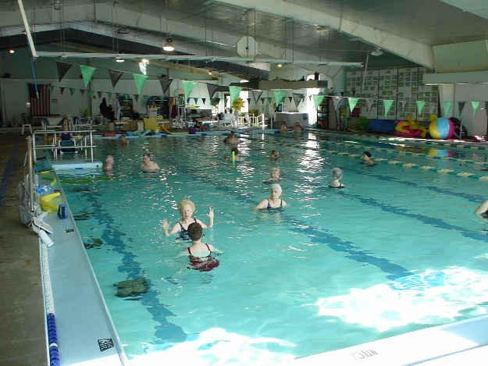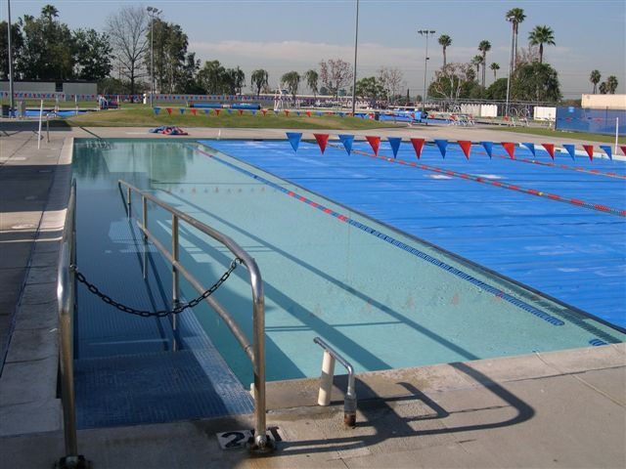

For communities that have the need the next size “up” would be an 8 or 10 lane 25-yard pool. Design considerations are the same as above the pool just has more lanes to accommodate more users at the same time.

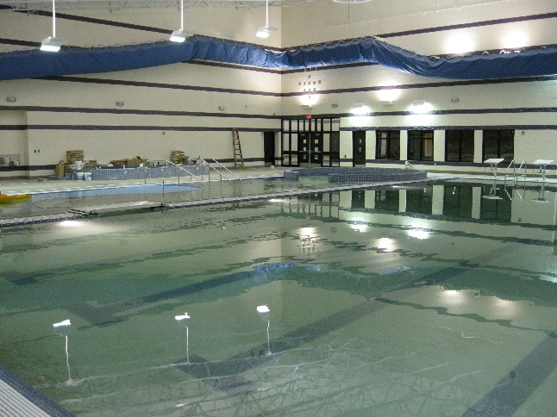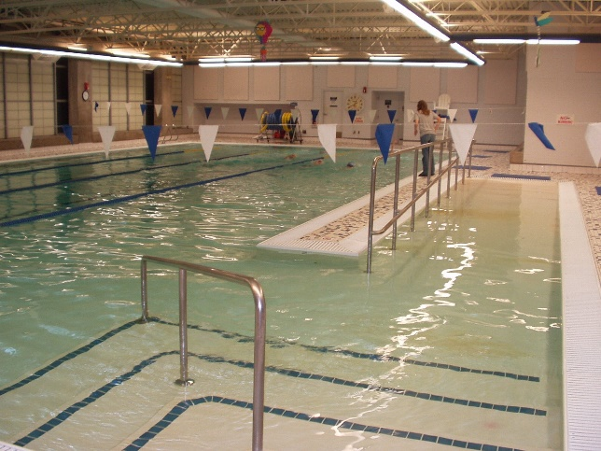

Stretch pools with bulkheads can also be considered – but many times a totally separate pool that has more Temperature Access and Depth control can be built for the cost of the bulkhead to create the “stretch” pool.

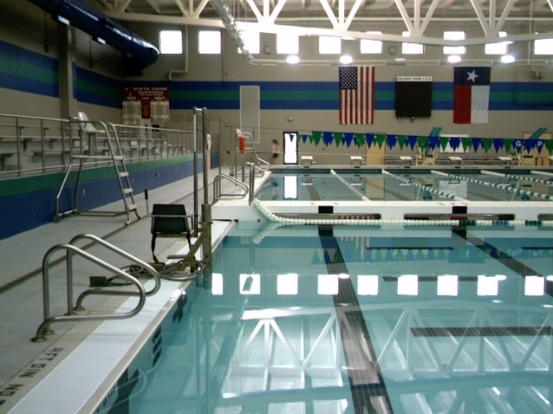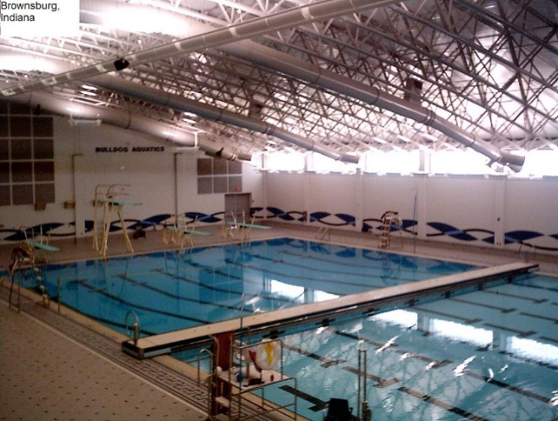

The bulkheaded pool should have the option for swimming both meters and yards depending on how the bulkhead is set.

For larger and more densely populated communities the 50.03-meter-long x 75’ 1 & 3/16” wide pool can be considered. These pools can be designed with or without bulkheads. One thing to always consider is that bulkheaded pools do not offer the option for various water temperatures. The programming implications of a single water temperature need to be seriously considered when designing the pool(s).

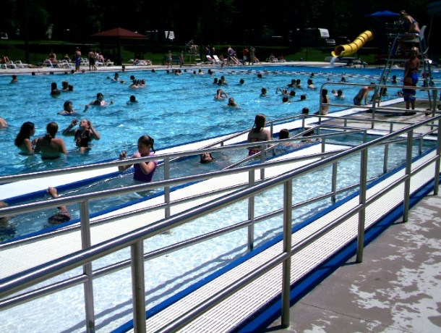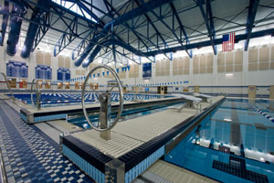

The main pool or competitive/community pool has the most important size implications. Design this pool along with deck spacing and spectator seating and dressing room-dry land supporting areas first. Then add the exercise/teaching pool then finally the rehab/therapy pool. Their sizing is much more adaptable to the building design.

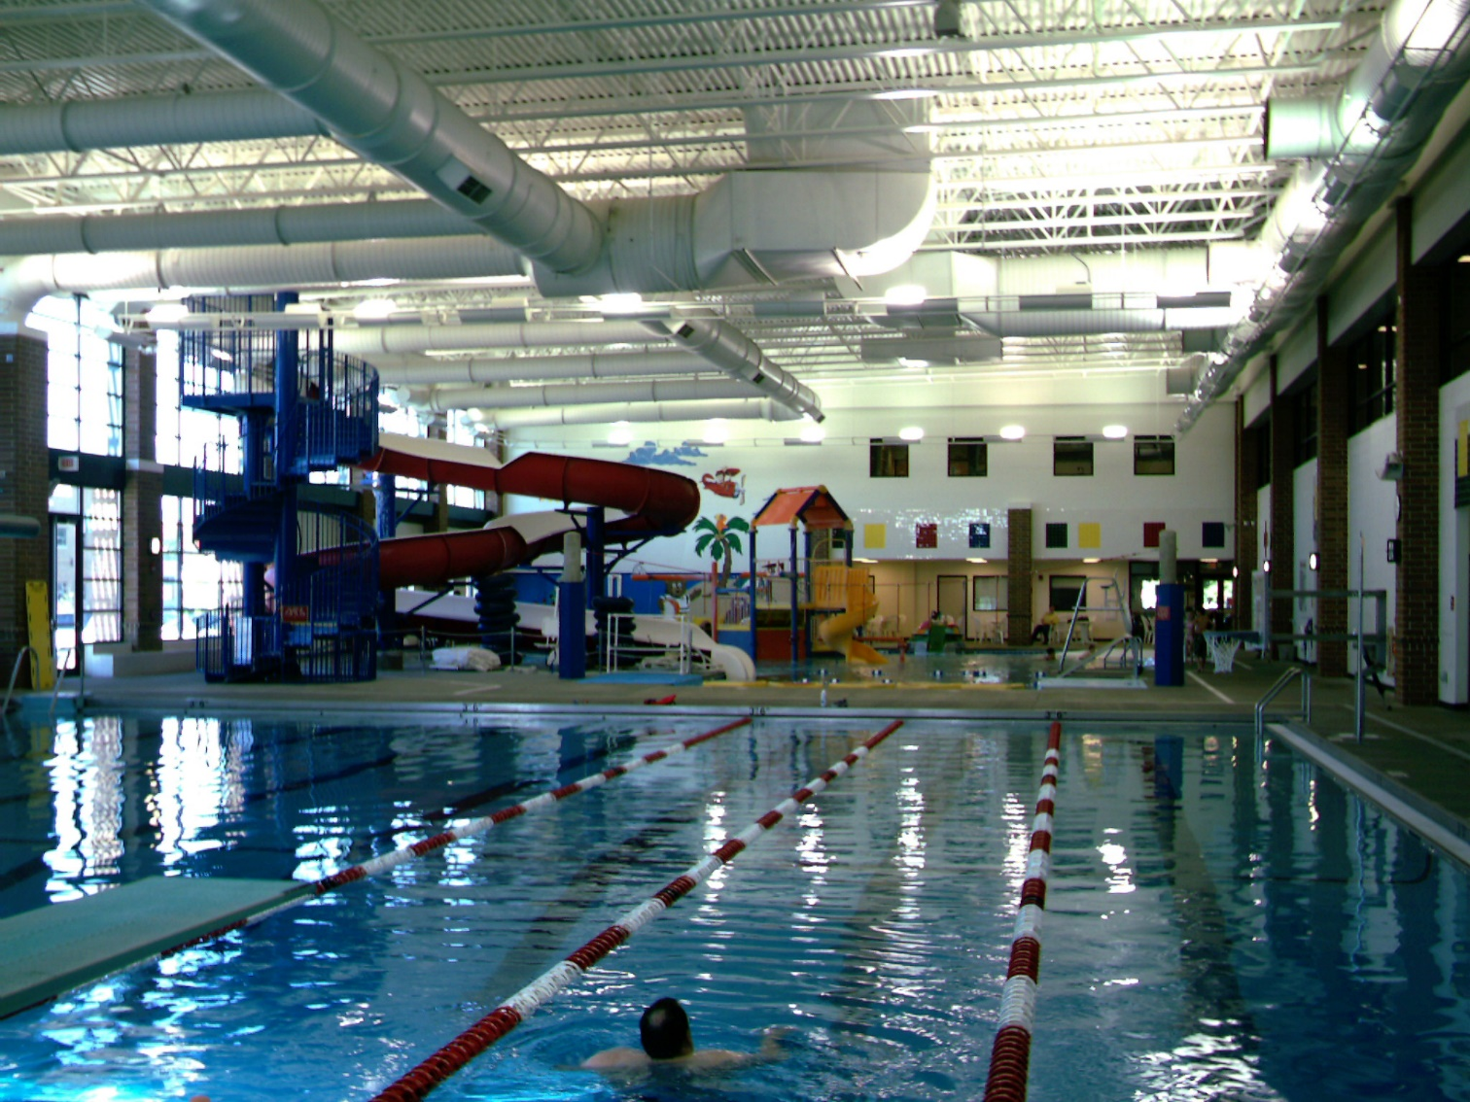

One last word about pool size and design. Try to incorporate all 4 pillars of aquatic programming in your plan…

- Therapy/Rehab
- Learn to swim
- Adult exercise
- Competitive/community

Ask the professionals in your community who are going to use the pool(s) in your community what they want and need. You may not always be able to build their ideal facility but the closer you get the better chance the facility must be financially sustainable and a community center piece for all aquatics.

Contact: mick@totalaquatic.llc for more design information.

