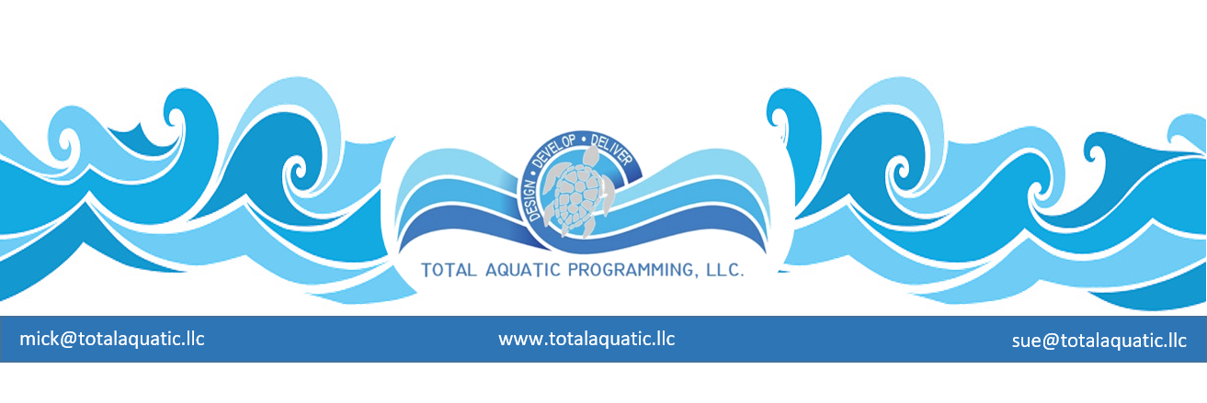
Past methods used to price aquatic programs.

The “old” process of deciding what a new Aquatic Facility would look like went something like this:

- Identify the property – size and shape
- See what the surrounding structures look like
- Hire an architect to tell you how big the dressing/shower rooms need to be and whether you can afford a 6 lane or 8 lane pool
- Draw all the squares and rectangles inside a square or rectangular building
- Figure out what programs you can operate to pay the bills

The “suggested” process should look something like this:
  - Validate the need for the type of facility you are planning to build. Never build a single use facility. Explore all possibilities for community service and aquatic programming. Programming precedes design.
  - Plan how the project will be funded. Where will the money come from and how will the debt reduction payments affect the budget?
  - Contact TAP -LLC
  - Location needs to be identified and be available.
  - Form a business plan and a sketch of a facility design.
  - Organizational Chart - Set up an organizational chart.
  - Financials: Financial Plan & Needs Summary.
  - Search for the Design & Build team.
  - Secure financing – You must have guaranteed financing before going any further. Financing the initial building cost is only a portion of the plan for success. Operational funding is always as important and usually where entities struggle.
  - Legal - Contracts – Escrows – Formation of Business both State & Federal- Insurance - Taxes – Governance
  - Contract the firm to make preliminary drawings and cost estimates. This is the solidification of you team or advisors.
  - Review the plans and conduct a “needs vs. wants” process to make sure project is serviceable to your plan and within desired budget. Compare the price per square foot construction cost with similar projects in the area. What will be included in your project?
  - Pre-bid and Bid process. Submit plans for bidding to contractors. Make sure that all the contractors have previous experience constructing pools.
  - Contract the firm to create construction plans and working documents. Submit plans for swimming pool construction and equipment to the Department of Public Health for review and approval.
  - Construction phase. Oversee as much of the construction as possible with emphasis on all of the equipment installation. If any changes are made make sure you consult with your team of advisors.
  - Develop a policies and procedures manual
  - Develop hours of operation, programming, scheduling, and equipment needs to meet the needs of your clients.
  - Staff – Establish Staff Positions and Management Structure.
  - Initiate the marketing and public relations campaign to launch your program.
  - Inspections - many building and health inspectors will have to give their “stamp of compliance” before you can open for business.
  - Schedule an official Grand Opening.

Details to help with each of the 21 above steps are available from TAP mick@totalaqutic.llc

