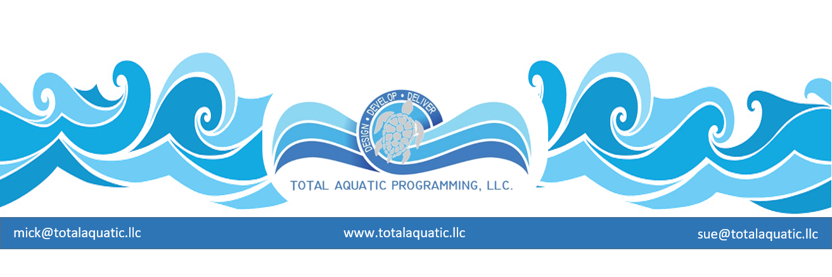
Saving pools Saves Lives – Programming Pools saves it all…….
Since swimming has been a social activity and necessary life skill since the beginning of recorded history, you’d think we’d have a reliable and consistent formula for delivery of the service. Not necessarily so.
Because of the social changes we seem to go through every decade or so, consistent delivery of any service may not keep up with the needs and wants of the end user. The businesses that stay ahead of the curve are those that are creative and innovative with constant vigilance for income and expenses.
Whose job is it to know what the end user wants?
If it is not the person(s) who creates, markets, and delivers aquatic programming then there is a good change the cart is in front of the horse. The end user seldom understands even the most basic benefits of aquatic programming. Because of safety issues the “need” is there but the want has not yet moved to the front of the line. A great yardstick for programming success is to spend a few minutes in conversation with the end user 2 months after they have been in your programs and ask a form of these questions”
- Why did you come to our facility?
- What did you want?
- What did you expect?
- Now after a few months what have you received and how have you benefited?
- What else do you need?
You will find that the end user probably had a problem that they needed help solving but did not have a clue what the solution really was. If you delivered the service properly you will find that you are actually providing:
- Service
- Solutions
- Satisfaction
Too many pools assume they are selling recreation or swimming lessons when they should be focusing on the above 3 S’s. People will pay for satisfaction.
“People don’t necessarily want to know how to swim they usually just want to be able to have fun safely in and around the water”. They mentally picture the benefits of the end result. Social recreation and healthy lifestyles are their initial but yet-to-be-defined needs.
- Define and market your real mission
If you are in a situation that requires the vast majority of your time and effort balancing the budget and handling crisis after crisis then no one is going to provide superior service and solutions therefore there will be no end-user satisfaction. Your basic business model probably needs to be over-hauled. The customer’s needs must be the primary focus and the business plan simply must be formed around how to deliver the services at a price and satisfaction level that makes the business sustainable.
- Spend time with your customers getting feedback and trying to identify ways to improve your service
- Always look for new and different ways to expand programming
- Spend time each day observing what your customers do, look at, and say when they are in your facility

- Don’t spend all of your resources preaching to the choir.
Who is not using your services and why? Do they even know you may have a solution for them? Do they know you exist? What are the barriers they perceive to using your services? These are called inhibitions and identifying them can be a driving force for your marketing strategy. Recognizing new and unique marketing opportunities can be a lifesaver for a facility but you have to get by the old model that no longer works and develop a new one that does. Growth opportunities are usually right in front of your nose if you spend time actually looking for them.
- Track and record everything.
Your partners, boards, committee members, council members, etc that the facility will deal with will seldom have any opportunity to have direct interaction with the end-users. You must develop some way to synopsize success in the Service – Solutions – Satisfaction categories so the cost to deliver programming is validated. The format you chose for reporting needs to be concise, informational, usable, and verifiable. Reports need to be sent monthly and follow up questions should always be welcomed.
Success must be both satisfying and rewarding to be sustainable

