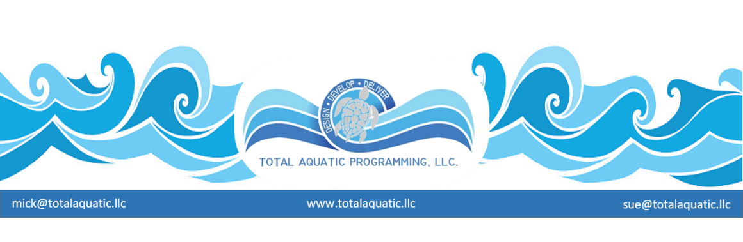
Project Input
A common every-day question we get at TAP is: “how can TAP-LLC help our project?” The answer is definitely and solely project specific. Our services are not “all-encompassing” but are multi-tiered and far reaching if we are brought into the project at the right time. The old cliché “timing is everything” applies.

Much of the early planning phase can be facilitated by TAP. It is our opinion that planning needs to be directed by the “owner” of the project – or their dully appointed representative. If a designer or consultant is contacted too early in the project, it may fall prey to the “cookie cutter” syndrome. That is, “here is what we have done in the past and you need to fit into this mold.” This is exactly backwards of the way it needs to be.

Programming must precede design.
Programming is based on community needs and no two communities are exactly alike. It is always easier and less labor intensive for a firm to modify designs from something they have done before. When the time is appropriate, if you pick the right consultant and/or designer, it should not be any more expensive to design exactly what you need.

Many times, because of the standard way of doing business, a firm is brought on board to do a combination aquatic design with a complimentary dry land design, in other words, a structure that has the ability to house many different land and water programs. Unless you have contacted a very unique firm, you will probably end up with an office building with a pool in it. Not a very practical or economical situation.

The bad news is that when projects reach the stage of realizing they do not have what they want or can afford, it is probably too late for us to be very effective. No firm likes to hear that the job they were earnestly trying to do was not adequate. Seldom will they listen to our “cutting edge” ideas because they have never worked with the technology and there have been significant amounts of money spent on design and it is hard to scrap the traditional ideas and start over. Many times, the politics of the situation will simply not allow this. Then we get the call from a swim coach or the club representative asking us what we can do.

This is not the way to plan a successful project. Therefore, we offer Regional Build a Pool Conferences trough USA Swimming and Custom TAP Workshops where we come to you. The Regional Build a Pool conference stresses:

- Planning
- Programming
- Project Development
- Providers that can make a difference

Email Mick@totalaquatic.llc for information about our Project Review and Owners Advocate services.

