Pool Projects for the First Timers
I I I I I I I I I I

Listed below is the relative order of steps for the development of a private-sector facility. Some steps may need to be done sooner in the order than others depending on the unique nature of the project.
Validate the need for the type of facility you are planning to build. Never build a single use facility. Explore all possibilities for community service and aquatic programming.
- Research the needs for the type of facility
- Discuss with community members
- Visit other sites in the area. What are the most successful models doing now? Who are the leaders? What are the successful types of organizations?
- Establish a Missions and Values Plan
- Identify user groups
- Collect census data
- Access recent demographic studies. Demographic study usually shows ~6% of population always looking for new ways to participate in lifestyle activities. Populations:
  - Ages 60 and over – Interested in low impact exercise- recreational aquatics – rehab follow up and lifestyle aquatic wellness programs
  - Ages 45-59 - interested in exercise of more than 1 type – recreational aquatics for themselves and children – likes extra amenities offered by the modern facility
  - Ages 25-44 – interested in multiple forms of aquatics and recreation – cares about family-based programs and healthy and safe recreation
  - Ages 13-24 – interested in swimming and playing in the water – social interaction with peers is important
  - Ages 0-12 – interested in what their parents introduce them to – skill & safety education is as important as play – organized activities are important
- Understand proposed programs and operations. Facility design should be program driven.
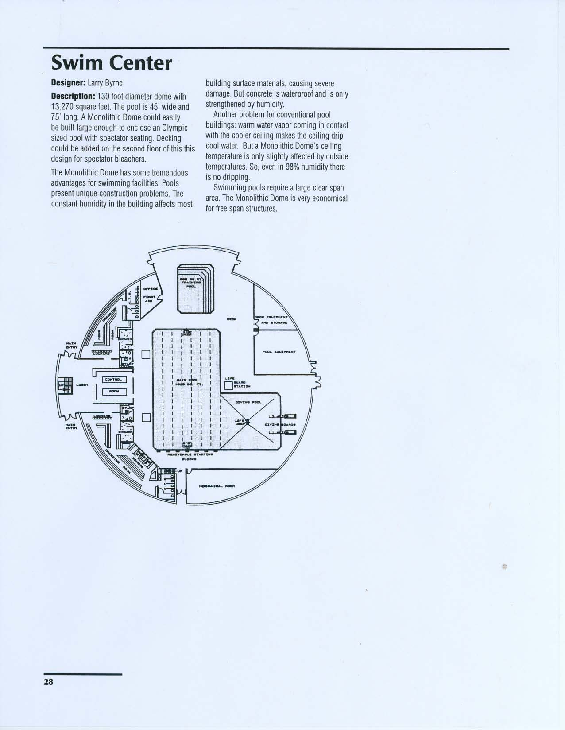

Below is a sample of the type of demographic information that is needed:
Summary Report
City Name: | Colorado Springs, CO
City Code: | 0816000
County Name: | El Paso, CO
State Name: | Colorado
CBSA Name: | Colorado Springs, CO
Dominant Profile: | ARMFORCE

Description | Value | % Total | EASI  Score | EASI  Rank  of 21249
DEMOGRAPHIC OVERVIEW
Population | 385,455 | 100.0 | C | 10,625
Households | 156,166 | 100.0 | C | 8,545
Total Household Income ($) | 9,728,736,985 | 100.0 | B | 6,138
Median Household Income ($) | 49,467 | N/A | B | 8,148
Median Age | 33.1 | N/A | E | 17,855
POPULATION BY RACE
White Population | 299,391 | 77.7 | D | 16,948
Black Population | 26,602 | 6.9 | A | 4,041
Asian, Pacific Islander Population | 14,111 | 3.7 | A | 2,211
Other Population | 45,351 | 11.8 | A | 2,603
POPULATION BY ETHNICITY
Hispanic Population | 54,552 | 14.2 | A | 2,465
White Non-Hispanic | 273,969 | 71.1 | D | 16,804

Footnotes:
EASI Rank: based on the concentration of the variable with a '1' being the highest rank and the number of areas in a geography being the lowest rank. EASI Score: arranges the EASI Rank into a quintile frequency distribution ranging from 'A' (the highest concentration group and top 20%) through 'E' (the lowest concentration group and bottom 20%). '(US Avg=100)' indicates an index value that has a range of 0 (low) to 200 (high). Easy Analytic Software, Inc. (EASI) is the source of all updated estimates. All other data are derived from the US Census and other official government sources. All estimates are as of 1/1/2006 unless otherwise stated.
Plan how the project will be funded. Where will the money come from and how will the debt reduction payments affect the budget?

- New business – Expansion – Renovation – Phases?
- Refinance – Borrow (personal investment – equity –
- Business partners - FUNDING!
- Fundraising study and plan
- Credit rating – (Equifax Experian TransUnion – FICO score) Credit Reports and Financial Statements
- Strengths and plan to optimize (and) Weaknesses and plan to improve
- Budget (Source and Use of Funds Statement 1 year) Last 2 years of IRS filing – Equity Statement – etc
- Record keeping and Accounting system – Bank/Credit Union
- Estimate square footage needed and construction cost using a per sq ft $ amount.
- Calculate income potential
- Calculate staffing needs
- Calculate expenses
- Develop preliminary 5-year pro-forma
Contact a professional facility planning advisor. TAP-LLC offers this preliminary service at a very reasonable price – about 70% less than the industry norm. The facilities planning advisor or team will assist you in identifying the community needs that your facility will fulfill. This process is what determines how many pools you will build and their size-shape-depth-and water temperatures. Remember – never build a single use facility. This is also the stage that you will identify your various client groups and what you need to service them. This is a different service than provided from an architectural design consultant, a consulting engineer, or a design & build firm. If the project will have any association with a school or a municipality you will probably need a professional Feasibility Study. TAP can do an Enterprise Plan (Feasibility-Lite) or refer you to one of our professional providers for a full Feasibility study.
Location needs to be identified and be available. You will probably need a Real Estate agent to help you with the process –
- Zoning requirements
- Utilities availability
- Building feasibility assessments
- Geotechnical engineer or soil specialist – topographical study – water table study – seismic zone restrictions – water shed and retention requirements
- Traffic flow and other neighborhood issues – security issues
- Accessibility and expansion capability
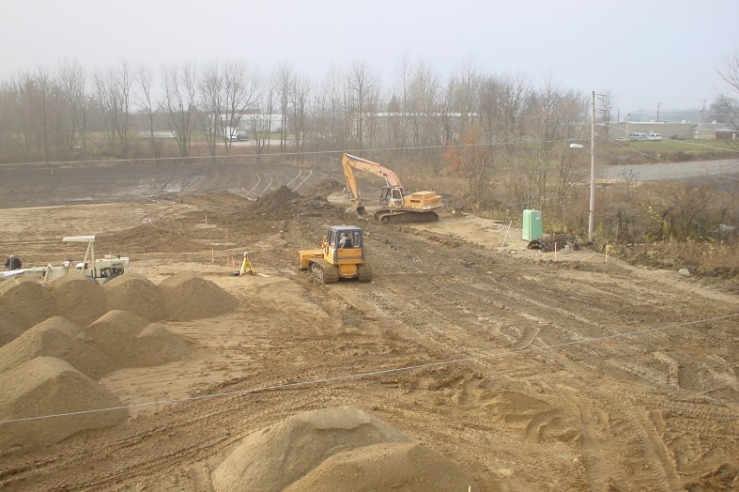
Form a business plan and a sketch of a facility design. If you intend to seek financial assistance, you will need a grant application or business plan which is understandable and verifiable. Your business plan should include:
- Facility description – this should include sketches (not drawings) of exterior and interior of facility – basic design
- mission/purpose
- marketing strategy
- organization and management plan
- customer base descriptions
- potential market growth
- competition in area
- retail sales opportunities
- equipment requirements
- operational plan
- business advisors and board of directors – with short biographies
- pro-forma *
- assets and liabilities balance sheet
- sources of funds statement
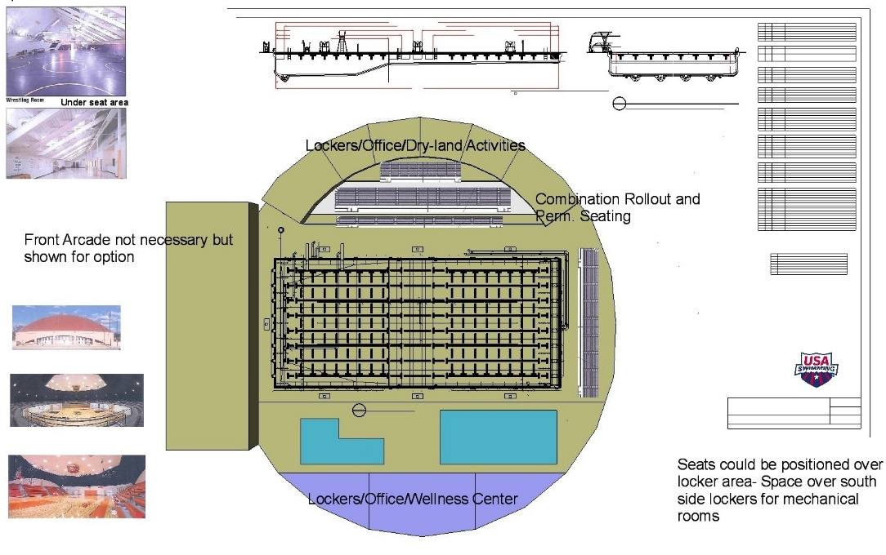
Write your overall management philosophy. Identify your company owners and board of directors. Answer the obvious questions such as how many employees you will have over given periods of time, how many of those will be directors, managers, coordinators, supervisors, support staff and what their experience and credentials need to be. For the key players you already have in place, provide summaries of their resumes highlighting pertinent experience, certifications, achievements, salary levels, and their areas of responsibility. For positions you are still trying to fill, summarize your minimum requirements for likely candidates along with the responsibilities of those positions. You may elect to contract those positions out to professionals who specialize in the area you need. You may find that contracting work out is the best solution initially. Be sure you include the credentials and track records of your contracted help and the timetables for hiring additional staff. Include a section on outside support, such as your CPA, your attorney, your banker, and your insurance broker. Also include any other outside resources such as your board of directors or management consultants. If dealing with a non-profit board confirm that they have recently taken part in educational and planning programs like “Board roles and responsibilities”, “Ethical practices and policies in the sector”, “Risk management”, “Board chair/CEO relations”, and “Strategic planning”. Their governance has to be solid for them to be an asset to the project. Look at your management plan critically and search for weaknesses in your organization Spell those weaknesses out and identify your plans to address them. Even if you don't see the weaknesses, it is very likely that your potential investors, partners, and clients will.

Organizational Chart - Set up an organizational chart. Having a visual illustration makes it easier for both you and your readers to understand the organization and see any possible gaps. organization and see any possible gaps.
BOD
Facility
Director
Business
Aquatic
Programs
Operations
Aquatic
Wellness
Land
Wellness
MakeASplash
Learn2 Swim
Swim team
Water Rental
Maintenance
Guards
Equipment
Safety
Billing
Membership
Advertising
Adult Prog
Per Train
Post Rehab
Classes

Health club
Exercise areas
Cust Serv Staff
Staffing Costs - Include either a table or a description identifying your personnel costs. These costs will be used in your profit and loss (P&L) statement. You can break it down by individual, or department. Include the title, department or group salary level and then in a separate line add 25% to 30% to cover employee benefits, taxes, etc. (also referred to as your Payroll Burden.) Extend this table to cover then next 2-3 years showing an approximate 3% per year increase on the salary line.
Facilities - List your facility information in this section. Describe the type of space your business requires, the costs and lease length and terms, your timetable expansion or moving to larger facilities, and any other pertinent information.
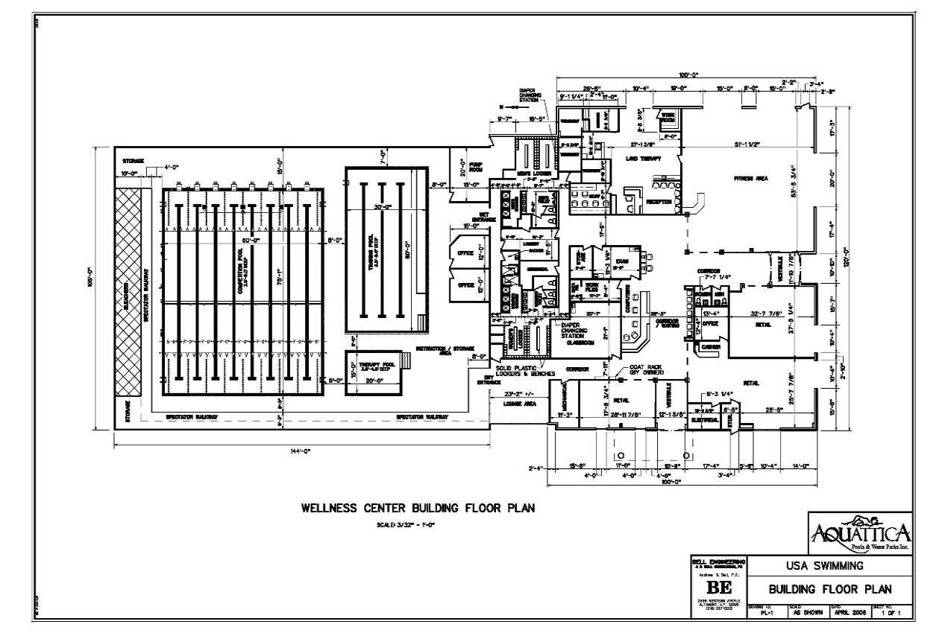
Miscellaneous - If a part of your strategy is to gain market share based on excellent or unique customer service, then you will want to include a section about your Customer Service plan. You may also want to include your Human Resources and Benefits plan to layout your strategy for getting and keeping top staff talent.
- Do any of your staff members have non-compete agreements they are bound to? Are there any other limitations that should be considered?
- Do your outside resources have experience in your industry?
- Do your outside resources or your existing management staff have experience with startups?
- Do you have stockholders or partners, and if so will they have any say so in management decisions?
- What role will your investors play?
Financials: Financial Plan & Needs Summary - If you're seeking funding for your business venture, you have some options. You can go to banks and other lending institutions and seek a business loan, or you can go in search of venture capitalists, or you can partner with a community service or business that would benefit from your services. Which source you choose, will depend on the amount of funding you need. The type of funding you need will dictate how your plan (especially the financial section) is written. Investors or partners will want to know how they are going to profit from this investment down the road, while lenders will want to see how you will be repaying their loan. Regardless of the source of funding, you'll need solid financial projections that cover all of the bases. For many, the financial portion of your business plan is its heart. If you think about it, why else are you going into business? You will fulfill a NEED you identified in the market and you WANT to make money doing it. Your potential investors, lenders, partners, are reading your plan to see if and when you're going to make that money.
What makes up the heart of your business plan is the profit and loss (or income) statement, the balance sheet, and a cash-flow statement. If your business is a startup, these will all be projections referred to as *pro forma statements. If you're writing this for an existing business, then these statements will reflect your past business history and current financial situation. One way to go about this is to break your financials down into monthly projections for the first year, then quarterly for the second and third year, then extend the 4th & 5th years to annual projections. Since this is a very critical part of your business plan, make sure you follow Generally Accepted Accounting Standards, and that your financial statements are all prepared correctly. It is well worth the expense to hire an accountant to review or prepare them. If you have an accountant prepare the financials, make sure you completely understand the process and what the terms and figures mean. Potential investors & partners will feel more comfortable investing in a company whose owners have a good understanding of the financial aspects of the business.
Financial Needs Summary Before you throw numbers and spread sheets at your prospects, summarize your financial needs. If you are seeking investors, this is where you will indicate how much cash you need to begin operations and how the funds will be used. How much will have to be spent on computer equipment, office furniture, etc.? You can break these down into "operating projections" or "capital needs" but have as much documentation as possible to back up this information
Financials: Revenue Model, Assumptions and Comments
Revenue model. This will describe the various programs you will be putting in place and how each will bring in money. If you've come up with a unique program be sure to describe it clearly. (You may also want to make sure you have confidentiality forms signed and any of your terminology copywrite or trademark protected)
Assumptions Explain the techniques you used to arrive at the information in your financial statements. For instance, you may want to state that all services and program fees are assumed to be cash based. If a retail aspect is included that certain inventory levels are maintained and paid for on specific terms and the sales commissions are based on x% of sales totals, etc. You can also include information about the general outlook of aquatics. This can be a bulleted list of short statements or written in paragraph form. In other words, describe how you plan to do business. For your own internal use, it is helpful to put together an assumptions spreadsheet that lists individual salaries (including costs of benefits), marketing expenses, other known budgeted business expenses, as well as revenue projections. This spreadsheet can help you identify when your expenses are going to peak due to marketing activity and planned hiring schedules. This tool will help you track spending and do efficient budget preparation later.
Search for the Design & Build team. The consultant(s) will need to communicate with the architect/engineer/design & build firm so you may want to include them in this process. It would be a good idea to contact TAP to get some referrals to their preferred providers. These companies have “cutting edge” products and information that can offer you better product at best prices. Secure a copy of your state's “code” on swimming pool construction and design from your Department of Public Health. Codes for competitive pools and community pools and therapy pools and hot tubs/spas will vary considerably. Do additional research and reading. Plan to attend a TAP – USA Swimming Regional Build a Pool Conference or host a Custom Build a Pool Workshop at your location. Current Regional Build a Pool Conf schedule can be found at: www.usaswimming.org/buildapool. Custom Workshop information can be received by contacting mick@totalaquatic.llc
Secure financing – Whether you raise money from existing business capital, a commercial loan or from other sources such as grants, private philanthropic organizations or the community, you must have guaranteed financing before going any further. Financing the initial building cost is only a portion of the plan for success. Operational funding is always as important and usually where entities struggle.

Legal - Contracts – Escrows – Formation of Business both State & Federal- Insurance - Taxes – Governance

Contract the firm to make preliminary drawings and cost estimates. This is the solidification of you team or advisors which will
probably include:
- Consultants
- Owners
- Community Partners
- Architect
- Engineers
- Builders & Contractors
- Equipment manufacturers and distributors
- Local Health Department

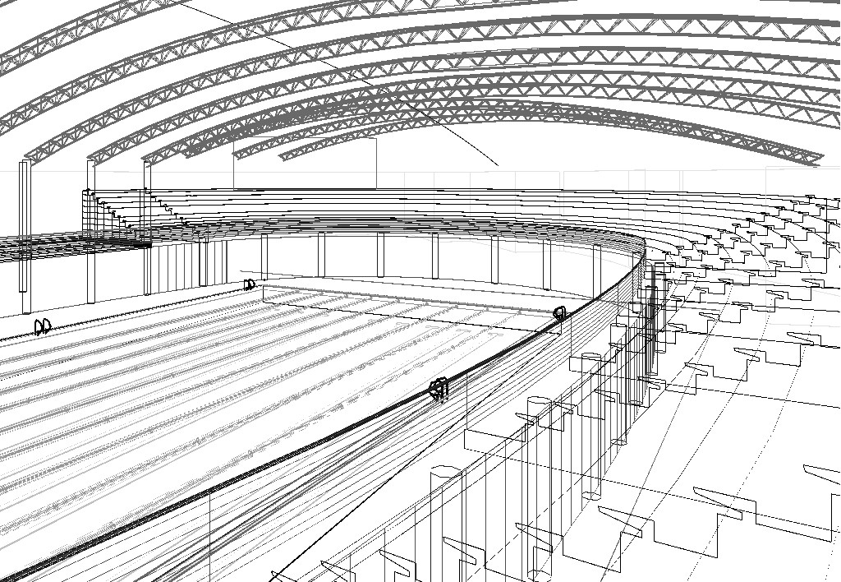

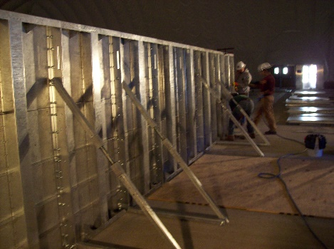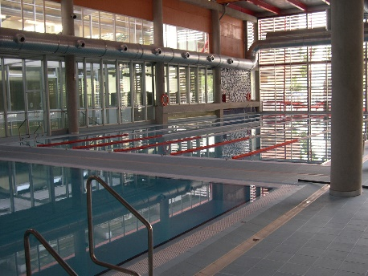
Review the plans and conduct a “needs vs. wants” process to make sure project is serviceable to your plan and within desired budget. Compare the price per square foot construction cost with similar projects in the area. What will be included in your project?
- Community pool for vertical exercise – 87 degrees minimum – 4’ average depth - can also be a lessons pool and overflow Therapy pool
- Therapy Pool for Aquatic Physical Therapy – 88 to 90 degrees – 4’ average depth - can also be used as a community hydro-pool and a warm tank for divers
- Hot tub (s) – 100 degrees to 103 degrees – 30” average depth - can also be used for some specific types of Therapy or rehab
- Competition pool (s) – 82 degrees – 6’ to 4’ average depth – can also be used for lap pool for exercise
- Diving pool – 87 degrees – 12’ average depth – can also be used for scuba lessons and lifesaving classes and synchro classes
- Leisure pool
- Zero-Beach pool
- Current Channel – Lazy River
- Waterslides
- Water Vortex
- Spray pools – wading pools
Develop different levels of equipping that fit specialty needs and a variety of budgets. Plan for success and expansion. Initial building cost are usually 300% less expensive than “add-it-later” cost. Plan for the basics then add the frills later if necessary.

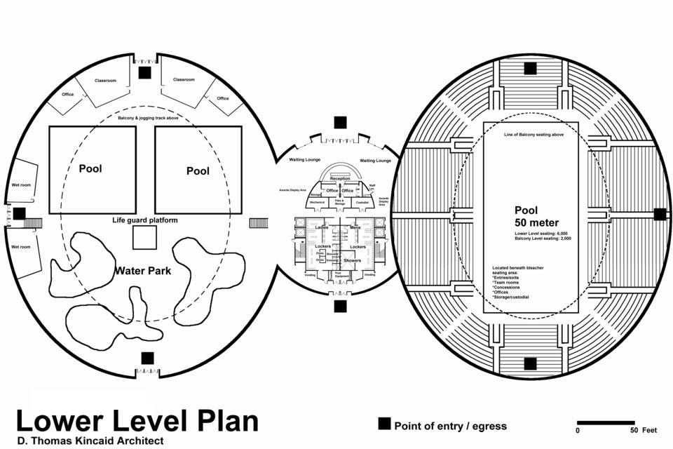

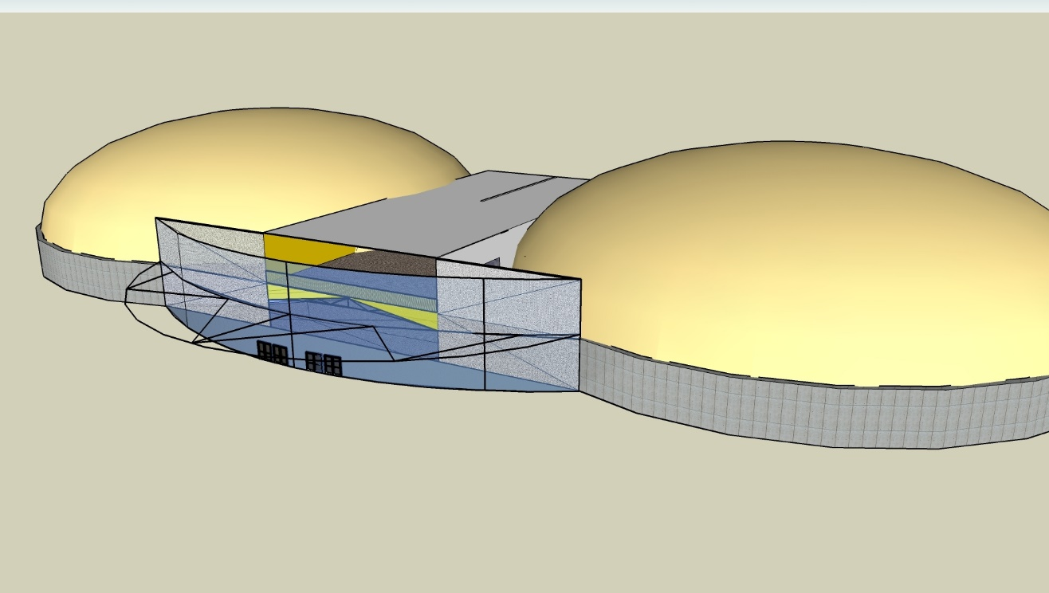

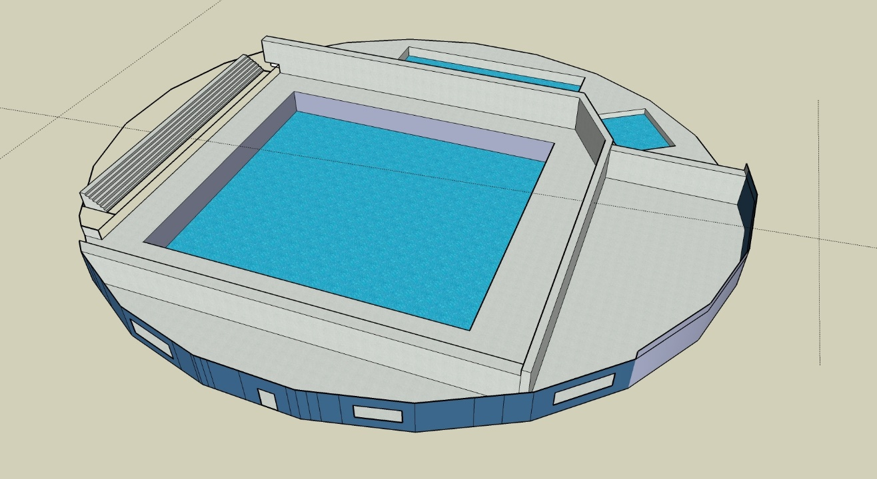
Contract the firm to create construction plans and working documents. Submit plans for swimming pool construction and equipment to the Department of Public Health for review and approval. After this approval process any changes that affect safety or operation of the pool must also be approved.
- Construction diagrams or drawings including floor plans, site plans, structural details, elevations, grading, pool orientation, utilities.
- Detailed construction plans (blueprints) including inlets, drains, hydrostatic relief valves, gutters, surge chambers, piping, decks, hose bibs, water fountains, walls, ladders-ramps-steps, rails, lights, diving boards, starting blocks, bulkheads, lifts, filtration & circulation equipment, locker rooms and fixtures.
- Schematic diagrams including pool piping, electric, mechanical, plumbing, and cross-sectional and longitudinal views of all pools.
- Specifications are the written instructions for the builders that provide technical information for the work that is to be done. They describe materials, size, type of equipment, standards of workmanship, material quality, options and alternatives and acceptable substitutions, installation methods or procedures, and inspection and testing requirements. These are more detailed and take precedence over the actual drawings.
- Change request and change orders
- Models and or aerial photos
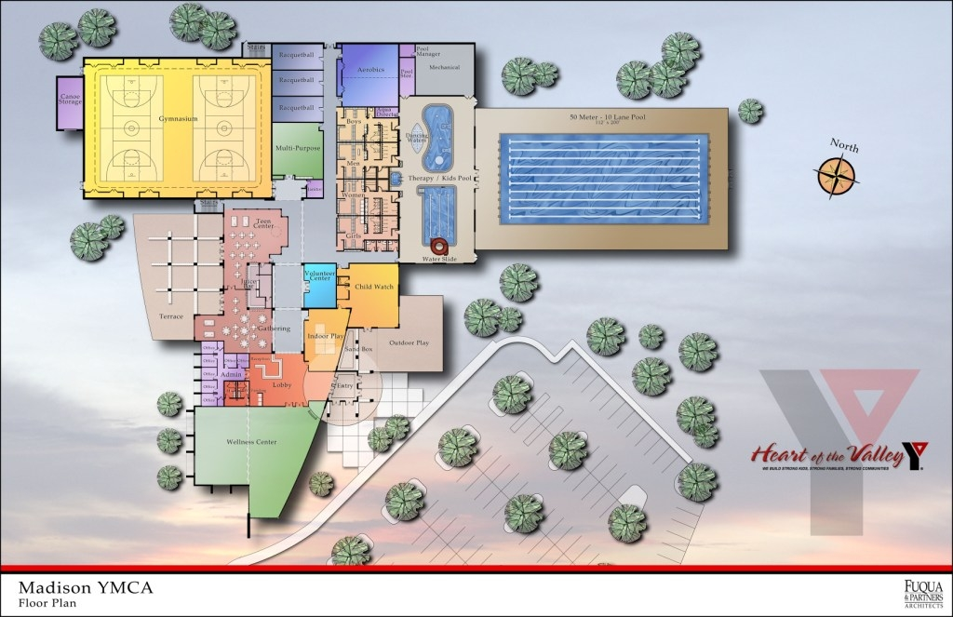
Pre-bid and Bid process. Submit plans for bidding to contractors. Make sure that all of the contractors have previous experience constructing pools.
- Announce opportunity to bid
- Pre-bid meeting at site
- Distribute construction documents with schedule or drawings and specifications will be given to proposed bidders
- Bid package – invitation to bid, instructions on how to submit bid, how the contract will be awarded, conditions for bid rejection, sample proposal forms, conditions of contract, time frame for project with penalties.
- Review and accept or reject bids, negotiate fees, award contract. Terms of payment and deposits must be spelled out in detail.
- Consider alternatives if the bid process is not going well (e.g. Negotiated Bid or Design Build)
Construction phase. Oversee as much of the construction as possible with emphasis on all of the equipment installation. If any changes are made make sure you consult with your team of advisors. Things that will be addressed are:
- Permits, fees, liability bond, insurance, clean-up, temporary facilities, security, tax, plan check, sub-contractors, summary of work, responsibilities, items furnished by owner, work to be performed after project in a different phase, pertinent codes, abbreviations and symbols, reports, storage, protection of materials and equipment.
- Site work: Clearing, grading, excavating, drainage, utilities, roads, landscaping, demolition, earthwork, clean-up
- Concrete: Formwork, reinforcing, material, water-tight, finish, deck, grout
- Masonry: Material, reinforcing, grouting, placement of rigs, mortar, stone
- Metals: Structural, steel, metal, joist, ornamental – specialty Type 304 & 316 stainless requirements
- Carpentry: Millwork, casework, walls, framing, rough carpentry, finish carpentry, adhesives, wood and plastics
- Moisture protection: Roofing, weatherproofing, insulation
- Hardware: Doors, windows, glass, skylights, retractable – sliding – opening
- Finishes: Drywall (wet & dry), tile (slip resistant), flooring, interior and exterior painting, plaster, tile, carpeting, acoustic ceilings, wall coverings
- Specialties: Toilet accessories, visual boards, lockers, signage, clocks, security and safety equipment systems, prefabricated products, pest control, fireplaces, flagpoles, telephones, televisions, radio, speakers
- Equipment: Athletic, exercise, therapy, audio visual, theater, spas, saunas, steam room, tanning, snack bar and concession/vending, cabinets, kitchen, office equipment
- Furnishings: Seating, artwork, drapery, blinds, shades, carpeting, furniture, plants
- Special: Competitive pool(s), Therapy pool(s), Recreation pool(s), Community pool(s), filtration and circulation, heating, dehumidifying, air conditioning, ventilation and air exchange, water treatment, courts, health clubs, specialty rooms
- Access: Stairs, ramps, elevators, escalators, lifts, hoist
- Mechanical Systems: Water supply, fixtures, sprinklers, heating, air conditioning, wastewater, fountains, plumbing, air handling
- Electrical Systems: Lighting, communication systems, controls
Develop a policies and procedures manual including –
- Job descriptions
- Licenses and training and certification standards
- Employee responsibilities
- Testing procedures
- Business auditing procedures and compliance plan
- Dress code and uniform guidelines
- Use of facilities by staff
- Performance evaluation process
- Employee benefits, insurance
- Resources and equipment support
- Absence, vacations, sick leave, substitution, schedule changes, breaks
- Payroll information
- Employee protection policies regarding accidents, universal precautions, protective gear, chemical, biohazard, electrical safety
- Closing procedures for weather, natural disasters, fire, chemical spills, power outages
- Aquatic and therapy practices and protocols
- Maintenance practices and operating procedures, for pools and major equipment
- Risk management program
- Facility rules for all areas
- Accountability – payment controls and loss prevention controls
- Mission statement
- Map & directions to facility
- Phone and communications listings
- General program information and services provided
- Service principles
- Hours of operation
- Admissions requirements & rental information
- Facility description
- Facility diagram with emergency action plan
- List of employees – their titles and short bio’s
- Copies of all forms used at or by the facility

- Records and reports summary: Including but not limited to – Employee procedures, Operating manuals and procedures, Chemical safety procedures, Evacuation procedures and emergency plans, Safety literature and posters, Release forms, Request for leave of absence, Work schedule sheet, Daily deposit sheet, Pool rental agreements, Contracts, Fee wavier forms, Accident report form and victim and witness statement forms, Incident or occurrence report form, Agreement to participate form, Liability release forms and waivers, Patient-member-client assessment, Refusal of emergency medical treatment form, Blood/bodily fluids contact report, Notice to guest, Verification of employee certification and licenses, Employee training log, Staff audit forms, Daily pool logs, Chemical logs, Daily maintenance and safety check list, Seasonal and preventative maintenance check list, Inventory forms, Equipment disposal forms, Maintenance request forms, Code compliance checklist, Marketing brochures and advertising flyers, Phone call log,
Develop hours of operation, programming, scheduling, and equipment needs to meet the needs of your clients.

- Resource planning and development
- Leisure component – Family access
- Therapy or Rehab access and water temp
- Swim Lessons temp and access
- Community programs – AEA – ATRI – Arthritis- Masters Swimming – Lap Swimming- Swim Team - temperature & access
- Special Needs programs – temperature and access

Staff – Management Structure: Staff Positions and Management
- Hire your project manager
- Get your technical staff in place
- Set up a management team that has good experience and track records in marketing, finance and operations. It can make the difference in whether your business plan works or doesn't work. Most businesses fail because of weaknesses in their management staff.
Minimum Staff Positions The staff you'll need to run your business will depend on the type and size of your business, and the programs and services you are offering. As a general guideline you'll need:
- Technical staff to develop and build your product or service
- Staff who can manage your finances
- Staff who can market your product
- Staff who can oversee your operations
- Administrative staff
Identify the positions and hire the staff that you will need.
- Facility Director
- Aquatic Coordinator
- Special Programs Coordinator
- Customer service staff such as tech’s or lifeguards
- Coaches and Personal trainers
- Instructors
- Office Coordinator
- Receptionist
- Housekeeping
- Maintenance

In house training programs and necessary certifications can take time so start this process soon enough (4-6 months before opening). All employees must have training in Basic Water Safety, CPR, First Aid, and Risk Management. They must participate in scheduled rescue drills and emergency action plans. Certification and in-service-training is important. For service professional providers or TAP Programming Workshops contact: sue@totalaquatic.llc
Initiate the marketing and public relations campaign to launch your program. Some of this needs to be done 6 months (or earlier) prior to the opening of the facility.
Inspections - many building and health inspectors will have to give their “stamp of compliance” before you can open for business. The Department of Public Health, the local Fire Department, the insurance inspectors, and others will also do periodic follow-up checks once the facility is open.
Schedule an official Grand Opening. This is usually scheduled after the facility has been open a few weeks. Be sure to invite all of the people who have had anything to do with all phases of the process including the design and build phase, plus community leaders, corporate leaders, and the people in the community who will be your “word-of-mouth” advertisers. This usually involves a few hundred people so put on a great show. Some facilities like to hold a VIP Grand Opening on a Saturday followed by a Public Grand Opening on a Sunday. All of your staff need to be present to answer questions and act as host.

TAP-LLC Workshops At the present time TAP is scheduling Custom Workshops for multiple projects. We do not schedule in September because of major aquatic conventions nor December because of Holidays. Projects are being prioritized according to how much work and planning has already been done by the group we have been asked to visit.

Priority #1

Projects that have attended a recent US Swimming Build-a-Pool conference and:
1. acquired land
2. capital fundraising started for the project and goals set
3. contracted Project Assessment and Review service from a USA-S professional provider
4. hired a preferred provider pool engineering firm, or architect for design
5. business plan and feasibility studies completed by our preferred provider

At the current time Priority #1 projects are 30 to 60 days out for scheduling

Priority #2

Projects that have:
1. formed a working committee
2. identified land and started procedures to approve the land for the project
3. identified potential community partnerships and had preliminary meetings with them
4. accessed needs and decided on a basic design for facility
5. established a verifiable budget for the project

At the current time Priority #2 projects are 60-90 days out for scheduling.

Priority #3

Projects that have:
1. developed a preliminary facility plan in their “minds”
2. have identified some funding for studies
3. have identified funding for schematic design
4. have a committee or focus group who are all on-the-same-page with the project plan

At the current time Priority #3 projects have not been able to have guaranteed scheduled visits. We highly recommend sending a representative to a USA Swimming Regional Build a Pool Conference …. reference www.usaswimming.org/buildapool

To get on the priority list please advise:
1. What has already been done for planning – see above list?
2. Who would we be meeting with during a visit?
3. What are we trying to accomplish with a visit?

This information will allow us to better plan where this may fall into our schedule.

