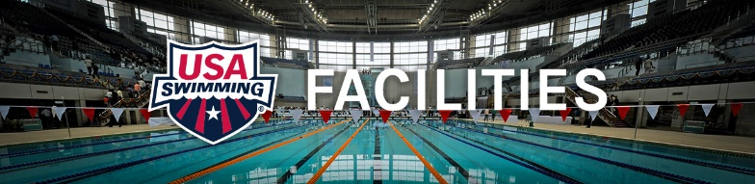

Renovating an existing pool:

With all the recently passed safety codes – e.g. the Virginia Graham Baker (drains) Act and the ADA Lift laws – more and more pools are considering major renovations. Renovations can include:
- Upgrading or replacing HVAC systems
- Adding Medium Pressure UV in the filter room
- Adding permanent ADA compliant lifts or ramps to pools
- Making the pool deeper at one end to meet diving form side or starting blocks codes
- Replacing pool perimeter gutters to more functional systems
- Changing pool bottom main drain grates or boxes
- Replacing underground rusting pipes to and from pool
- Replacing pool tank interior with liner system or new gunite
- Replacing pool filter and circulation system for more efficiency

There are a few things that need to be checked out before a renovation is started….

- When the pool was designed and built, how close were the specs meeting minimum flow rate and pool turnover. In other words, were the pool operational and circulation systems designed right at the minimum necessary to meet state codes? Adding a foot of water depth to a typical 6 lane 25-yard pool can increase total volume by more than 2500 gallons. Is the filter system and pipe sizing designed to handle this extra gallonage and still meet code? The pool heater?

- If adding depth by digging out the bottom of one end of the pool, make sure state codes are met for distance from end wall to slope up to shallower water. 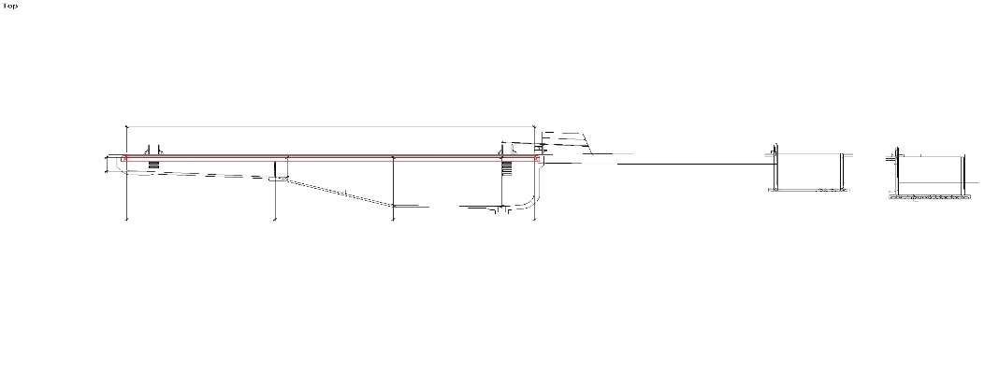
Usually around 26’ from starting blocks to beginning of slope to shallow end. If adding depth, we recommend going to at least 6’ at the starting block end of the pool. The “codes” have no consistency state to state and organization to organization. Allowable depths still range from 4’ to 6’. The depth requirements are and will continue to be greatly affected by lawsuits involving head-first-entry accidents. When a state or organization changes, they most likely will not give a variance (grandfather) an existing pool. Plan for the future while you are spending the $ now.

- If raising the pool edges and installing new gutters the same as above applies. Understand that you cannot raise one end of the pool you must raise all of it. This makes the shallow end also deeper which may negatively affect the pools ability to offer many programs. Learn to Swim and adult vertical programming usually need 4’ maximum water depth. This can impact programming income for the pool if the water is too deep at the shallow end.

- When raising gutters, the starting blocks and diving boards are also affected. New anchors will have to be set, and the deck/gutter profile will have to be designed so there is adequate room for deck equipment to be installed according to codes. New lane line anchors will also need to be set.

- Make sure the design includes in deck channels with grates and retrofits for automatic timing system cables and scoreboards. It is not very practical to have a newly renovated pool and then have timing system and touchpad cables running all over the pool deck.

- Pool tolerances are extremely important. The LENGTH of a pool must be exact for sanctioned competition to be approved. A 25-yard pool must have every lane be a minimum of 75 feet 1 and 3/16” long without touchpads installed. That is 25.03 yards. Even a fraction of an inch less and the pool will not be able to be length certified. The same for 50 meters. 50.03 meters is minimum for every lane. There is always an option to measure a pool with touchpads in place which makes the required minimum lane length 25.00 yards or 50.00 meters. Measuring pools with touchpads installed has become the preferred method. The USA Swimming Course Certification Form is on the website www.usaswimming.org/poolcertification

- Most indoor pools need Medium Pressure UV water treatment for clean fresh air. This can usually be retrofitted into an existing filter room. These units must be sized properly so it is important to get the right manufacturers involved early in the process. This is the first step even before evaluating the HVAC. Also consider an activated carbon filter on the freshwater pool fill inlet.
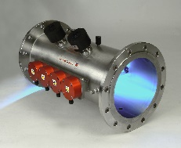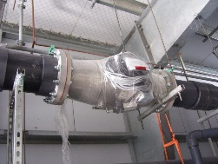

- HVAC units and sizing can be a challenge. Most manufacturers sell lots of bells and whistles and these units can get very pricy. Due diligence is key here. Contact the Facilities Development Department at USA Swimming for assistance. There are good units and then really gimmicky units.

- Pool water treatment. BEWARE. There are manufacturers who will promise you the world and then disappear when the pool, building, and equipment are falling apart. Once again feel free to email mick@totalaquatic.llc for information. Water sanitization is extremely important.

- If the pool was built before 1972 there is a good chance it has black iron pipe underground. This needs to be researched carefully. It does not make sense to spend hundreds or thousands of dollars to face-lift a pool and have the rusting pipes out of site ready to fail at any time.

- Pool resurfacing. There are many options and doing your homework is once again important….

  - Concrete painted pools (three types of paint)
  - Gunite type pools with plaster or Marsite or Diamond -Brite finish
  - Tiled pools
  - Polyurethane sprayed pools
  - Renovac steel lined pools
  - PVC lined pools

All of these types of pool coatings (waterproofing) are acceptable but some may be better than others for your situation. Not only the product but workmanship is critical here.

- Other renovation considerations can be:
  - Bleachers
  - Lighting
  - Air circulation and vent fans
  - Shower rooms
  - Concessions areas
  - Public access and deck areas
  - Office equipment
  - Etc.

Let us know how we can help. Mick Nelson TAP mick@totalaquatic.llc

