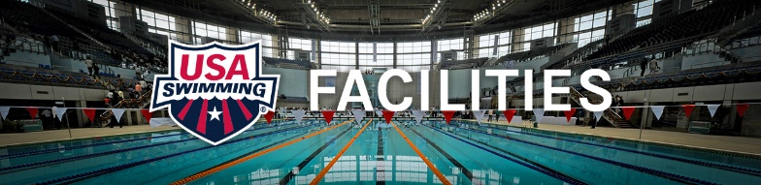

Renting Water and Owning Water

A very common subject discussed is the cost comparison of owning team practice water compared to renting water. We just had a phone call from a team who has paid over $500,000 the past 6 years for practice water time. Is this a ‘waste of money”? Let’s take a look….

We will use a 15,000 square foot facility that houses a 6 or 8 lane 25-yard pool as an example. It would be in a seasonal climate in a suburban population. This is a fairly normal size for a high school or small college pool.

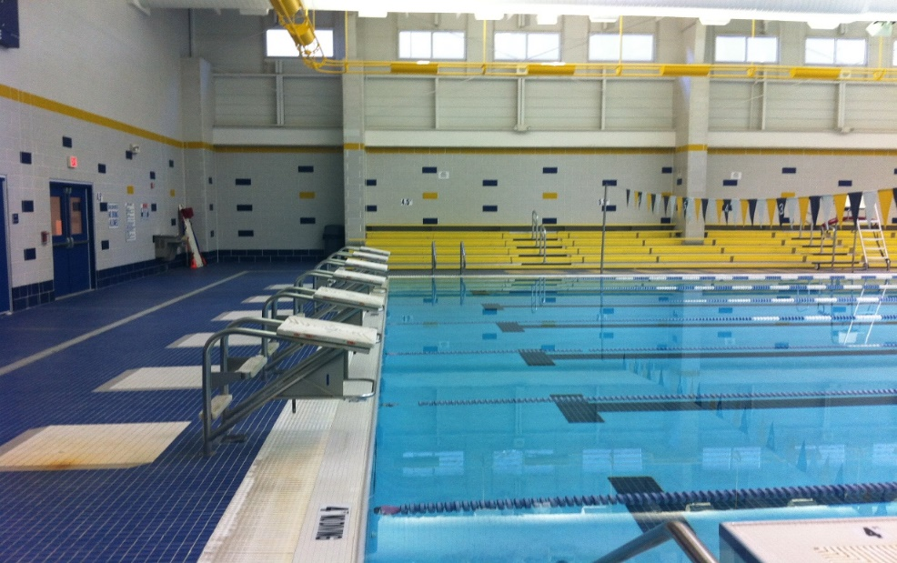

The average annual operational cost for a facility like this would be …. $504,000
- Operations and expenses = $210,000 annual
- Staffing = $294,000 annual

Most pools like this are open about 75 hours a week – so the hourly cost to operate would be ~$140 per hour. In addition, pools must have a built in 10% minimum profit to build up a capital improvements and repairs fund. That makes the total cost to operate $154 per hour.

That means for an 8-lane pool the facility must recover $19.25 per lane per hour.

USA Swim Clubs usually want to rent practice time during “Prime Time”. The average club would want ….
- 8 lanes 1.5 hours in the morning 3 times per week
- 8 lanes 3 hours in the morning on Saturday
- 8 lanes 5 hours after school 5 days a week

That = 47.5 hours per week @ $19.25 per hour x 8 lanes = $7315 per week
Based off a 48-week training year that totals = $351,120 annually in water rental

What if the club built their own training facility?

The operational cost would be the same or slightly less depending on style of building (reference USA Swimming Build a Pool conferences www.usaswimming.org/buildapool ), and the income from Total Aquatic Programming e.g. Swim Lessons – Adult membership – Rehab rental – etc. could be a real plus for the budget.

However, a 15,000 square foot training facility would cost approximately $5,000,000 if done on a very tight budget.

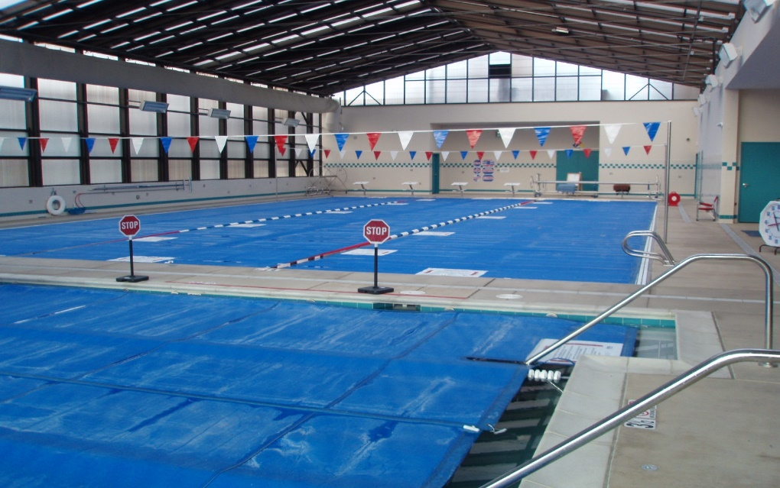

In addition to operational cost and staffing the club will also have to make enough money to pay off debt. At today’s commercial loan interest rates, it would take $36,000 a month to pay off a $5,000,000 20-year loan. That is $432,000 a year just to debt service. Therefore, coach or club pool ownership is heavily dependent on Capital Fundraising and Total Aquatic Programming.

We have seen privately owned pools generate well over $1,500,000 a year income but it is full time work for aquatic professionals and competitive swimming cannot come close to footing the bill by itself.

So renting is not better or worse than owning – it is simply different. Over 90% of USA Swimming clubs rent water for swim practices learn to swim, and swim meets. This is a good model if our clubs are willing to charge their members the fees that can pay the water rental necessary for facilities to operate.

The one big advantage of pool ownership is that the club/coach does not have to negotiate with the facility each year for water time. Club growth and total aquatic programming is more secure.

For more information about Total Aquatic Programming contact Sue Nelson sue@totalaquatic.llc

