We often get calls regarding “putting a pool” in an existing “big box” space or warehouse that has already been built. Many times, retail corporations change locations or expand to build the SUPER store and they are left with a location that they either need to lease or sell. The validity of this will be market-current economy driven.
There are quite a few things that need to be considered when looking at this retrofit concept:
- Zoning – Swimming pools usually fall under the same classification as health clubs. Check the Zoning ordinances.
- Parking – Is there adequate parking for all businesses that may want to partner with this venture?
- Sewers and sanitary – Can the existing plumbing handle the pool and filter backwash requirements?
- Utilities access – there may be some 3 phase 220V electrical service required, make sure it is there or can be added.
- Bathroom locations in the existing facility – what type of additions and retrofits will be needed to accommodate codes and your needs?
- HVAC – can the existing building be retrofitted with a SERG type interior vapor barrier structure so the necessary dehumidification can be designed for just the pool and the rest of the building can use existing HVAC and be total protected from humidity? Or can the pool building be added and built to specifications?
- Will codes allow Myrtha commercial on-the-ground pools with proper decking built around them? www.MyrthaPools.com
- Can you lease a large enough space to develop a Health and Wellness mall business and then sub-lease to?
  - Gymnastics
  - Dance studio
  - Karate studio
  - Hair & Nail salon
  - Juice bar / Coffee shop
  - Chiropractor
  - Dentist
  - Private Therapist (pools are a tremendous advantage if properly designed)
  - Health Club
You will only be limited by your imagination and funding resources. Don’t hesitate to consider this type of option.
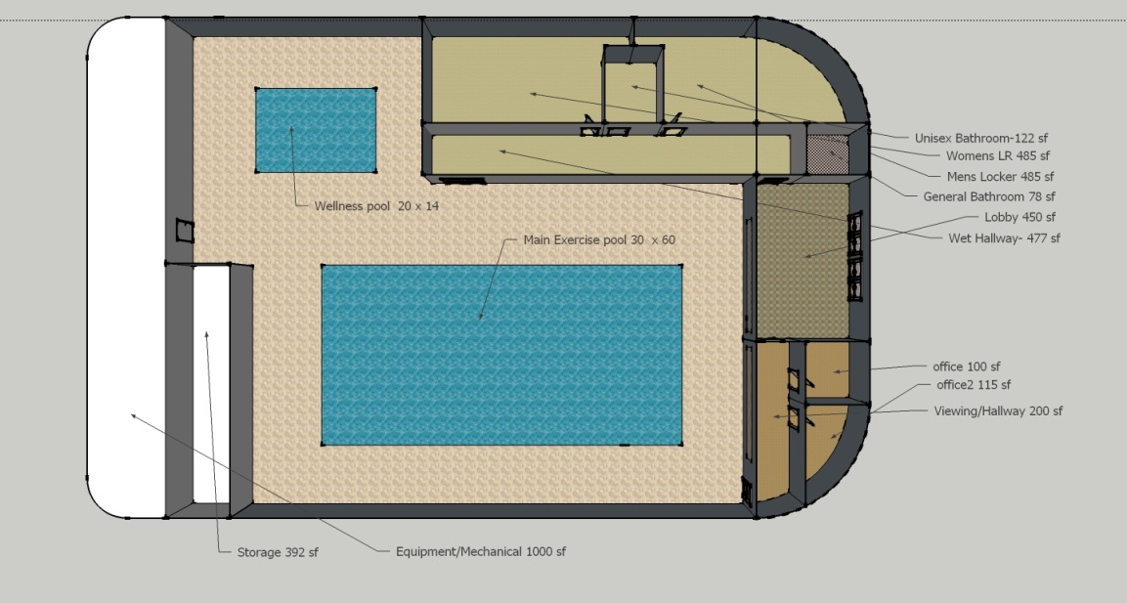
Juice bar and coffee shop
Public Restrooms
Public access and entrance
CommunityRoom
Therapy space rental

