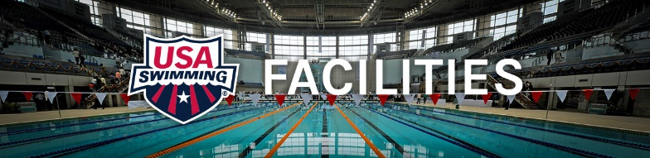

The Seven Pitfalls of Project Development

The planning and development of a pool project is a fragile process. It doesn’t take very much at all to shatter the chances for it to be what the community really needs. The pitfalls are predictable – we hear and see them every day. Maybe identifying the most common and devastating pitfalls or “Deadly Sins” can help people avoid them. So here they are….

- Hiring the wrong firms for Feasibility – There are many good firms that have a plethora of strengths. Unfortunately, there are not that many who understand aquatic facility design for total aquatic programming to service the community. Even many of those with reference to aquatics in their name or literature do not have an “up-to-date plan or vision for the facility to meet tomorrow’s needs. The firm that is hired for the Feasibility study could determine the scope and style for the facility. It may end up not being what you wanted or what the community truly needs but rather what seems to be the “fad” at the present time.

Solution: Ask Tap for referrals for Feasibility studies and for current design trends for community total aquatics.

- Designing the facility before planning for programming is established – This happens frequently, and many “designers” like to use the “cookie cutter” approach. The closer your project approaches something they have designed previously, the less “in house” development expense the designer has. Many will continually try to get you to settle for types of pools you don’t want because the “drawings” are already on the shelf in their office. Standardization is an admirable goal but seldom yields the best product possible. Unfortunately, even if a customer can use a standard design, they seldom see the cost savings they deserve.

Solution: Know the Temperature – Access – and Depth for each pool your programs need and make sure you stick to your programming goals. Do not give in for budgetary reasons – there is usually another way to get want you need.

- Hiring the wrong design or engineering firm – The design firm simply must listen to the person designated to represent the owner or director. The way a spec is written can decide who can bid the project and what equipment will be supplied. The politics have to be eliminated from this process and all qualified bidders and products need to be considered. This is the only way a project will get the best value for the dollar they are investing.

Solution: When conducting the search for the design firm, let all parties know up-front that you want all building options explored and that the bid language cannot be exclusive.

- Building only 1 pool – This antiquated design is the first option considered by many designers. In fact, it can save some deck space – however – a single pool, regardless how it is bulkheaded, cannot give you variable water temperatures for programming. This
temperature control is imperative for learn-2-swim, aquatic rehab, and aquatic exercise which are all important services and profitable programs for facilities.

Solution: Make it clear that the footprint of the building has to include multiple pools. In most cases, a separate pool will cost less than a stretch pool or bulkheads.

- Putting the emphasis on faddish recreation rather than community based aquatic services – There is nothing wrong with a water slide or a zero-depth area with a spray mushroom. However, this should not the focus of the facility. We see slides and water features sitting unused after the novelty wears off. Make the play area an add on and spend the money on programmable water that focuses on Drowning prevention, fitness (health & wellness).

Solution: Proper innovative design can include multiple features in the same pool. Diving and slides and sprays and vertical exercise all like 88-degree water so a single tank with a variety of accesses and depths can work well.

- Partnering with an entity that cannot deliver total aquatic programming – Partnering with a school, or YMCA or club or other entity can be a lifesaver for a project. Make sure from the beginning that everyone knows who is going to be responsible for what. Nothing is more frustrating for a community than to have a new facility with old fashion programming. Every single program needs to be designed with excellence and safety foremost.

Solution: TAP has an Aquatic Programming Specialist at your service. We have also partnered with the best of the best for national programming agencies.
Contact sue@totalaquatic.llc for information about Learn-2-Swim, Aquatic Exercise, Aquatic Therapy and Rehab, Risk Management, and of course competitive swimming.

- Not having a local leader who can keep project on track - Whenever there is community service and money involved, there will be people appear with private agendas. There must be a local leader who can defend the needs vs. wants process and be the champion for “programming precedes design”. This is a daunting task but is most important if the project is to be successful.

Solution: Send a representative to a USA Swimming Regional Build a Pool Conference www.usaswimming.org/Buildapool or email mick@totalaquatic.llc about hosting a Custom Build a Pool workshop at your location.

For more information about project planning and facilities development please contact:
mick@totalaquatic.llc

