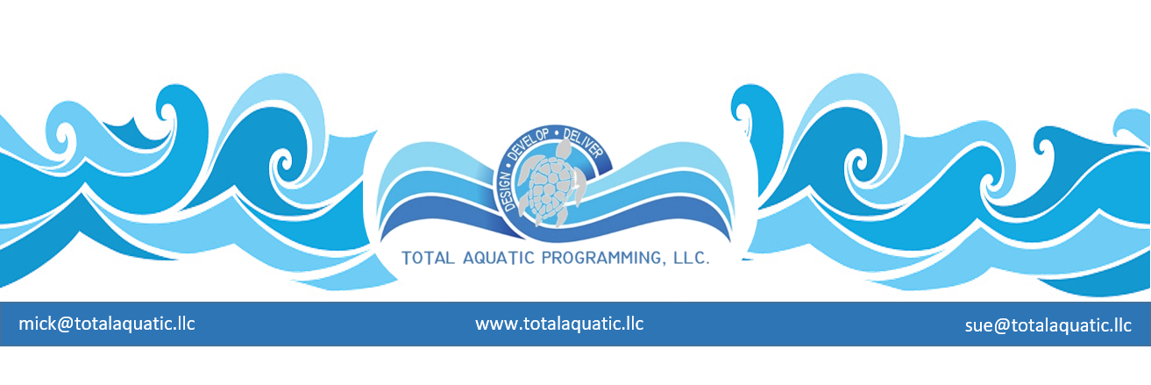
Coaches: “Is the Business of Learn-to-Swim for You?” Is developing a Learn-to-Swim program is right for your career or club?
- A Learn-to-Swim program can be a feeder program for the club team
- It can be a financial support mechanism for the coaching staff and the club, as well as provide a community service.
- Running a Learn-to-Swim program can make the coach the owner of a small business.
Questions to be answered:
- Does the coach have the personal qualities to own their own business?
- What are some things that need to be investigated before venturing into a Learn-to-Swim business?
- How does one create a business plan?
- What steps does the coach take to get the business off the ground (and into the pool?)
- What resources are available?
The Essential Questions
Three questions are generally answered before starting a business:
- What type of business do I want to start?
- Can I actually get paid to do what I want to do?
- How do I get started?
Successful small businesses are created and succeed because they are fulfilling a need. Nationally the Swim School business is thriving and experiencing growth. Years ago, parents would check out their local Y’s and city parks for swim lessons. Now, there are many more options. Private swim schools make a full time very successful business of teaching swimming. The Swim School business is both an economic opportunity and a service to the community.
Needs fulfillment:
- The importance of water safety
- The importance of learning to swim no later than the third grade
- The importance of child fitness and the health benefits of swimming
- The attractiveness of competitive swimming as an activity for their children
A swim school’s focus is two-fold:
- To educate both parents and children about water safety
- Teach children to swim.
The focus is not necessarily on the sport of competitive swimming. One obvious extension of having a child learn to swim is the opportunity to join a swim team, but it would be a mistake to assume that all children are going to go from the swim lessons to the swim team. Some may, many will not. In the beginning, concentrate on swim lessons. Down the road one may want to expand offerings to include other aspects of aquatics including pre-competitive programs, stroke schools and fitness swimming.
Can I actually get paid to do what I want to do?
Yes! Parents want to make sure their children know how to swim and know how to be safe in and around the water. This is the main service a Learn-to-Swim provider offers. Additional aquatic services may be provided if expansion is desired.
How do I get started?
Each year 7 million Americans decide to become their own bosses and start businesses. Obviously, not all are a rousing success, so one needs to think carefully about their personal motivation. Investigate both the reasons why to start a Learn-to-Swim business and the reasons not to start a Learn-to-Swim business. Check out: Why Businesses Fail and Succeed: Gaebler.com Resources for Entrepreneurs Branching out from coaching may seem intimidating and overwhelming. Remember, starting a Learn-to-Swim business is not just about the experience in the water, it is also about making a commitment to the community that will make a difference in children’s lives.
Are You an Entrepreneur?
Passion is listed as the key attribute for successful small businesses. Passion is what allows the entrepreneur to get up every day with the enthusiasm to meet the daily challenges. In addition, interviews conducted with successful entrepreneurs have determined that being resilient and in good health are two prime indicators of success. Think about it. Successful entrepreneurs can work for extended periods of time without taking time off or getting sick. In small businesses, where there is no depth of management, the leaders must be there day in and day out.
FAQ: The Learn to Swim Business
Question: What type of swimming curriculum should be provided?
Answer: Many swim schools choose to use national curricula because they have already done much of the work. One has access to their marketing tips, logos, awards systems and other resources. The recognized national curriculums include: American Red Cross - Starfish Aquatic Institute - Swim America - YMCA of the USA - Alternatively, one might already have developed a swimming curriculum. Just make sure to consult and follow the best practices of the leading national Learn-to-Swim organizations. TAP also encourages all programs to provide a water safety component and educational tools for the parents.
Question: Are there any programs that provide information on infant swimming or lessons for children aged four and under?
Answer: All of the curricula listed above have components for infants and very young children. In addition, there are other sources that provide training. For example, the United States Swim School Association (USSSA) has a course of “Best Practices” for infant training and there are other professionals who have created training programs for swim instructors. (See references at end of this issue)
Question: Does a pre-team or stroke school fit into my business plan?
Answer: One great reason to start a swim school is to provide a feeder program for the swim team. Most students cannot go directly from lessons onto the competitive team and remember that not every child in swim lessons will be interested in competitive swimming. Develop a plan to move a child (and the parents) through the continuum by providing a stroke school or pre-team as an introduction to competitive swimming. Your business can provide health, fitness and fun for your community. Remember to always emphasize water safety.
Question: Do I have to get in the water?
Answer: Let’s restate this question. Are you willing to get in the water and train instructors? Are you willing to get in the water to teach students? If no, then hire a qualified person to manage this side of the business. Train swim instructors to follow your teaching philosophy and then make sure that the lessons are being taught appropriately by the staff. If yes, the advantage is not being rushed to hire and train staff. Teach the lessons yourself and hire and train staff as needed. Remember that this can be a tiring and stressful time so focus on planning and evaluating how many staff will be needed to meet the demands of predicted growth. Trying to do it all yourself may not be wise.
Question: What is the growth potential of my Learn-to-Swim business?
Answer: This will depend on how many days per week and you are willing to teach swimming. It will also depend on the number of hours water time is available for rent. It makes sense to start small with a limited number of classes and then add more as the business grows. Remember to factor in predicted growth when developing contracts for pool rental.
Question: How many hours should I plan on working to run a Learn-to-Swim business?
Answer: This will be determined by the business plan, operational budget and other life commitments. Work enough to satisfy community service needs, to make a profit and to be able to manage other personal and professional commitments, such as coaching the swim team.
Question: Should I offer swim lessons in the summer only or is a year-round program better?
Answer: It depends on pool time available. From a business perspective the year-round program is better. From the student’s perspective, an ongoing program is a better way to learn versus starting and stopping. (See article The Benefits of Swimming Year-Round in this issue.)
Question: How long should each swim lesson last?
Answer: The length of swim lessons will depend on the age and level of the students. The trend for ages four and under is 20 to 25 minutes. For pre-school children, 30 minutes seems to be the norm, while school age children do well with a lesson of 30 to 45 minutes. The length of successful swim lessons gets longer as the children get older. Attention span and fatigue are the determining factors.
Question: How many classes or lessons make up a “session”?
Answer: Some of the leading swim schools are advocating offering swim lessons on a continuum basis. Some of the leading swim schools offer an 8-week session with 45 minutes for each lesson. Monthly sessions are also an option; however, be sure to create a sign-up system that promotes convenient continuation from month to month. The goal for the students is not only to learn how to swim but also to build endurance in the water. Greater endurance means greater safety. Scheduling is a critical part of the business. Offer the optimal lesson schedule, but also address school schedules and other pool usage including the swim team schedule.
Question: Do I really need to provide lessons for children of all ages, or can I focus on particular ages?
Answer: One’s philosophy and vision will be a big factor in how the programs are designed. The staff may have individual preferences or qualifications for teaching different ages and stages of development. Do everything possible to fit the right students with the right instructors with the right schedules. Staff and water time limitations may require a decision to be made about what ages and stages will be focused on first.
Now would be a good time to write down all desired outcomes for the business, including personal, measurable goals.
Here are some examples of possible goals.
- Reduce drowning and increase awareness of all water programs
- Increase my personal income
- Provide careers and earning potential for my assistant coaches
- Provide financial support for my swim team
- Provide an income source for senior athletes
These goals may change as the business grows but a mission and vision is the place to start. The next steps in this process are explained in the long version of this article available from sue@totalaquatic.llc

