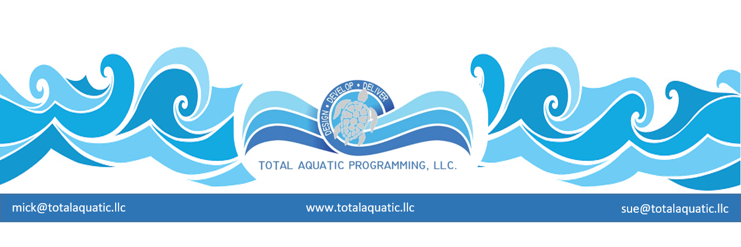

**A new or renovated Aquatic Facility offers more for the community than Economic Impact.**

We hear a lot about the **“Economic Impact”** that swim events and other activities can have on a community.

**Economic Impact Analysis (EIA)** examines the effect of a program, project, activity or event on the economy in a given area. The area can range from a neighborhood to the entire city or county. Economic Impact is usually measured in terms of changes in economic growth (output or value added) and associated changes in jobs (employment) and income (wages). The analysis typically measures or estimates the level of economic activity occurring at a given time when the project or event is going-on, and then calculating the difference from what would otherwise be expected if the project or policy did not occur (this is referred to as the counterfactual case). This analysis can be done either before or after the fact (ex-ante or ex-post). The term economic impact can be applied to analysis of the economic contribution of a given activity or industry to the existing local economy.

TAP.llc has collected Economic Impact data that we can share with our potential projects to help make the case that Aquatic Facilities can have a positive effect on the community. The facility itself cannot “spend” Economic Impact dollars; they go directly to the businesses in the community. The facility or club however, can realize some income from tracking Economic Impact and soliciting local business sponsorships for events. These can be significant sponsorships for naming rights for events or sections of the facility itself or can be support for heat sheet ads or signage advertising throughout the facility.

**However – EIA** is only tracked during special events the facility host which may be only 20 to 30 days a year, usually on weekends. There is another very valuable impact that goes on 365 days a year. It is called **Social Savings Impact (SSI)** and can be especially appealing to schools and cities.

**Social Savings Impact** benefits are shared throughout the community. The Aquatic Center directly helps …..

• The citizens and families themselves live a healthier lifestyle which makes everyone more productive.

• Organizations can spend their community support dollars more effectively since the community as a whole is healthier.

• All businesses can realize a savings with more healthy and active citizens in the workplace and the shopping force.

• Non-profits, especially in the medical community, can redirect some dollars to preventative care.

• Schools can be the beneficiary of a healthier and more socially responsible student body and staff.

• The government of the community can redirect dollars towards needed services such and streets and parks with fewer dollars spent on solving social challenges.

So when talking with potential school or municipal partners, don’t forget to spend some time talking about the importance of **Social Savings Impact** which can translate into millions of dollars for the community.

On the next page are slides and information from the Regional Build a Pool Conferences that help sum up the importance of **SSI**: For more information about Regional Build a Pool Conferences or **EIA** or **SSI** contact:

Mick Nelson – [mick@totalaquatic.llc](mailto:mick@totalaquatic.llc) Sue Nelson – [sue@totalaquatic.llc](mailto:sue@totalaquatic.llc)

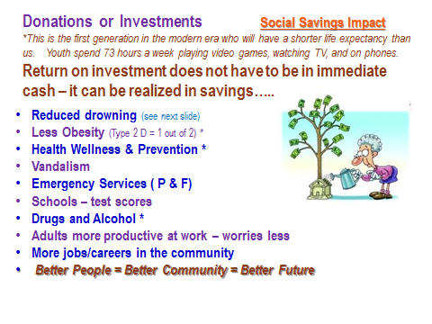

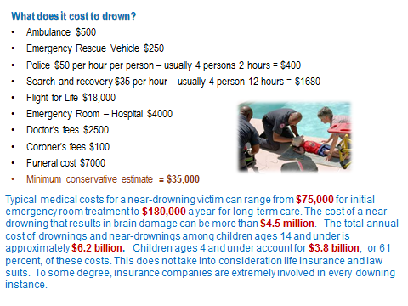

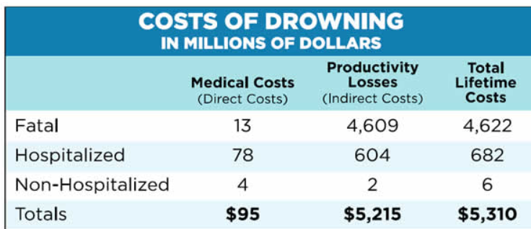

Drowning does not discriminate. Drowning is fast. Drowning is silent. Drowning is PREVENTABLE.

• For children ages 1 to 4, the leading cause of injury-related death is drowning.

• Due to brain damage in some survivors, nonfatal drowning has the highest average lifetime health and economic impact of any type of injury.

• Up to 3 million children each year survive a drowning incident.

• Total lifetime costs associated with drowning were estimated to exceed $5.3 billion in 2000, including $2.6 billion for children aged 0 to 14 years.

• Drowning is the number two cause of death in children ages 0-14.

• See more at: <http://www.safekids.org>

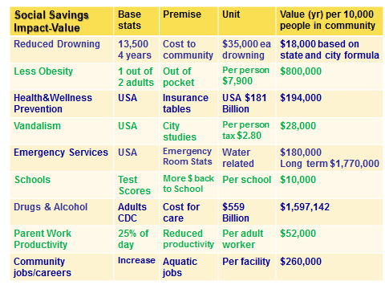

***It doesn’t happen overnight!***

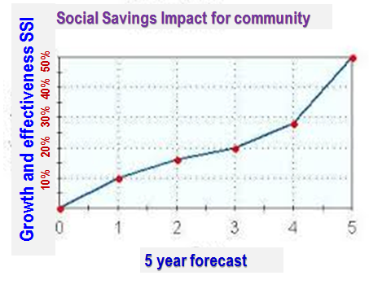

**Background and some stats:**

**Less Obesity –** community impact = $7,900 per year out of pocket expenses for medications and medical services not covered by insurance. That is $800,000 per year of non-spending in the community per 10,000 population.

**Other stats –** more than half of adult Americans live with a chronic condition. A recent study from the Texas comptroller found that obesity alone cost Texas businesses an extra $9.5 billion in 2009, including more than $4 billion for health care, $5 billion for lost productivity and absenteeism and $321 million for disability. “If you look at this from a financial point of view, it’s scary,” said Karl Eschbach, author of the comptroller report who is now a professor at the University of Texas at Galveston.

**Vandalism -** Schools and youth In schools, 52% of public high schools and 47% of middle schools reported incidents of vandalism during the school year. Data shows little difference between cities, towns, and rural areas.

Clean up costs -Although the cost of graffiti vandalism in the U.S. has yet to be definitively documented, for many communities, private property owners, and public agencies the cost is rising each year. Figures from a variety of cities across the U.S. suggest that graffiti cleanup alone costs taxpayers about $1-3 per person each year. For smaller communities the amount dedicated to graffiti cleanup annually may be less than $1 per person.

A recent survey of the 88 cities, Caltrans and Metro in Los Angeles County on graffiti removal found the cost was about $28 million. With a population of close to 10 million, the per capita cost is about $2.80

With a population of just under one million, the City of San Jose, CA spent approximately $2 million in 2006 fighting graffiti.

For communities with smaller populations, per capita costs are typically under $1.00. Pittsburgh, PA (population just over 300,000) spends around $350,000 annually for graffiti clean-up.

Omaha, NE spends about $100,000 a year on graffiti removal (population just over 400,000).

The Tennessee Department of Transportation spent more than $240,000 on removing graffiti along its roads and bridges.

Denver, CO and Milwaukee, WI, with similar populations each spend about $1 million annually.

This is a per capita cost of about $1.80.

In Houston, TX (population just over 2 million), the city earmarked $2.2 million for cleanup of existing graffiti. Chicago, IL budgeted $6.5 million in for graffiti removal and Graffiti Blasters, the city's removal program (population a little over 2.8 million). This is a per capita cost of around $2.30. Las Vegas, NV with a population of about 1.7 million spends more than $3 million each year cleaning up graffiti.

*Source - .Deborah Lamm Weisel, "Graffiti," U.S. Dept of Justice Problem-Oriented Guides for Police Series.*

[](https://www.google.com/url?sa=i&rct=j&q=&esrc=s&source=images&cd=&cad=rja&uact=8&ved=0CAcQjRw&url=https%3A%2F%2Fwww.jccmilwaukee.org%2Faquaticsupdate&ei=kQjRVPydI4akyQTgy4DoCA&bvm=bv.85076809,d.aWw&psig=AFQjCNH4oNN7MWRXfKozpSOAFCUBEIrd_g&ust=1423071672112640)

**DRUGS & ALCOHOL ….. 218,000,000 people over 18 years old in the USA = ~$2500 per person per year**

[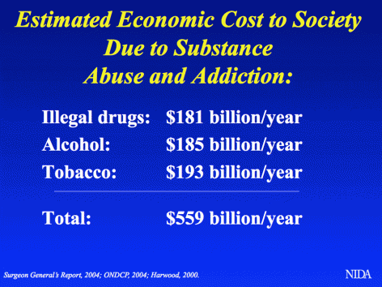](http://www.drugabuse.gov/sites/default/files/images/colorbox/aslide4.gif)

The total costs of drug abuse and addiction due to use of tobacco, alcohol and illegal drugs are estimated at $524 billion a year. Illicit drug use alone accounts for $181 billion in health care, productivity loss, crime, incarceration and drug enforcement – *National Institute on Drug Abuse.*

**Adults more productive at work –** Adults with school age children – particularly Junior High & HS age – are preoccupied with their child’s welfare. This seems to manifest itself between the hours of 2:30 and 5:00 PM when the adult is still at work and the “child” gets out of school. That is approximately 30% of the typical work day that the adult is not as efficient or effective as they can be. I personally have talked to many working parents who are extremely thankful that their children are taking part in one of the healthiest and safest sports during those hours. The parents can be more productive at work with more “peace of mind” that their children will be ready to be picked up after work with wet heads and healthy safe bodies. The employer is also thankful that their business is 30% more productive.

**Study Finds Swimming Grows Minds** By Nate Traylor, Pool and Spa News February 28 2014

Trying to sell a pool to a family that isn’t quite convinced? Hit ’em with this fact: Kids who swim are smarter.

According to a recent Australian study, children who participate in swim lessons at an early age reach significant developmental milestones earlier than their non-swimming peers. They score higher in tests and are generally better coordinated.

The research was conducted over the course of three years to validate or refute the popular belief in the aquatics industry that young, competent swimmers appear to be more confident, articulate and intellectual.

Now data is available to back up those claims. Read more: <http://www.poolspanews.com/health-and-fitness/study-finds-swimming-grows-minds_o.aspx>

The Relationship Between Physical Fitness and Academic Performance

By Toby Brooks, PhD, LAT, ATC, CSCS, YFS-3, Director of Research & Education, IYCA

In today’s tight-budget, high stakes, teach-to-the-test world of secondary education, states and districts have largely forced traditional physical education to the wayside. The reasons seem logical: the cash-strapped district can save money on PE teacher salaries and equipment while simultaneously injecting time that had been allotted to PE activities back into the teaching curriculum, subsequently saving money and improving standardized test scores in one move. However, what research has consistently and continues to show us is that it simply isn’t quite so easy. Instead, a mounting body of evidence supporting the use of physical activity in enhancing both academic performance and behavior suggests that cutting PE is absolutely the wrong thing to do. This is because physical activity has consistently been linked with improved academic performance.(2) What is less well understood is the precise mechanisms through which this relationship exists.

Read More: <http://williamstownpt.com/the-relationship-between-physical-fitness-and-academic-performance/>

Science Reveals How the Brains of Swimmers Are Different Than Everyone Else's

By Sam Wollner, Sports.Mic, August 22, 2014

USA Swimming's finest are currently in Gold Coast, Australia, for the Pan Pacific Championships. The event, which began Thursday and continues through Monday, is the first of several high-level competitions leading up to the 2016 Olympic Games in Brazil. Pan Pacs marks Michael Phelps' return to international competition and also features America's latest swimming prodigies: Katy Ledecky and Missy Franklin. Ledecky is especially exciting to watch as she may be emerging as America’s best swimmer now that Phelps is past his prime.

But few Americans care. As USA Today suggested, Ledecky may be "the most dominant athlete you don’t know."

Phelps aside, this is a common phenomenon in the sport. American swimming is, like Ledecky, dominant. During the 2012 Olympic Games in London, Americans won more medals in swimming than they did in any other sport. Bleacher Report noted the 31 medals that Americans won in swimming alone in London were more than every country that participated in the Olympic Games except China, Russia, Great Britain, Germany, Japan, Australia and France.

This comes despite the International Olympic Committee's (IOC) best efforts to curb American aquatic dominance: After the 1976 Games, to ensure that Americans could not sweep the medal stand, the IOC reduced the number of swimmers that each country could enter in a race from three to two.

Perhaps no sport better reflects America's athletic prowess on the global stage than swimming. U.S. Soccer continues to fall short at World Cups. USA Basketball suffered through the 2004 Athens Games embarrassment. USA Track & Field has experienced a few too many doping scandals. Through it all, USA Swimming has consistently been a stalwart for national pride in international competition.

So, why don't we care? Read more: <http://mic.com/articles/97020/science-reveals-how-the-brains-of-swimmers-are-different-than-everyone-else-s>

What They Don't Teach You In School: 21 Life Lessons I Wish I'd Learned Sooner By Maria Mooney, Mind Body Green, May 2013 I adore academia. I was consistently in school until my mid-twenties, and at 28 years old, I now teach college-level Sociology to classes filled with wonderful, inspiring students. But as this year’s spring semester came to a close, I couldn’t help but think of the wonderful life lessons I wished I'd been taught in my 20+ years of schooling.

Despite all of the invaluable knowledge I learned in school (especially graduate school), a chronic illness has been my greatest teacher, beckoning me to slow down and look within for answers to life’s most pressing questions. There are so many important lessons I've learned—too many to list—but below are some highlights of a lecture I gave at the end of their semester titled, “What They Don’t Teach You In School: Life Lessons From A Sociology Instructor.”

Read more: <http://www.mindbodygreen.com/0-9619/what-they-dont-teach-you-in-school-21-life-lessons-i-wish-id-learned-sooner.html>

**There are many careers/jobs that are more available to people who know how to swim.**

The list goes on-and-on but here are some of the more popular:

|  |  |  |
| --- | --- | --- |
| Lifeguard | Swim Instructor | Aquatic exercise instructor |
| Therapist | Teacher | EMT |
| Fireman | Policeman | Cruise ship employee |
| Military | Scuba instructor | Resort employee |
| Pool operator | Swim coach | Aquatic Director |
| Boy Scouts | Boys & Girls Club | JCCA |
| Aquatic Industry Representative | Sports media | NGB representation |
|  |  |  |

**Social Savings Impact benefits are shared throughout the community. The Aquatic Center directly helps.**

*TAP is gathering information and working with economic professors, consultants, and researchers to gather the most reliable and current information for Social Savings Impact. We will update this article periodically to reflect our findings.*

[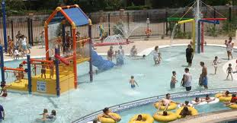](http://www.google.com/url?sa=i&rct=j&q=&esrc=s&source=images&cd=&cad=rja&uact=8&ved=0CAcQjRw&url=http%3A%2F%2Farchive.azcentral.com%2Fcommunity%2Fglendale%2Farticles%2F20110523glendale-aquatic-centers-open-memorial-day-prog.html&ei=rdbQVL2-OMKhyATBxoKYCg&bvm=bv.85076809,d.aWw&psig=AFQjCNFcORh_Q7T-QfDf5LQt3n_5uh1HbA&ust=1423058888237073) [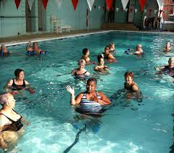](http://www.google.com/url?sa=i&rct=j&q=&esrc=s&source=images&cd=&cad=rja&uact=8&ved=0CAcQjRw&url=http%3A%2F%2Fwww.columbus-ymca.com%2Faquatic-programs.html&ei=eNfQVMiNI8P9yQTKrYHYCA&bvm=bv.85076809,d.aWw&psig=AFQjCNEv0L1VreGYKKg6pseNfqREfJlw9g&ust=1423059092670133)

**Market it – Talk about it – Sell it – Deliver the service every day !**

[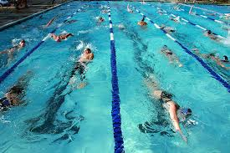](http://www.google.com/url?sa=i&rct=j&q=&esrc=s&source=images&cd=&cad=rja&uact=8&ved=0CAcQjRw&url=http%3A%2F%2Fcoachrickswimming.com%2F2014%2F04%2F27%2Fwhy-swimmers-need-to-be-on-time-and-ready-for-practice%2Fcomment-page-1%2F&ei=JNjQVL3tKoaXyASnpYHIDA&bvm=bv.85076809,d.aWw&psig=AFQjCNHTQt1QisfD_gsN4_u74t2otg1ZqQ&ust=1423059352483654) [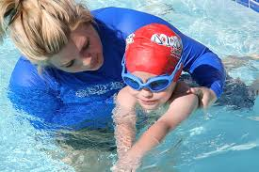](http://www.google.com/imgres?imgurl=http://www.aquatots-detroit.com/wp-content/uploads/2012/02/IMG_8892.jpg&imgrefurl=http://www.aquatots-detroit.com/swim-lessons/&h=640&w=960&tbnid=Au2at6AlwR34YM:&zoom=1&docid=kXVMpoDch2LbbM&ei=0-zQVN3vOIHiyAS2nYHgBw&tbm=isch&ved=0CD0QMygKMAo)