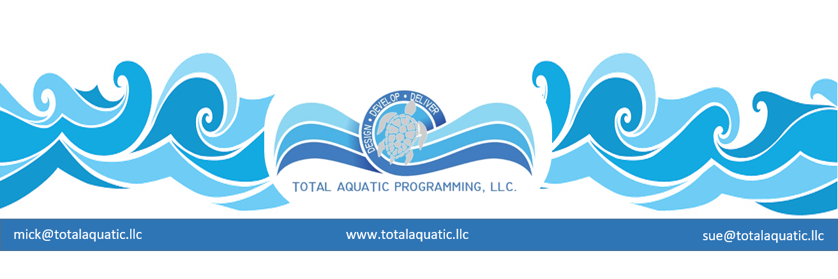

Sustainability for facilities

Sustainability is more than just a word or a catchy phrase. It is a PLAN that has working parts. If ant part is deficient, the plan fails. As with any successful plan, it’s the people that make things work rather than the building they work in. If as much time and effort was spent on the staff preparation and education as went into the facility planning and building, all would be better off. This is the job and vision of the people leader, sometimes called manager sometimes called director.

What do managers need to constantly “focus on” to promote program success?

First – what is a “MANAGER”?

For this discussions purpose, it is anyone who is in charge of anything that involves more than themselves.
You do not have to be a president, upper level director, or have an important sounding title to manage or lead. Coaches manage swimmers and parents and staff. Learn to Swim instructors manage children and adults and co-staff.

If you want to give yourself and your programs the best chance for success and longevity, learn not only to lead/manage, but also make a constant effort to understand what works and what doesn’t. The only way success can be reproduced is if you track the steps taken to reach your end goal.

Motivation and Tracking are critical and you can never quit learning how to do them better. Categorizing helps both the manager and their team clarify what is being tracked and how it impacts the total plan. There is no BEST WAY since all managers are unique, but here’s one way that works:

There are 3 main areas each with 2 sub-areas - of aquatic leadership importance:

- The Facility
    - Aesthetics
    - Safety

- Staff
- Certification
- Style

- Participants
  - Satisfaction
  - Goals

Just a few comments to help get the ball rolling:

The FACILITY: It really doesn’t matter whether you are renting a facility or own your own, the same principles still apply.
- The facility has to be clean, and attractive. Everything from the parking lot to the reception area to the shower rooms to the pool itself has to say welcome to our facility and we care about both the facility and the patrons.
- Risk management is and always has been super-important. However, it is receiving more public attention than ever before. You have to have a “plan” and make everyone aware. The days of winging it are gone. There are great nationally recognized firms that specialize in helping you development and implement your plan. For more information contact sue@totalaquatic.llc

The STAFF: You can never spend enough time and resources on staff training and support. Teamwork has become a catchphrase but it is so important.
- Staff training and certification benefits everyone. The certification needs to be relevant and from a reputable organization. There is much more to aquatics than just first aid and CPR. Once certifications are achieved, all clientele need to be made aware that the staff is among the best in the country.
- Each staff member has to be conscious of their personal style. How do they appear and relate to others? No one should ever think their “style” is proficient. Improvement is something that just doesn’t happen, it is caused. Staff motivation and a concerted effort to be better than last week is critical.

The PARTICIPANTS: These are the people who write the checks. Without them the business does not succeed. Many customer service businesses fail because the staff did not recognize what it took to keep people happy, healthy, and coming back day after day.
- Customer satisfaction is a daily challenge that has to be discussed, analyzed, and tracked. Customer comment cards should be available at the front desk. Periodically the staff needs to talk with the participants and see how they feel they are doing.
- Do all your participants have goals? Have they been taught goal getting? Have you discussed their personal plan and the benchmarks they will use along the way? People quit because they feel they are wasting their time.

We are in the SERVICE BUSINESS. "Aim to please!" Remember the code word AIM.

- Appreciated = always make people feel their efforts are appreciated. Don’t forget staff and customers are both equally important.

- Important = make someone feel important whenever possible. This applies to both clients, co-workers, acquaintances.

- More = give people more that they expect and more than they have paid for.
Quantities of Quality!

Every facility has a better chance of success and survival with Total Aquatic Programming. Every program has a very important place in the culture of success. It is very difficult to have one program functioning with one plan, delivery method, and staffing philosophy while another program works an entirely different way. Aquatic programming has way too many commonalities for us all not to take advantage of the above 6 points and collaboratively make the business a sustainable success.

The two main parts of any successful business plan are:
- Managing expenses
- Increasing income

Income and program pricing must be based on Value Received Pricing.
sue@totalaquatic.llc for information on VRP.

Expenses need to be evaluated quarterly.
- Do you cover the pools at night?
- Do you use the best pool chemicals?
- Is the HVAC system checked twice a year (or more) for operational pumps, condensers, vents, and filters?
- Are cleaning supplies the highest quality at best price?
- Have contract services been evaluated and comparative bids collected?
- Do you have a capital improvements budget that has income every 2 weeks just like an employee?

