When considering an initial design for a new or renovated aquatic facility, it would be a good idea to give some serious thought to space for aquatic therapy and warmer water for special needs classes. This space is not only a valid income stream but one of the most marketable community services that the facility can offer. Of course the 2 pitfalls for this type of consideration are over designing and under designing the space requirements. The “professionals” who are going to actually use the space on a rental contract (probably) will always recommend the deluxe version. Not a bad way to go if you have a liberal budget but in the end this space usually has to be value engineered down so it might be better to start with the more practical and affordable.
The people who “pull the purse strings” will tend to leave out necessary amenities (space) that will reduce the functionality of aquatic therapy offerings. Make sure everything needed is included – just make it a reasonable size. Below is one sampling of a functional reasonably sized space in less than 4,000 square feet

Unisex changing rooms and showers ~ 10’ x 12’
Patient exam room and Therapist office 8’ x 10’
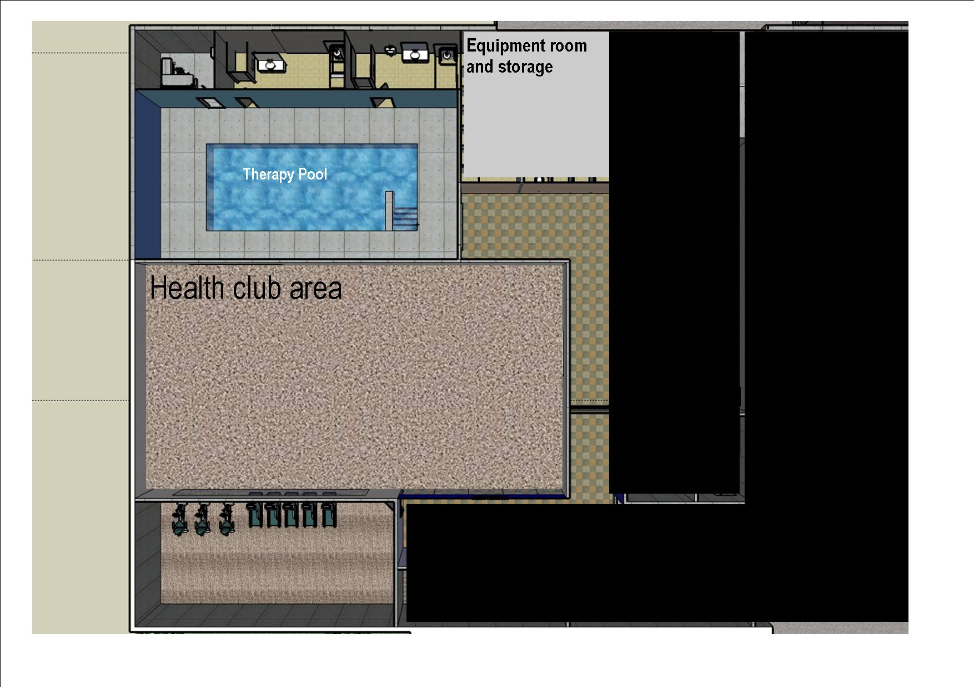
Access corridor to and from therapy areas
150 sq ft minimum
Pool approx 14’ x 26’ with 6’ decks
Ranging form 2,000 to 2,500 square feet

Same concept but slightly larger versions.
