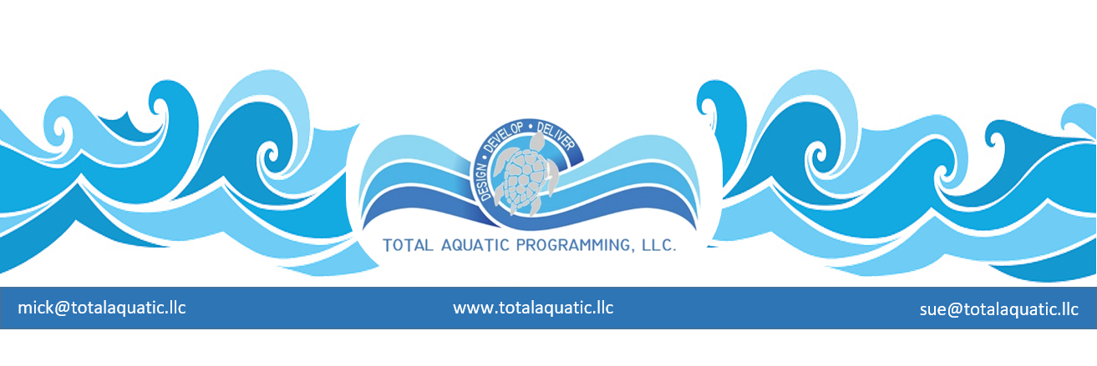
New facilities design sometimes comes up short. Case study = The new $6.3 million Johnstone Sports Hub is creating a big splash in the town - for all the wrong reasons. Opened in July amid much fanfare, the facility boasts state-of-the-art all-weather outdoor areas, a fitness club and a swimming pool. However, there are now complaints the new four-lane pool, which is much smaller than the old Johnstone Pool, is causing injuries and inconveniences to swimmers. George Kennedy, secretary of the town's community council, said: "People are always telling me how they are stubbing their toes, banging their elbows and knocking their heads and knees. "The pool is just too small for the amount of people who are visiting it. It only has four lanes for swimming and walking. "It just isn't deep or wide enough, so people are hurting themselves while trying to move around in there. The pool replaced the ageing Johnstone pool which has since been demolished. Councilor Kennedy said: "We used to have a wonderful pool in the town. "It was a bit tired by the end but in terms of facilities and size, it was great. Even though the children can play or splash about away from the adults, there is not enough room for lap swimming and exercising in the new pool water. Councilor Kennedy added: "There are changing rooms to die for, but people are being inconvenienced and “put off” by a pool that is too small." Mother-of-three Angela Griffin, aged 42, of Johnstone, agrees. She said: "It can get really cramped in there! I myself have been bumped by somebody trying to swim under water. We need at least 6 lanes not 4. Councilor: "As for the design of the pool, it was designed in accordance with industry standard guidelines backed by a professional consultant. In addition, the lane widths meet the standards set by FINA, the international governing body of competitive swimming. Griffin: It’s not the size of the lanes there just aren’t enough. People walk in and see how many people are crowded into the lanes and leave perturbed without getting in.

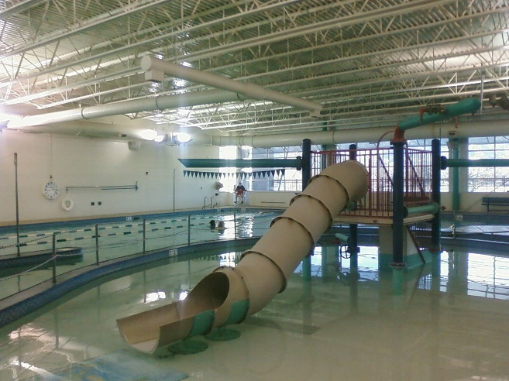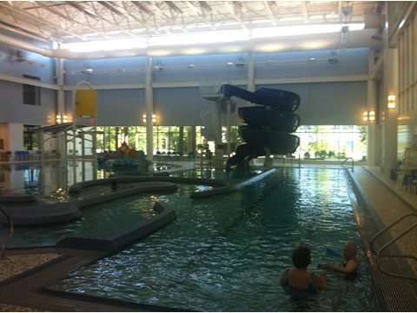

Both pools (left = Memorial Park Pool Colorado Springs and right = Kroc Center Philadelphia PA) have expressed the need for more rectangular lap lanes. They are missing opportunities for lane rental to teams and learn to swim providers.

One of the most prevalent planning and design errors is to over design the play features and leisure water in a new facility and under-design the programming water necessary for income.

Aquatics are growing in popularity. Existing facilities are looking for ways to increase revenue and
decrease overhead. New facilities that are still in the planning and development stages must weigh the pros and cons of aquatic design and what pools they can afford to include in the construction. Many times, we hear from consultants that “rectangular pools” are not self-supporting and should be eliminated from the design. We also hear that “curvy” pools with fountains and slides are money makers. It is just the opposite.

Putting things in perspective, rectangles are the cornerstone of the aquatic facility. They are used for so much more than competitive swimming and should really be referred to as ‘Community Pools”. Without the rectangular community pool, the other bodies of water become a “drowning risk”.

We use the rectangles for a variety of programming that is necessary for the community. For example, a 25-yard variable depth pool can be used for:

Competitive swimming, Adult lap swimming, Safety training and Adult water acclimation classes, Kayak and boating classes and safety courses, Masters Swimming programs, Snorkeling and Fins instruction, Scuba instruction, Fireman’s – Policeman’s - and EMT rescue training, Water Polo, Water Basketball leagues, Boy & Girl scouts – Boys & Girls clubs – Water introduction classes, Adult vertical water running with floatation belts, Tri-athlete training, Rehab of athletes by Athletic trainers, Camps and clinics, Age group swimming, Learn to swim programs, Aquatic rehab continuum programs and much more…..

Programmable rectangular pools are income producing and foster growth for the business. Water rental can be by pool – usually around $100 per hour, or by lane – 25-yard-long 7’ or 8’ wide lanes average 14$ to 18$ per lane per hour. When you hear that the curvy pools financially out-perform rectangles, that just isn’t true if the proper professional programming is in place. A facility of the 21st century should include multiple pools properly sized for community use including both rectangle and other supporting recreational designs.

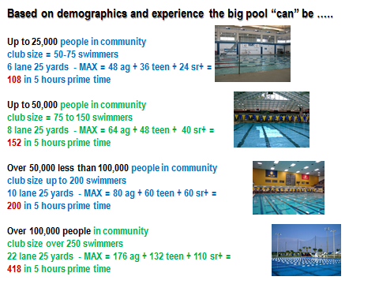

The water features in a facility can attract “day pass” members but the novelty wears off quickly and memberships or drop-in-fees decrease. Programming such as learn-to-swim, team water rental and adult fitness, on the other hand experience growth and seldom have the drop off in popularity that recreation does.
