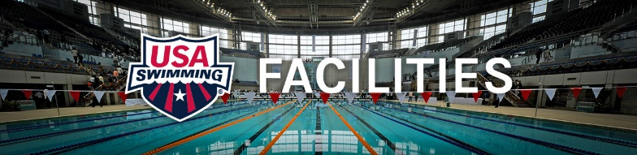

For those projects that are planning to build a 25-yard competitive pool, here are some tips that may help:

- Can you build a pool to be fast? What makes it this way?

Pools can be built to be “fast.” There are four primary considerations –
- First and foremost, you need fast swimmers to compete in the pool
- Key structural considerations include pool depth deeper than the average height of the swimmers,
- Wave-quelling lane lines with wide lanes – ideally 8’ but 7’ is OK for age group competitions
- Proper gutter size and design.

All of these features reduce wave action and water turbulence.

- What does my facility absolutely “need,” in order to be a home to competitive swimming?

To start a competitive swim team, you need access to a 25-yard pool. Another length (e.g. 25 meters) could be considered, but 25 yards is most common size in the USA and we do not foresee any changes soon in this trend. High Schools, YMCA’s, Junior Colleges, Colleges and Universities Division I – II – III, summer clubs and conferences, etc. all are predominately based on 25-yard competition. One of the most common calls the facilities department receives is from a pool wanting to know how much it would cost to install a bulkhead or false wall to change their 25-meter pool to 25yards.

The pool needs to be marked with lane lines on the bottom and turn crosses on the end walls of the pool. See USA Swimming rules and regulations for actual measurements and specs. A minimum pool-depth of four feet at the shallow end and 7’ at the starting block end is desired – however if it will be used exclusively for competition a deeper depth constant can be considered. There are pre-engineered steel pool options available today that are 2 meters constant depth and designed for competitive swimming.

The pool should be equipped with floating lane lines that attach to the end walls, backstroke flags at both ends, a pace clock, and the safety equipment mandated by local health codes. In addition, the facility owner/operator must be willing to commit the necessary pool time. The most important need is a safety-certified swimming coach who knows the basic fundamentals of competitive swimming.

- What would be nice to have, “wants”?

From an equipment perspective, it would be nice to have individual training equipment such as kickboards, hand paddles, fins and pull buoys; a video camera to help with stroke correction; and a dry erase board for various instructional purposes.

From a facility perspective, it would be nice to have starting blocks, spectator seating for at least 500 people, and ample deck space for athletes and volunteers during a swim meet. Usually 20’ of deck
behind the starting blocks and 15’ deck on the other 3 sides is ideal. It is also very helpful to have access to a classroom or meeting space.

In the “really nice to have” category is an automatic timing system with an 8-lane scoreboard. If the pool is indoors, there should be a properly sized Ultraviolet pool water purification system and a HVAC system designed and sized for the proper air flow and relative humidity.

One of our prime directives is make sure multiple pools are built so total aquatic programming can take place and competitions have proper warm-up and warm-down space for meets. The other pools do not have to be as large and need to be on their own dedicated filter system so there is control of water temperature.

