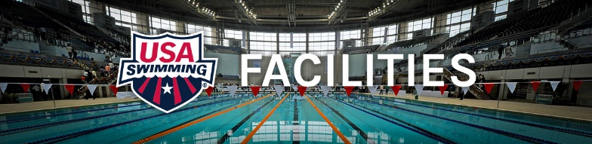

20 minutes

TAP makes every effort to publish information that will allow our clients to do Better Business and business better.

Since TAP firmly believes in “Total Aquatic Programming” we need to have some “rules of thumb” available when considering business plans and programming forecast.

We can generally say that for a multiple pool facility (2 or 3 pools) to have good chance for financial and community service success, the following applies:

- A facility that has a 50,000 population draw within a 20-minute drive, ideal facility = 12,000 to 15,000 square foot facility.

- A facility that has a 75,000 population draw within a 20-minute drive, ideal facility = 16,000 to 22,000 square foot facility.

- A facility that has a 100,000 population draw within a 20-minute drive, ideal facility = 23,000 to 35,000 square foot facility.

- A facility that has a 150,000 population draw within a 20-minute drive, ideal facility = 36,000 to 45,000 square foot facility.

- A facility that has a 200,000 population draw within a 20-minute drive, ideal facility = 46,000 square foot facility or larger

The demographics of a highly populated community near or in a metropolitan area can drastically change within a 20-minute drive. In a rural area the demographics may be almost identical 20 minutes in any direction. Therefore there are not “set guidelines” only “rules of thumb”.

One “rule of thumb” is that an area being considered for an aquatic facility should have an annual median household income of around $75,000 or more with a population base of no less than 50,000 people. As one of these numbers decreases, the other number must increase. The median income number is most important because Total Aquatic Programming depends on customers who can afford to pay for optional programming. There are a few exceptions thus the “rule of thumb” designation.

One thing is apparent! There is plenty of room in densely populated areas for more than 1 facility……

Example:

A metropolitan area a 50,000 square foot facility that houses 3 pools, one being a 50-meter x 25-yard competitive pool.

When set up short course that pool can offer 22 x 25 yard 7’ wide lanes. In most situations the training for our competitive swimmers takes place from 3PM to 8PM during weekdays. (We are not including early morning training in this example because those are the same swimmers who are attending a second practice in the afternoon.)

Assumptions:

- Based on training 6 senior level swimmers or 8 age group level swimmers per short course lane we will use 7 as our median number

- 6 hours pool availability divided into 3 x 2-hour time blocks.

- In most scenarios 18 lanes can be used for team while leaving 4 lanes open to the community.

Calculations:

- 18 lanes x 3-time blocks = 54 available practice lanes per day.

- 54 x 7 swimmers = 378 participants

This is looking good! A USA team with almost 400 swimmers – nice!

Oh wait! We forgot that this is a community project and that we also have to service High School teams. If we offer 3 High School teams 6 lanes each to train each night, we how have only room for a USA team of 252 swimmers.

What happens if Water Polo wants time? Masters swimmers? That is 1/3 of the pool time block. We won’t belabor the obvious. As the demand for water goes up, there are more people competing for the same access times.

There are many areas that have 10 or more High Schools in their densely populated area and all these schools may want to consider swim teams if they had access to a facility. This leaves less opportunity for USA teams to have prime-time access.

Point being that densely populated areas can support more than one large full-service facility. Sometimes 3 or 4 can all be successful if programmed properly and demographically located to service their chosen populations. Remember the 20-minute drive rule when planning your facility.

