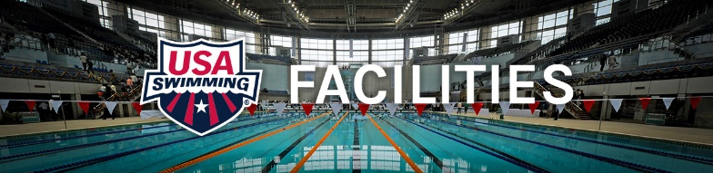

Pool utilization and planned growth

Identify challenges: Proposed Strategies:

1. Number of pools in dense population areas are not sufficient to allow for growth of clubs.
The inflated land cost and cost to build are 2 of the largest hurdles to cross. On new projects, partnering with Municipalities, schools, hospitals, etc. may reduce the initial capital investment.

2. Many clubs are not prepared for growth because of management and operational issues.
Most clubs in the United States don’t have contracts for their pools or at best are in a short-term situation making it hard to plan. Most municipal/school facilities have “inclusionary”
policies which also limit the space due to their need to allow every special interest group
access. Not an easy thing to juggle since most of the facilities are taxpayer subsidized.
Develop sample pool contracts and agreements that are based on not only competitive
swimming but are also on Total Aquatic Programming including Make a Splash initiative.

3. Many coaches are not prepared or motivated to increase their area of responsibility to include
satellite sites for their existing teams. It appears that new clubs start and fold, merge with
existing clubs, and/or their markets do not present a club with enough market share to
present a “viable” entity. Many of our clubs that are under 75 athletes are not viable,
sustainable business entities thusly can’t afford to be “key stone” tenants of any facilities.
There are not enough professionally prepared “coaches” that have the ability and/or desire to
start new programs.
Develop a Coach’s educational workshop that addresses Programming, Growth, Business
Planning, Staffing, and Management.

4. Many of the areas that have pools that are not being utilized are in neighborhoods that are
not kept up and safe.
Through Make a Splash, partner with Boys & Girls Clubs of America, Big Brothers-Big Sisters so
outreach efforts can be located where our targeted demographics exist in facilities that
can be utilized with minimal efforts.

5. Many of the pools that are not being used are not of a shape or dimension that is condusive
to competitive swim training.
The “grass roots” of any competitive swim program is the “learn-2-swim” program that is the
foundation of the club. Pool shape and dimension is not nearly as important as depth and
temperature. TAP can assist pools with project plans and referrals for heaters and other such
amenities. Not every functional pool has to be a rectangle.

6. Many pools are in dis-repair or have been decommissioned because the money for up-keep
or renovation is not available.
We listed this even though it is a tough one. Local corporations are sometimes willing to
offer grants or assistance for those clubs offering programs like the Make-a-Splash initiative.
Child safety and drowning prevention are keys in this effort.

7. We have not identified and communicated effectively with the people who own and
operate many of the pools.
There may be some history that is not favorable for a club or aquatics professional to use a
pool. TAP has information about community programming and learn-2-swim. Maybe a different
approach with the key person in charge of the pool is in order.

8. Leisure pools and recreational pools are more attractive to municipalities than rectangles.
Municipalities argue the financial viability of the traditional rectangle but continue to offer
pool time to our clubs but at a national average of somewhere in the neighborhood of
$14/lane/hour indoors hence a team requiring 8 lanes of pool space for 2 hours/day would
need to pay $1344/week for lane space or approximately $5000/month. This is a daunting
proposition for most start-ups to engage in immediately.
TAP has advice for clubs and aquatic professionals to help them negotiate better contracts that ramp up with success as well as develop the necessary complimentary services so clubs can afford the rent. Also, most municipal pools are outdoors with limited availability.

9. The “value” of a swimming pool has lost focus in the community.
Marketing and Make a Splash can change this.

10. A very high percentage of our underutilized pools are getting close to there projected
lifecycle. We have seen an overwhelming referendum in the public-school market which has
voted 3 to 1 against the renovation of existing school pools. The advent of many states and
local schools taking aquatics out of the educational curriculum is also a factor in this statistic.
Our TAP industry partners can get us preferred service and pricing to assist some of the
economic issues.

11. We are underutilizing existing infrastructure in the United States, however, we (USA-S) are
not the only game in town. YMCA of America, Boys and Girls Club, Police Athletic leagues,
Public High School Athletic Directors and Municipal Parks and Recreation Directors all have
agendas which translate into a no-nonsense approach to management. It’s all about dollars
and time and MOST of our clubs have been overwhelmed with the rental needs especially
the smaller ones and start-ups. There is a general consensus amongst many small to
medium public schools that it is more cost efficient to close early.
As clubs become more involved in total Aquatic Programming, they will be able to offer
packaged services that are community based and have a highly visible value to the school
and its position in the community.

