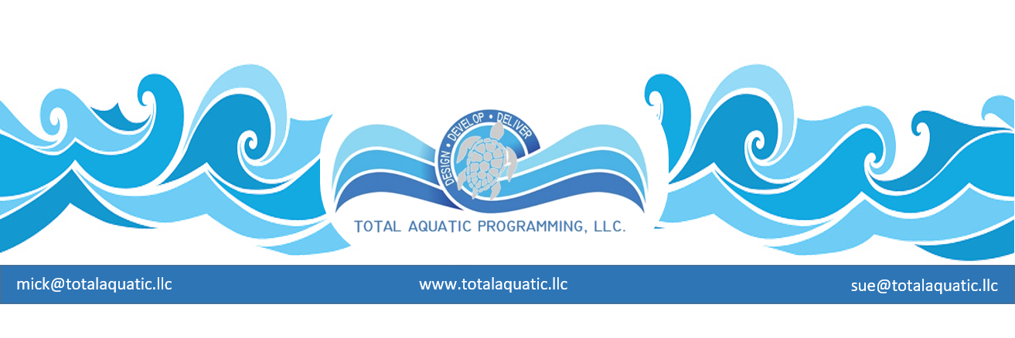

There has been a lot in the press recently about the “dangers” of pool drain suction. Unfortunately, most people really cannot picture a pool drain and fewer still
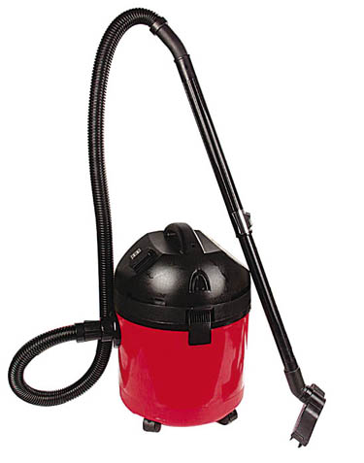
understand how they work. Think of your typical “shop vacuum” or canister type
house vacuum) with a suction motor and a hose connected directly to that motor.
Its job is to suck air and dirt into the hose, run the air through the hose into a filter
so the dirt goes into the tank and the clean air is exhausted out the other side of tank.
Very simple and effective process. Now, if your 5-year-old has never seen one
of these shop vac’s and you lay the hose down and turn your back there is a good
chance that they will pick up the hose and put it in their mouth.
Goodbye tongue and any chance to breathe.
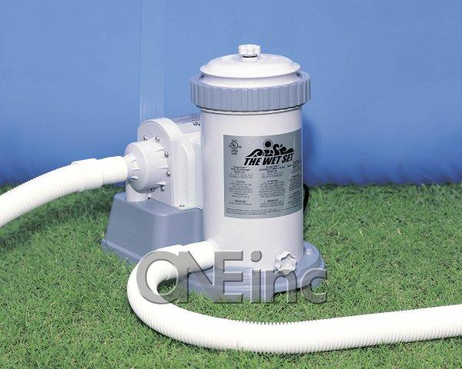
There is not much difference between this and the residential pool pump and filter.
The water and dirt are sucked in a hose that is attached to a drain in the pool then
run through a filter that traps the dirt and sends the clean water out a hose on the
other side back to the pool. This “pump” must be stronger than the shop vac because
water is 10 times denser than air – therefore lots of suction. The suction hoses
also, must be attached to something so it stays in place. There are three places
where a suction hose (pipe) are normally attached.

- In most above or on-the-ground pools and spas there is a wall skimmer that
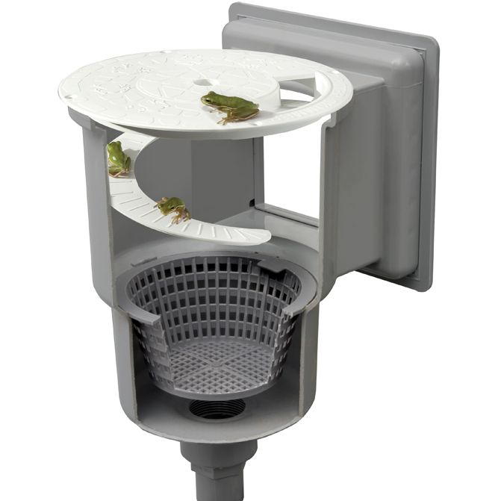
Sucks the water out of the pool/spa and back to the filter. These usually are not easily
accessible for hands and arms because they have a protective basket with hundreds
of holes. The basket sits on top of the actual intake at the bottom of skimmer.
However, it is not that unusual for someone to remove the basket for cleaning and
forget to put it back in the skimmer. This makes this a dangerous suction place
There are very inexpensive safety face plates that can be purchased to make the skimmer harder for hands to reach through.
in the pool.

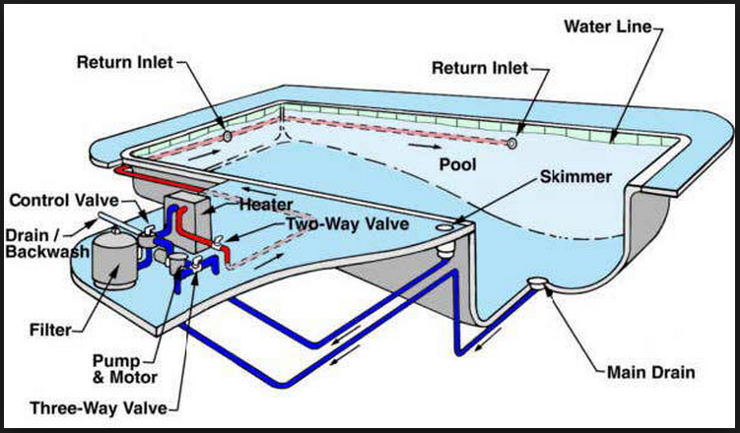

- In some above ground pools – most spas – and most in-ground
Pools there is a drain at the bottom of the deepest part of pool. It is called
a main drain and is directly hooked to the pump. It usually has separate
piping from the skimmer so it has its own suction. This has the potential
for the most serious problems since it is under water therefore anyone
messing around with it would also be totally submerged.

Until a few years ago all pools were built with a pipe or hose connected
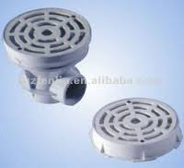
to the main drain and a simple grate that screwed to the drain box.
Suction entrapment was not really a problem because kids and adults
were told to stay away from the drain.

That recently has changed. There have been cases reported of children and
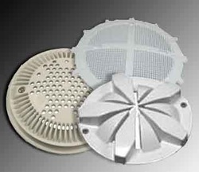
adults being severely injured or drowned by suction entrapment.
In the past few years anti-suction drain covers have been invented.
There are usually many styles and sizes of covers to choose from.
This is something every pool simply must have if they have a main drain in
the wall or floor.

The third area for suction problems is the vacuum line for pool cleaners.
This is usually a plastic fitting (hole in the wall) where a vacuum hose
attaches to clean the bottom of the pool. The cleaner can be hand operated
with a vac head on a pole, or a robot cleaner that works automatically off the
pool pump suction. Swimmers should never be in the pool when it is being
vacuumed. That vacuum line is supposed to be piped and valved so it can be
turned off when not in use. Unfortunately, people forget to do this and now there
is a hole in the wall with direct suction. This can be extremely
dangerous. This hole must be plugged with a flush-to-the-wall pool fitting
when not in use.

The Virginia Graeme Baker Act (2007) legislates all commercial/public pools
have entrapment preventing drain covers. Unfortunately, home pools and spas
are not covered by this law. There are over 12 million home pools and spas in the USA so this is a problem that needs attention by pool owners.

WHAT NEEDS TO BE DONE NOW?

- First line of defense is proper supervision. No swimmer should ever use the pool alone; adults or teens or children. When children are in the pool, eyes must be on them the 100% of the time. Even the slightest distraction like a cell phone call or side conversation is dangerous.
- Every swimmer needs to be aware of the risk of putting hands and feet in places that they don’t belong.
- Every pool and spa (regardless of size) that has a pump needs to have an automatic emergency OFF SWITCH at poolside. The switch needs to be electrically safe and as close to the pool/spa as possible. Pushing this button immediately stops the pool/spa pump(s) which eliminates suction.
- All skimmers and drains and inlet fittings must have anti-suction covers installed and checked periodically to make sure they are securely attached and in god condition.
- All pools and spas sold must have anti-suction covers and grates as original equipment – why do we need laws to do what is right?

Liability = It depends on who gets injured, how they were hurt, and who owns the pool. If someone died or sustained permanent brain damage due to lack of oxygen because of suction entrapment, the pool manufacturer (and the drain manufacturer) might be liable if they knowingly built a drain without enough safeguards to protect children from getting stuck in it. Because these types of product liability cases are so difficult and are unique to each case, it really depends on what happens and why.

