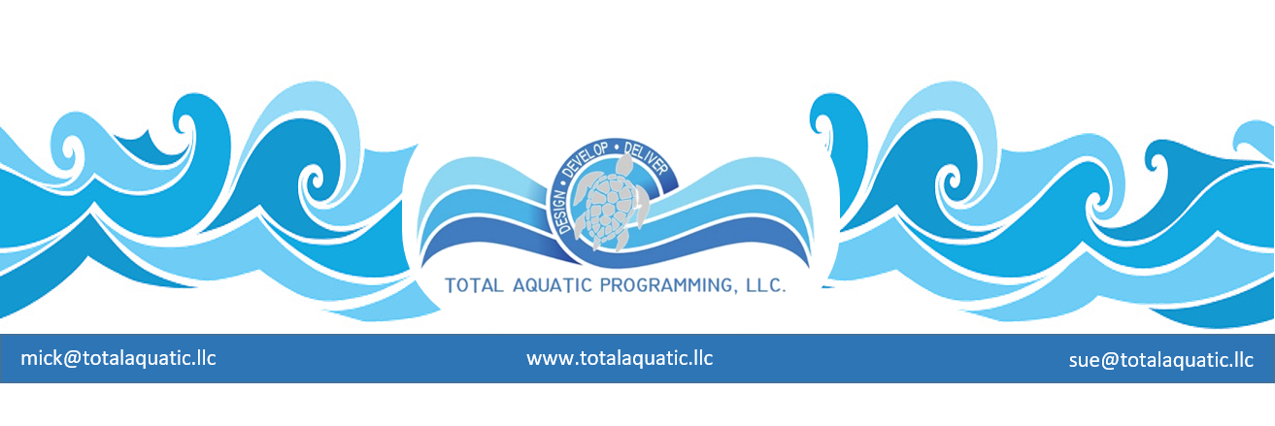

IT” S THE LITTLE THINGS THAT MAKE A BIG DIFFERENCE – There are some really good architects and aquatic engineering firms available to contract for facility design. We are fortunate to see dozens and dozens of facilities each year and hear what they like and what they would change. Here are some tips to share with the professionals you will hire:

The front end of the building:
- Entry way and public areas.
  - You only get one chance to make a “first impression”. Watch your color selections for walls and floors and trim. Usually 3 basic colors work well. Carry that color theme throughout the facility when possible.

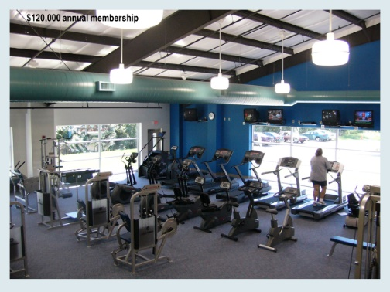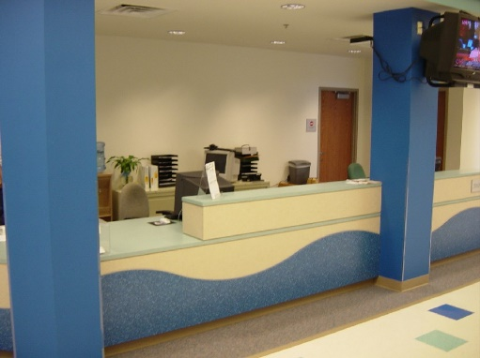

- Viewing areas and concessions should be as close together as possible and have a view of the programming pool. TV monitors and plastic (rust proof) tables and chairs should also be in this area. Vending is located here. Plenty of electric outlets need to be designed. This will be the most used area by the public.

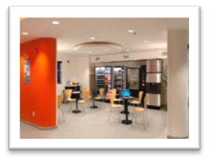

Flooring. You will have quite a few choices and budget can be the deciding factor. Color coordination is again important. Colors not showing dirt and scuff marks also needs to be considered. Light “broom finished” concrete is the most affordable and the lowest maintenance. There are also some very nice synthetic decking materials for the shower rooms and pool decks. Suggest you try to deal with a local distributor and installer on this. That way you have good warranty follow-up.

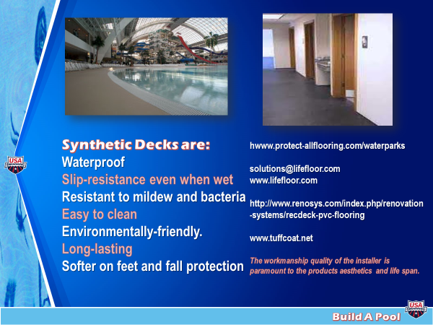

- All doors and frames and windows need to be rust proof material. The same with hinges and screws and all hardware.

- Lighting – LED is the preferred method. Pricing has come down and they last 10 x as long with much less energy. You will have direct and indirect lighting options for each room.

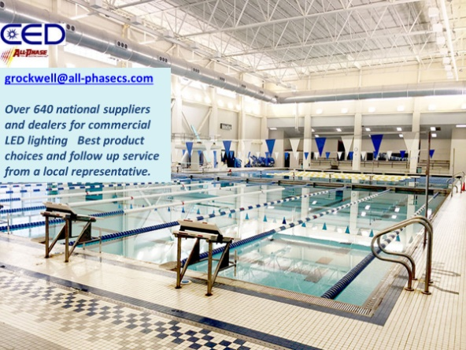

Shower rooms – The amount and size of the various dressing and shower rooms will depend on the size of the facility. Generally you will need a main Mens and Women’s shower room – a team M & W smaller shower room – all with privacy shower stalls with curtains and 1 x ADA shower in each. At least 2 unisex family changing rooms with showers and a common dressing area for small children – the appropriate number of dry public bathrooms an staff M & W dressing and shower room. You will also need at least 6 on deck rinse stations – maybe more for larger facilities.

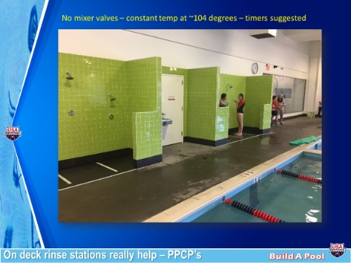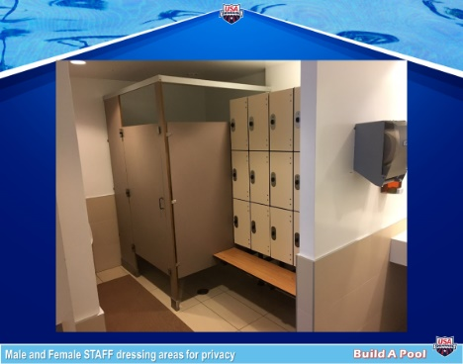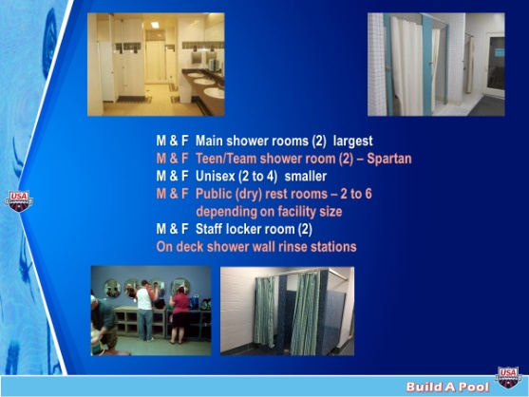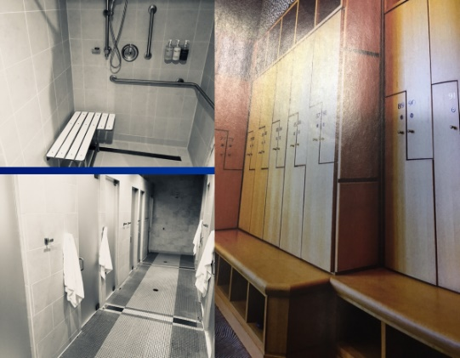

- All benches in the shower rooms must either be backed up to the lockers or a wall or have a back on them to prevent falling off backwards. No metal lockers – use ABS plastic or composite materials so there is no rust. ½ lockers stacked are fine. No need for full height lockers.

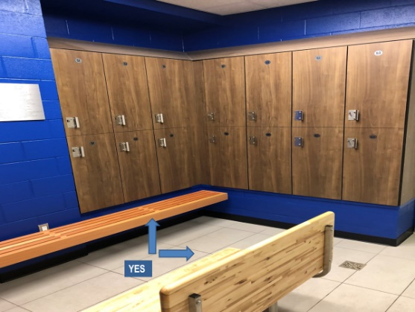

- Storage – This is always one of the areas that is undersized. We recommend storage be 20% of the total facility size. Pool deck storage needs to have 3 things that differ from other storage areas
- Pocket sliding doors so no doors tearing off toenails and usable storage area increased on both sides of door.
- Floors sloped to drains – all equipment comes in wet and this prevents water puddling on floor.
- Vent fans so air circulates, and equipment does not get mold.

- Programming support rooms – such as offices and exercise rooms and meeting rooms and party rooms, etc. Size and location of these area are important – Programming Precedes Design.

- Pools – we prefer Myrtha Stainless Steel pools because they last 4 x that of a concrete or gunite pool with much less overhead and maintenance. Contact for Myrtha is Mike Mintenko mmintenko@myrthapoolsusa.com

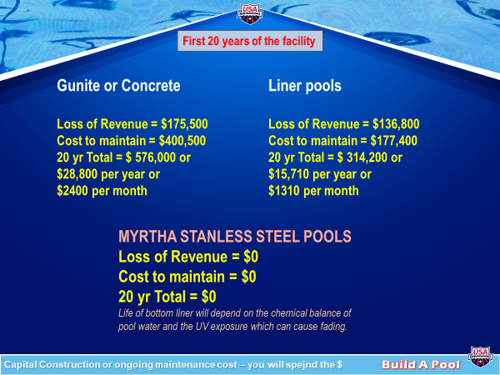

- Pool deck equipment – Starting Blocks, and Lane Lines with reels, and pool covers with reels, touchpads, guard stands, ladders, diving boards, poles, cleaners, etc. You will have a lot of choices. Email mick@totalaquatic.llc for recommendations

- HVAC – Heating Ventilation and Air Conditioning – the lungs of the facility. This is a very important part of the design. You can never downsize units and there is a difference in manufacturers. We recommend Desert Aire – contact keith@desert-aire.com Also use Duct Socks for return air when possible: They save $ and are better.

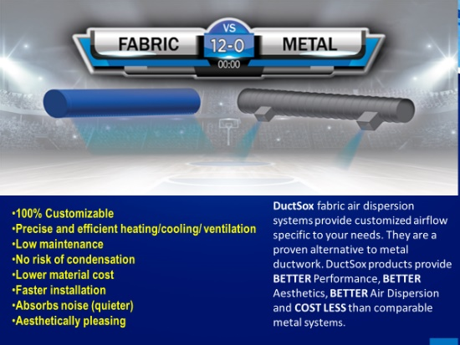

- Pool operational equipment – The filter room is the heart of the facility. There have been many advances in design the past 10 years. There are many professionals that are still designing 20 years in the past. Here are just a few things that need to be assessed:

- Every pool needs (must) have its own dedicated filter system. Pool filters should be Neptune Benson Defender regenerative perlite filters for operational efficiency, clear safe water, and low maintenance.

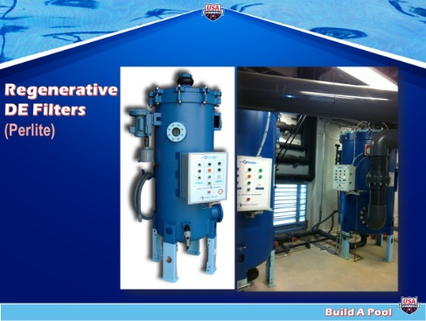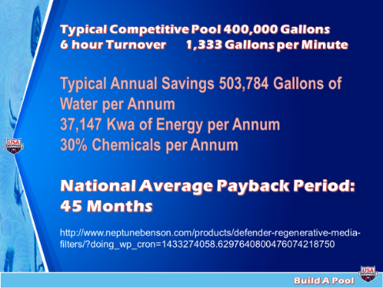

- All indoor pools need Neptune Benson Medium Pressure UV for each pool

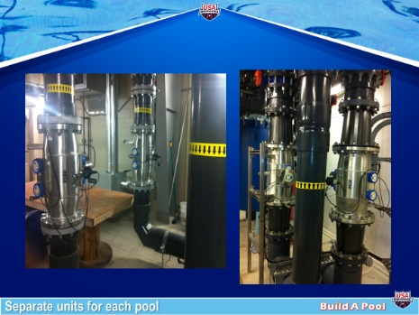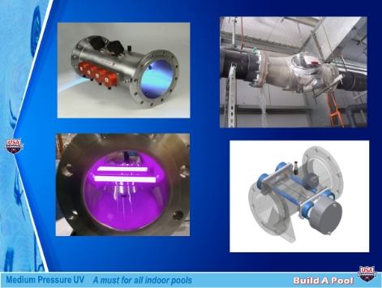

- Pool pumps should be energy saving Variable Speed. All pool heaters should be titanium core and use 2 pool heaters to get the required BTU’s for each pool. That way if one heater fails you can still operate for the couple of weeks it takes to get repair parts for heaters.

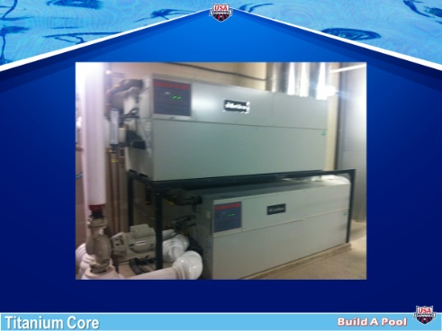

- Filter room design needs to be done by the best aquatic engineers. We recommend you contact Counsilman Hunsaker KevinPost@chh2o.com for all design and aquatic engineering needs.

- The main pool will need stairs and ladder access with an ADA lift. It will have gutters to return water to filter room. The smaller programming pool will have stairs and a ramp for programming access. It will not need a lift if it has the ramp. The programmimng pool if 20’ x 40’ or smaller should have skimmers instead of gutters. They are less expensive to install and offer the advantage of 4” controllable water depth.

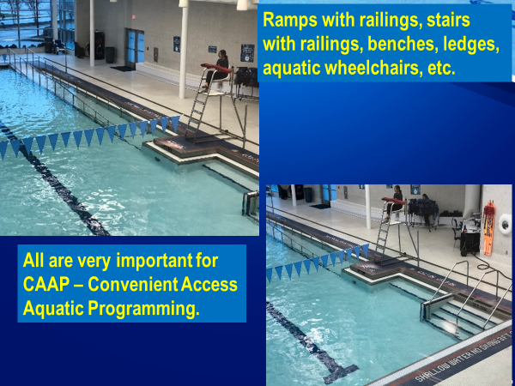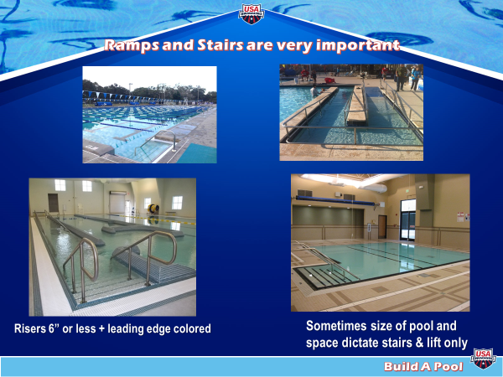

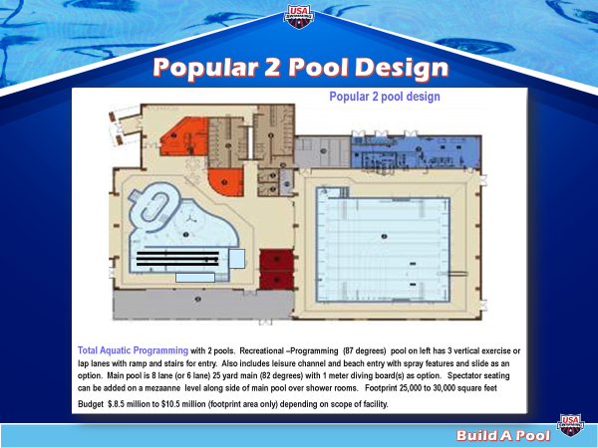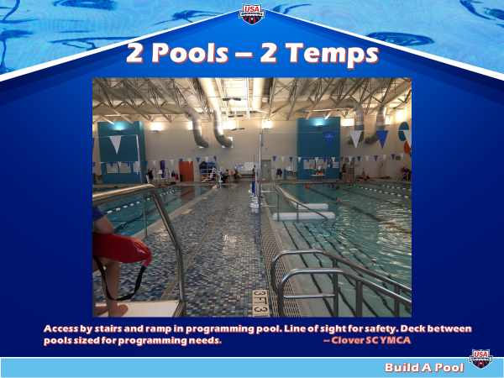

These are just some of the catagories that you need to be aware of.

Please email Mick Nelson mick@totalaquatic.llc for more information.

Programming questions please send to Sue Nelson sue@totalaquatic.llc

