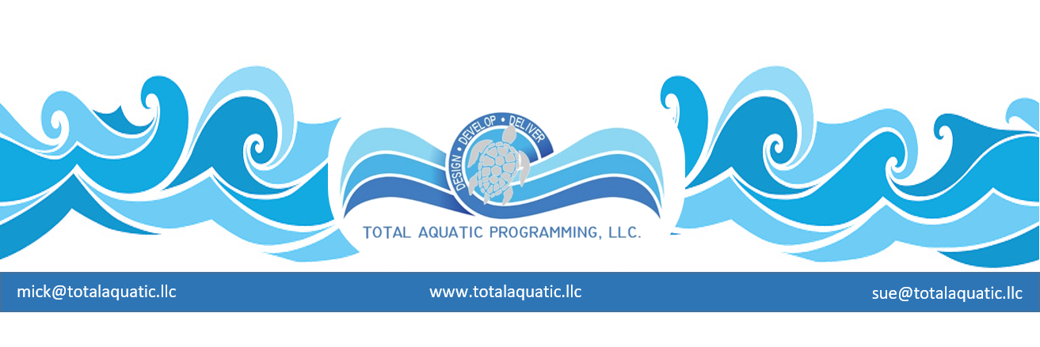

YES – NO – MAYBE SO …….

If you are involved with a project, at some point you may be asked to:
- Do some research and make a report
- Form and opinion
- Possibly make a decision or cast a vote

There are differences between a personal choice and a professional choice; sometimes the differences are subtle and other times they are catalyst for insomnia. You must bring your “A” game to the table when discussing things that will require decisions. Here are a few things that may help:

- The shot clock …. You have to learn to perform under pressure with time constraints. This comes with experience and preparation. It is also easier if you have paid attention to all points of view. Early listening and late talking are key. First notions are many times the best. If you feel you or the discussion is being rushed, slow it down. Maybe even take a 10-minute break to collect your thoughts or have a side-conversation to get more information.

- The big bang …. Out of nothing the universe was created – this project seems just as large, chaotic, and random. You feel you are simply not prepared to make a decision of any magnitude. Ask yourself “who at the table is better qualified”? The answer will probably be that unless a person is in the room with a private agenda, you are all in the same boat. Therefore, meetings are held, and planning is done, to sort things out.

- Use what you have …. Even though you may not be the worlds’ most renowned expert, you bring something useful to the table or you wouldn’t be there. Don’t be afraid to put your “point of view” out there for discussion. Keep personal opinions to yourself and present the opinions you think are best for the project based on your research.

- Don’t be intimidated …. Think about the last time you went to the Doctor or had an appointment with an Attorney. How did you feel? Many people feel inferior because they are in the presence of an “expert”. Well guess what? You can hire and fire the experts if they are not giving you what you want. They are not always right and not always truthful. You have to decide what is best for the project, what is right for those you represent. If you are being told that your wants must give way to someone else’s needs, it is time to STOP and reevaluate. After this you may have to either say or vote NO and go to bat for what is right. You were not drafted to say YES to everything.

- Get ‘er done …. Many times, when issues get discussed and there are a variety of opinions, the inclination is to table the issue until next meeting. This is not always wrong. Sometimes people need to do more research before deciding which way to proceed. But often, if everyone stays with it, the best decision can be reached during the current session. If this was easy, everybody would be doing it. If every time someone has different opinions the decision is delayed, you will be nowhere slowly. The only thing unanimous at most meetings is how long of a lunch to take and when to adjourn.

Having a facilitator with professional expertise (and no private agenda) join the meeting by conference call can be a tremendous asset. For more information contact TAP-LLC mick@totalaquatic.llc

