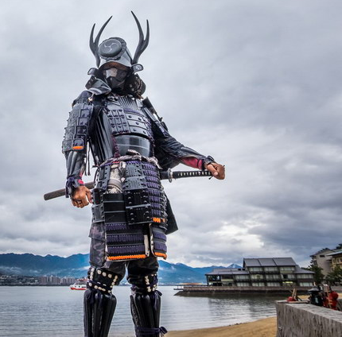
Saturday,
March 14, 2026
2022
Perform your Weapon Kata for Hanshi Ricky Smith
in the AKANA Kobudo Warrior Showdown!
Saturday, March 14, 2026 at SideKick Karate of Salisbury
2600 Cottage Street, Salisbury, North Carolina
Schedule:
Screaming Eagles Test: 12:00 – 2:00 p.m.
Junior and Solid Rank Test: 2:00 – 4:00 p.m.
Beginner, Intermediate, Advanced & Black Belt patches will be awarded. Please read and decide which weapons category you will perform. If you have any questions, consult with a Sensei.
Beginner (2 Kata) Intermediate (5 Kata) Advanced (7 Kata) Black Belt (10 Kata)
Two Weapons ($30) Three Weapons ($50) Four Weapons ($70) Five Weapons ($100)
Bo Pivot Form Bo Pivot Form Bo Pivot Form Bo Pivot Form
Nunchuck Pivot Form Nunchuck Pivot Form Nunchuck Pivot Form Nunchuck Pivot Form
Tonfa Pivot Form Tonfa Pivot Form Tonfa Pivot Form
Butterfly Bo Set (1) Butterfly Bo Set (2) Butterfly Bo Set (3) Bo Kata 1 Bo Kata 1 Bo Kata 1 Sai Pivot Form Sai Pivot Form
Nunchuck Kata 1 Nunchuck Kata 1
Tonfa Kata 1
Sai Kata 1
Kama Pivot Form Adv. Black Belt (+7)
Kama Kata 1
Bo Kata 2
Butterfly Bo Set (4)
Nunchuck Kata 2
Tonfa Kata 2
Sai Kata 2
Kama Kata 2
Test Procedures:
1. This American Open Kobudo test is endorsed by AKANA.
2. Substitution of any Kobudo Kata must be approved by the Head Sensei.
3. If a Kobudo Kata is not performed to belt rank standard, it will not count.
4. Kobudo Kata may have to be performed more than once to pass.
5. Kobudo Kata may be performed in a group or solo depending on participants.
6. If a Kobudo Kata is not counted, the student can try again at a later date.
7. Students who pass will receive an AOKS patch for the level they have obtained.
8. Students will also receive an AOKS certificate for the level they have obtained.
9. Certificates will be signed by GM Jerry C. Piddington, founder of our system.
Earn your Kobudo Patch & Certificate
Helpful Hints:
- Make sure you have practiced the kata you select and feel confident performing it.
- Judges will be looking for things such as strong stances (no bouncing), proper body alignment (posture), proper positioning of the weapon, directing the gaze (focus), and rhythm of the kata (proper speed).
- Make sure you perform your salutation before and after the kata and remember to “Kiai” at the proper places.

