

**1**

**2**

**3**

**4**

COMPANY PR OFILE

**5**

\

**About Us**

**Product & Service**

**Our Partners**

**References**

**Contact Us**



About Us

At Eternix Jordan, we are a leading information technology company dedicated to delivering unparalleled expertise and innovative solutions in the realm of Oracle, Linux, and Virtualization products. Our commitment to excellence empowers businesses to harness the full potential of these cutting-edge technologies, driving growth, efficiency, and competitive advantage.



2

PRODUCT & SERVICE

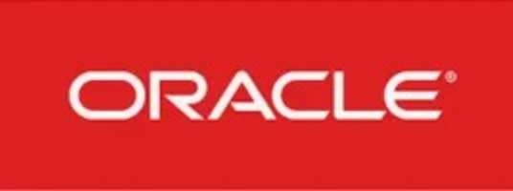

Oracle Database Support, Upgrade, Migration.

Oracle E- Business suite support, administration and upgrade.

Oracle Audit Vault and Database Firewall.

Oracle Database Vault. Oracle Key Vault.

WebLogic.

Oracle Identity Management. GoldenGate.

Oracle Hyperion.

High Availability and Disaster recovery solutions.



Linux administration and support (Red-Hat, Oracle Linux and SUSE ).



Database Installation and Configuration.

Database Design and Development.

Performance Monitoring and Optimization.

Backup and Recovery.

Security and Compliance.

High Availability and Replication.

Database Maintenance.



KVM installation and Administration.

Migrating from virtual machines to KVM.



Eternix Solutions offers comprehensive outsourcing services tailored to meet the dynamic needs of modern businesses. With a proven track record in delivering cost-effective and scalable

solutions, we specialize in outsourcing IT functions such as software development, technical support, virtualization and operating systems. Our approach combines deep industry expertise

with cutting-edge technology to ensure seamless integration and superior performance. Whether you are a startup looking to accelerate growth or a large enterprise seeking to optimize

operational efficiency, our outsourcing services provide flexible and scalable solutions that drive innovation and deliver tangible business results. Partner with Eternix Solutions to streamline

your operations, reduce overhead costs, and gain a competitive edge in today's digital landscape.



3

Our Partners

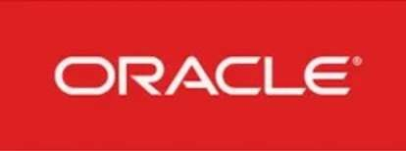



4

References



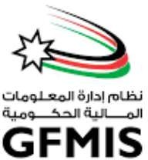



 





5

Contact Us

**Eternix Jordan**

**Amman Gate, Queen Zein Al-Sharaf Street, Amman, Jordan**

**E mail:** [**info@eternix-jo.com**](mailto:info@eternix-jo.com)

**+962 6 200 1 409**

**+962 79 09 1 2320**