BEAR AFFAIR
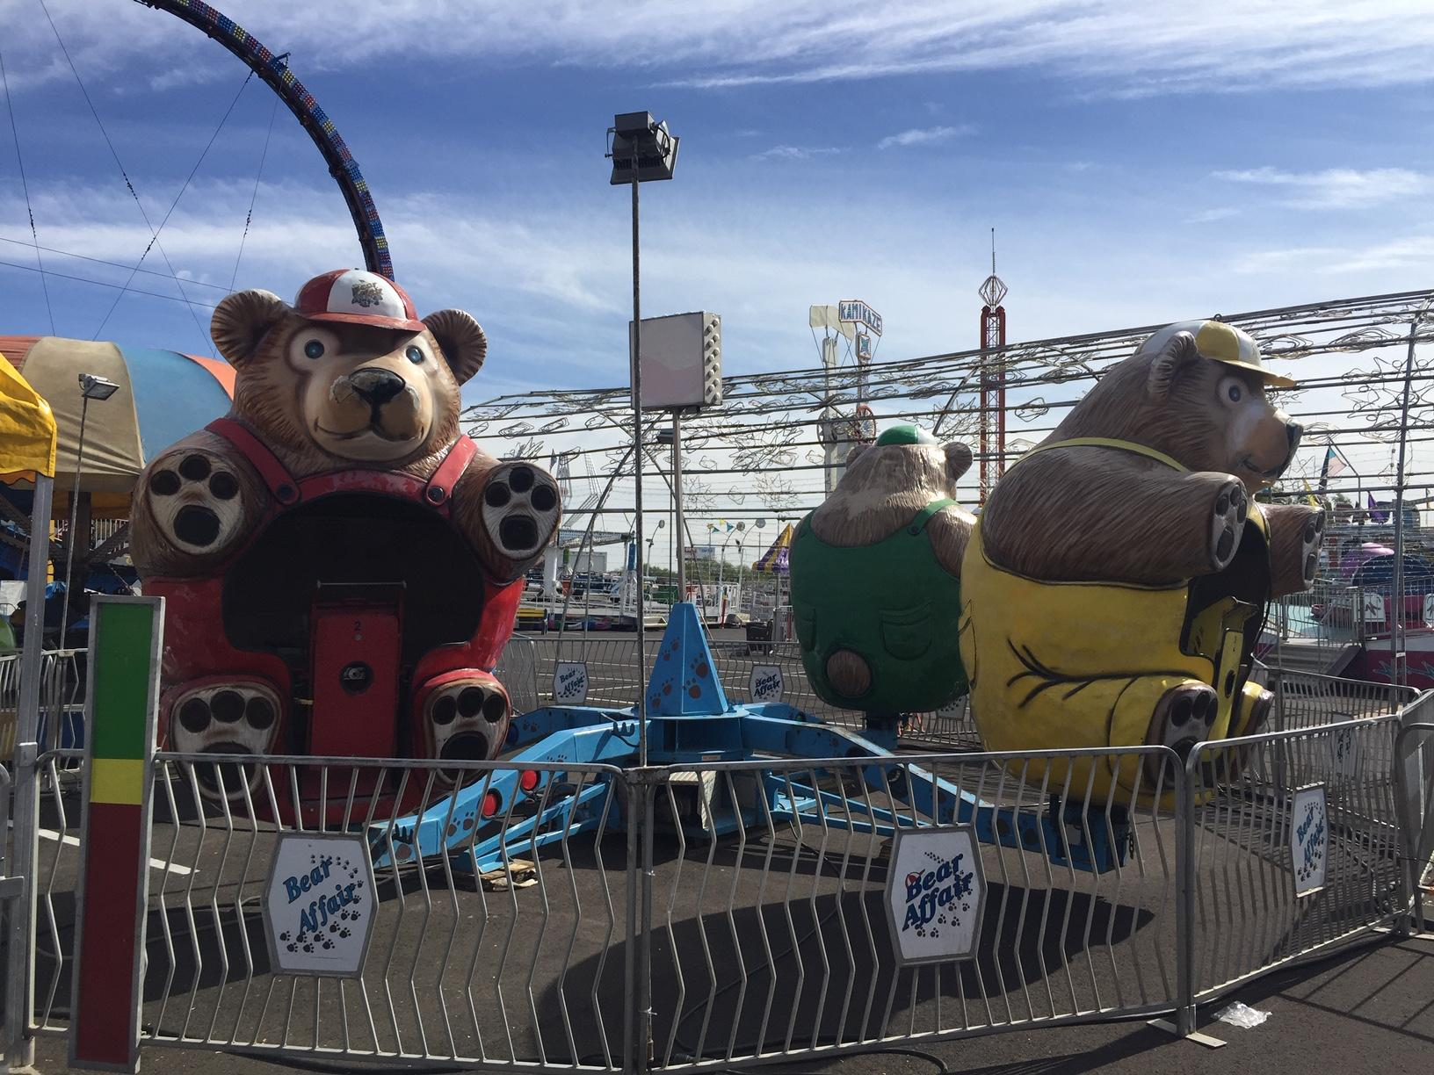

The Bear Affair is a Larson International, Inc. interactive spin ride with the friendliest looking bears you have ever seen. Once the ride begins, the entire structure rotates and guests can begin spinning each vehicle independent of one another. The faster you spin the more dizzying the views become. The ride finally comes to a stop and guests see if they can walk straight after exiting the ride. The Bear Affair is a children's ride which easily accommodates adults as well. With its interactive spinning action it is already a proven winner.

RIDER REQUIREMENTS
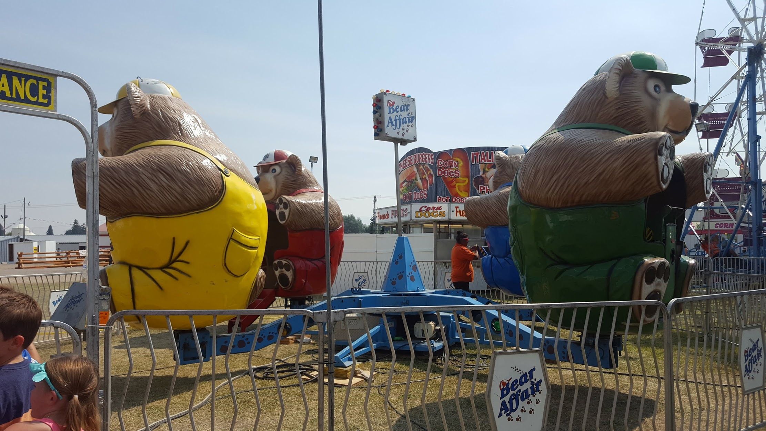
Minimum Height- With Adult Supervision Minimum Height Without Supervision- 36”

Maximum Weight Per Dragon- 800 lbs.

HEIGHT
10′ 7″

DIAMETER
24′ 6″

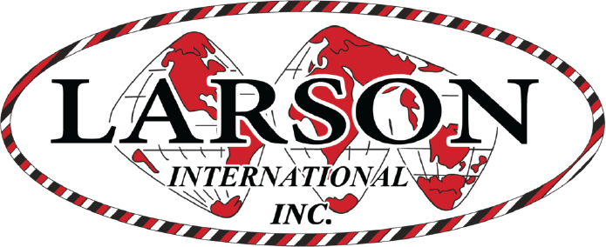
WEIGHT
5280 lbs

MANUFACTURE
Larson International

Bear Affair
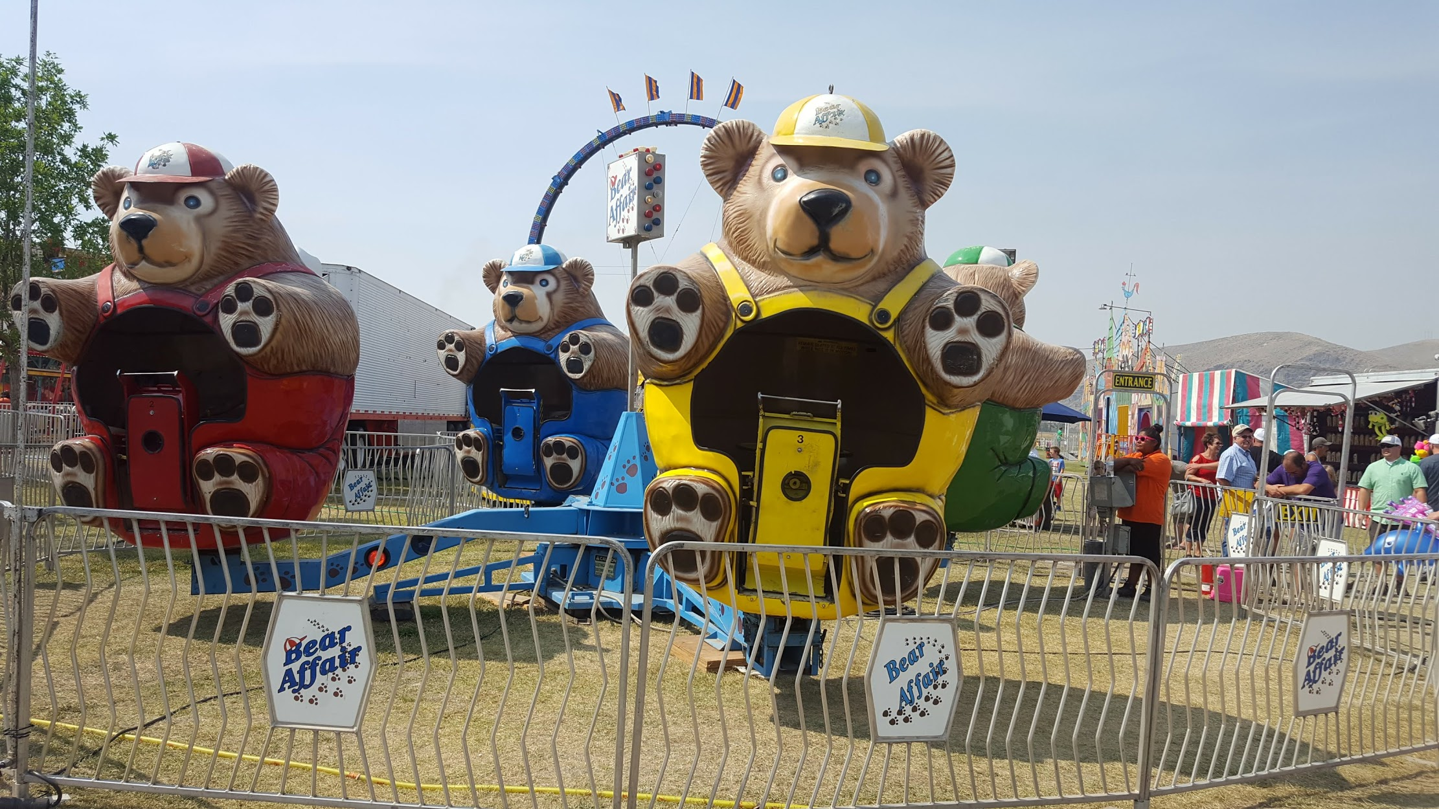

DREAMLAND CARNIVAL COMPANY
bRIDGER, MT

