CASINO
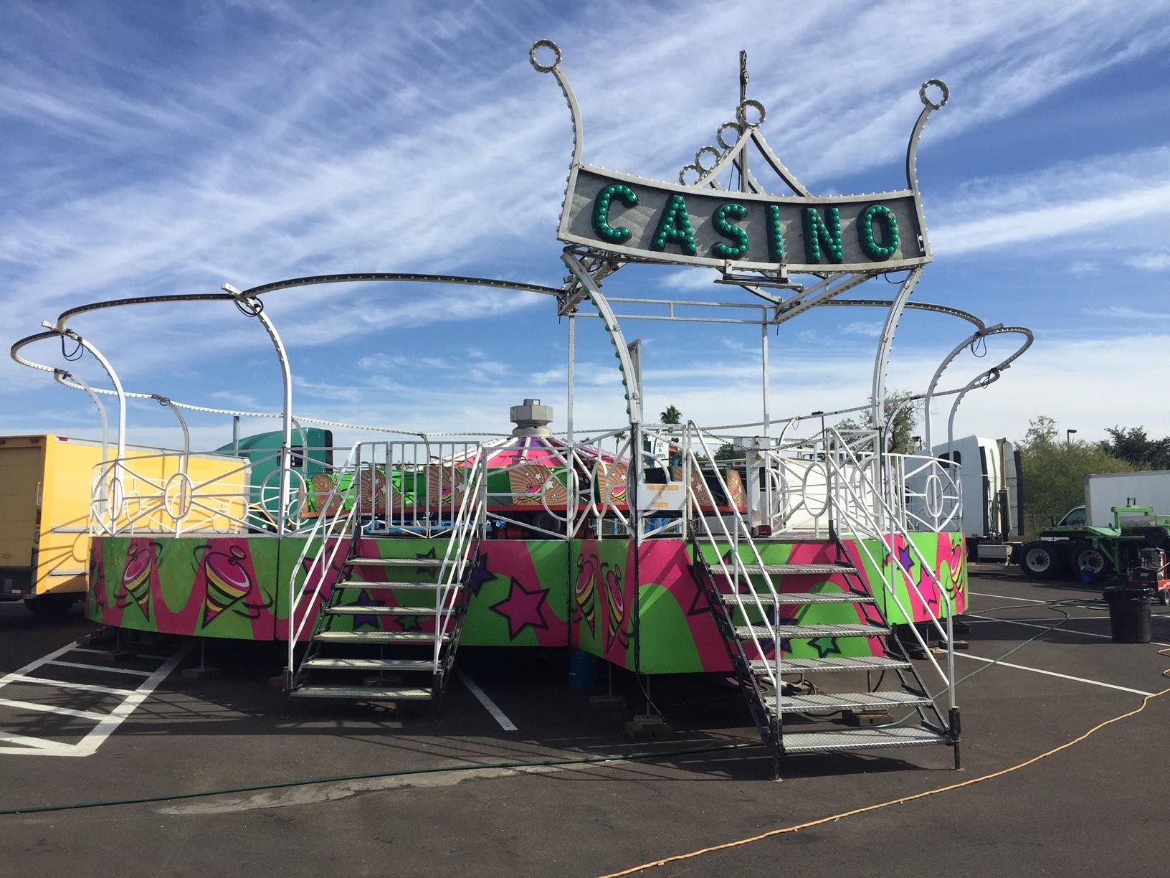

During the duration of the ride, the ride changes speeds. When the ride is fluctuating in its wavelike manner, the person will feel like the ride is not going that fast. However, when the ride is almost over, the person will feel forces on their body, and get pushed toward the outside of the cars.

RIDER REQUIREMENTS
Minimum Height- 42” With Adult Supervision
Minimum Height- 48” Without Adult Supervision
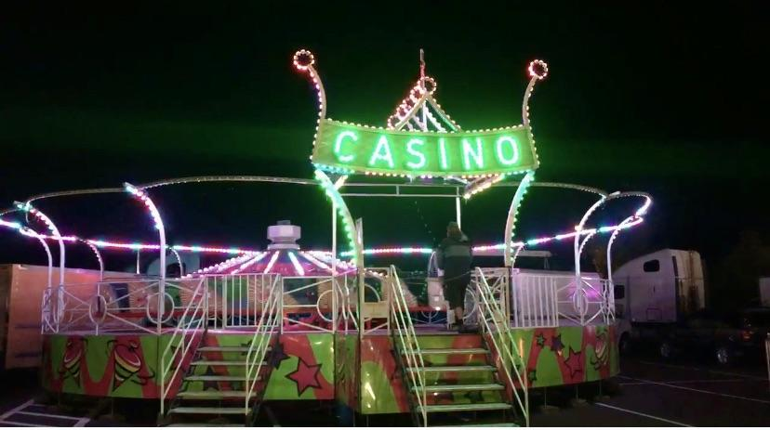

FRONT
44’

DEPTH
54’

HEIGHT
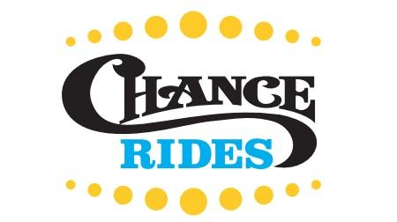
29’

MANUFACTURE
Chance Rides

Casino

DREAMLAND CARNIVAL COMPANY
bRIDGER, MT

