COMING SOON

HILLBILLY TRAIN

The Hillbilly Train is an SBF made ride that is coming to North Star Amusements in 2020. This ride is fun to take the kids on. It’s brand new to North Star Amusements!
​
The Hillbilly Train entertains customers of all ages. Young and old alike get great pleasure from this spectacular ride.
​
HEIGHT REQUIREMENTS
With Adult Supervision
​Must be 36" Without Adult Supervision

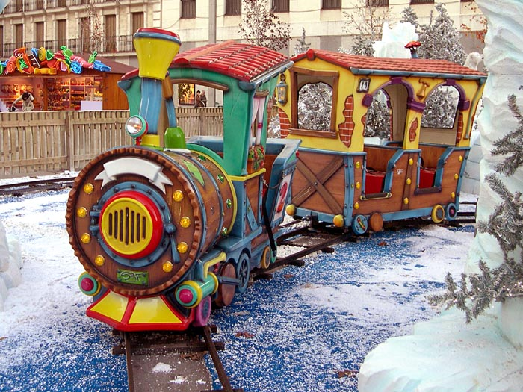
DIMENSIONS
Size: 230x100x190 cm
Engine
Seats / 2
Weight
200 kg
Wagon
Seats / 4
Weight
170 kg

Hillbilly Train

NORTH STAR AMUSEMENTS
bRIDGER, MT

