GRANNY BUGS
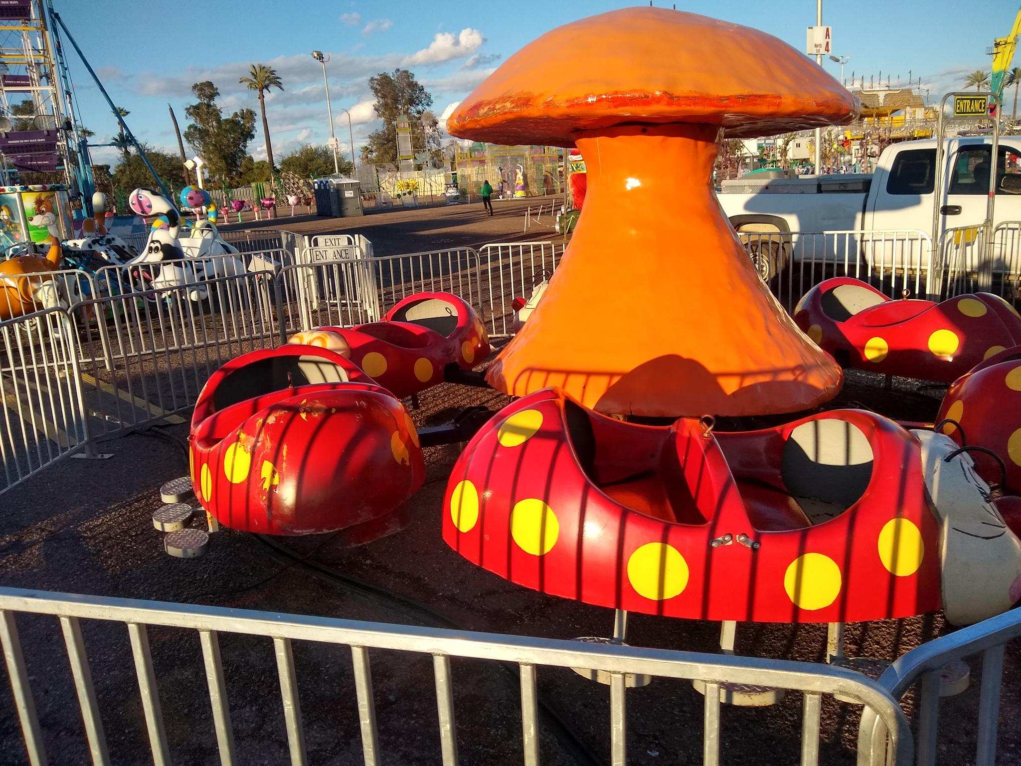

Kids love to ride inside the cute lady bugs at Dreamland Carnival Company! These bugs are arguably the cutest attraction on our midway!

RIDER REQUIREMENTS
Minimum Height- 32”
Maximum Height- 52”
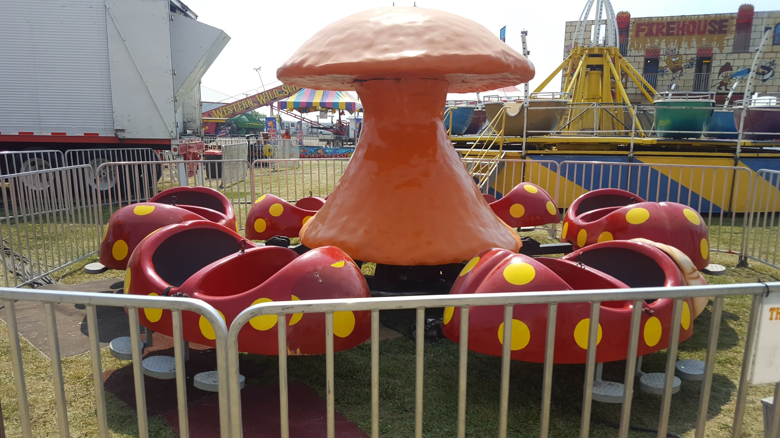

DIAMETER
26’

WIDTH
26’

CAPACITY
400/hour

MANUFACTURE
Venture

Granny Bugs

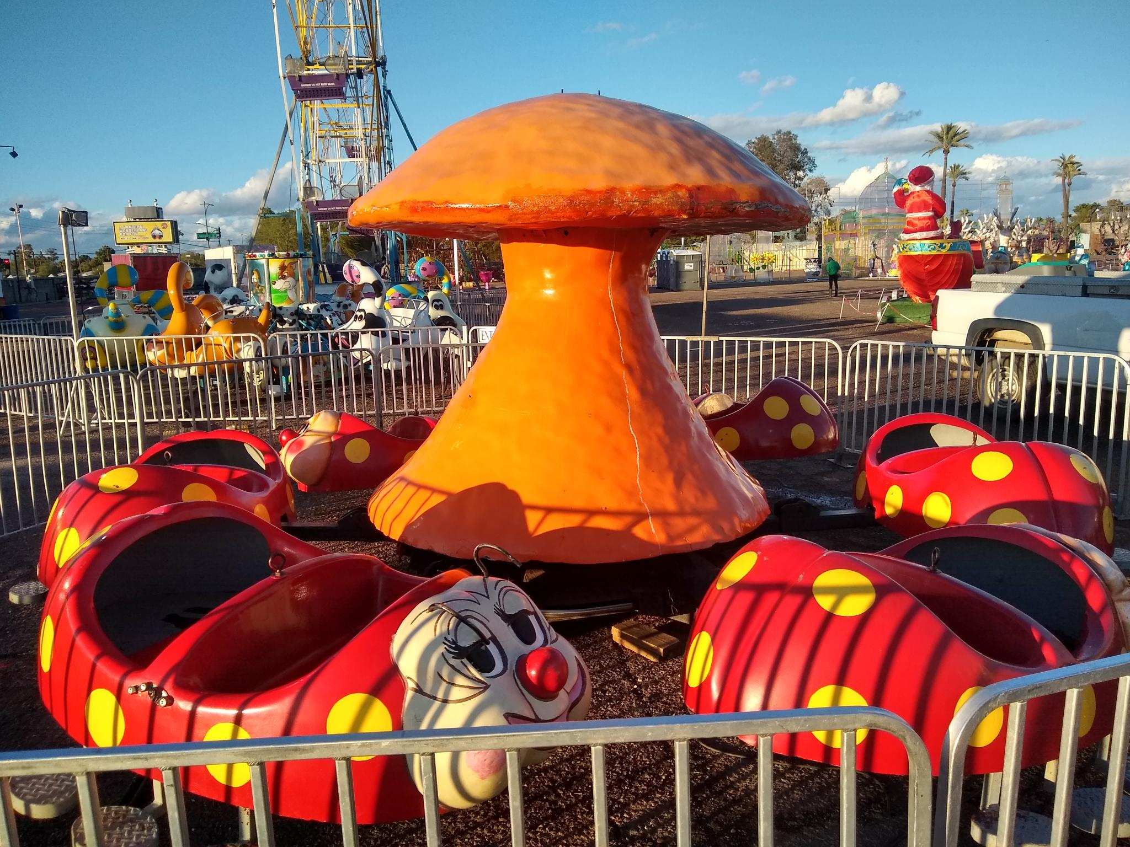
DREAMLAND CARNIVAL COMPANY
bRIDGER, MT

