High Roller
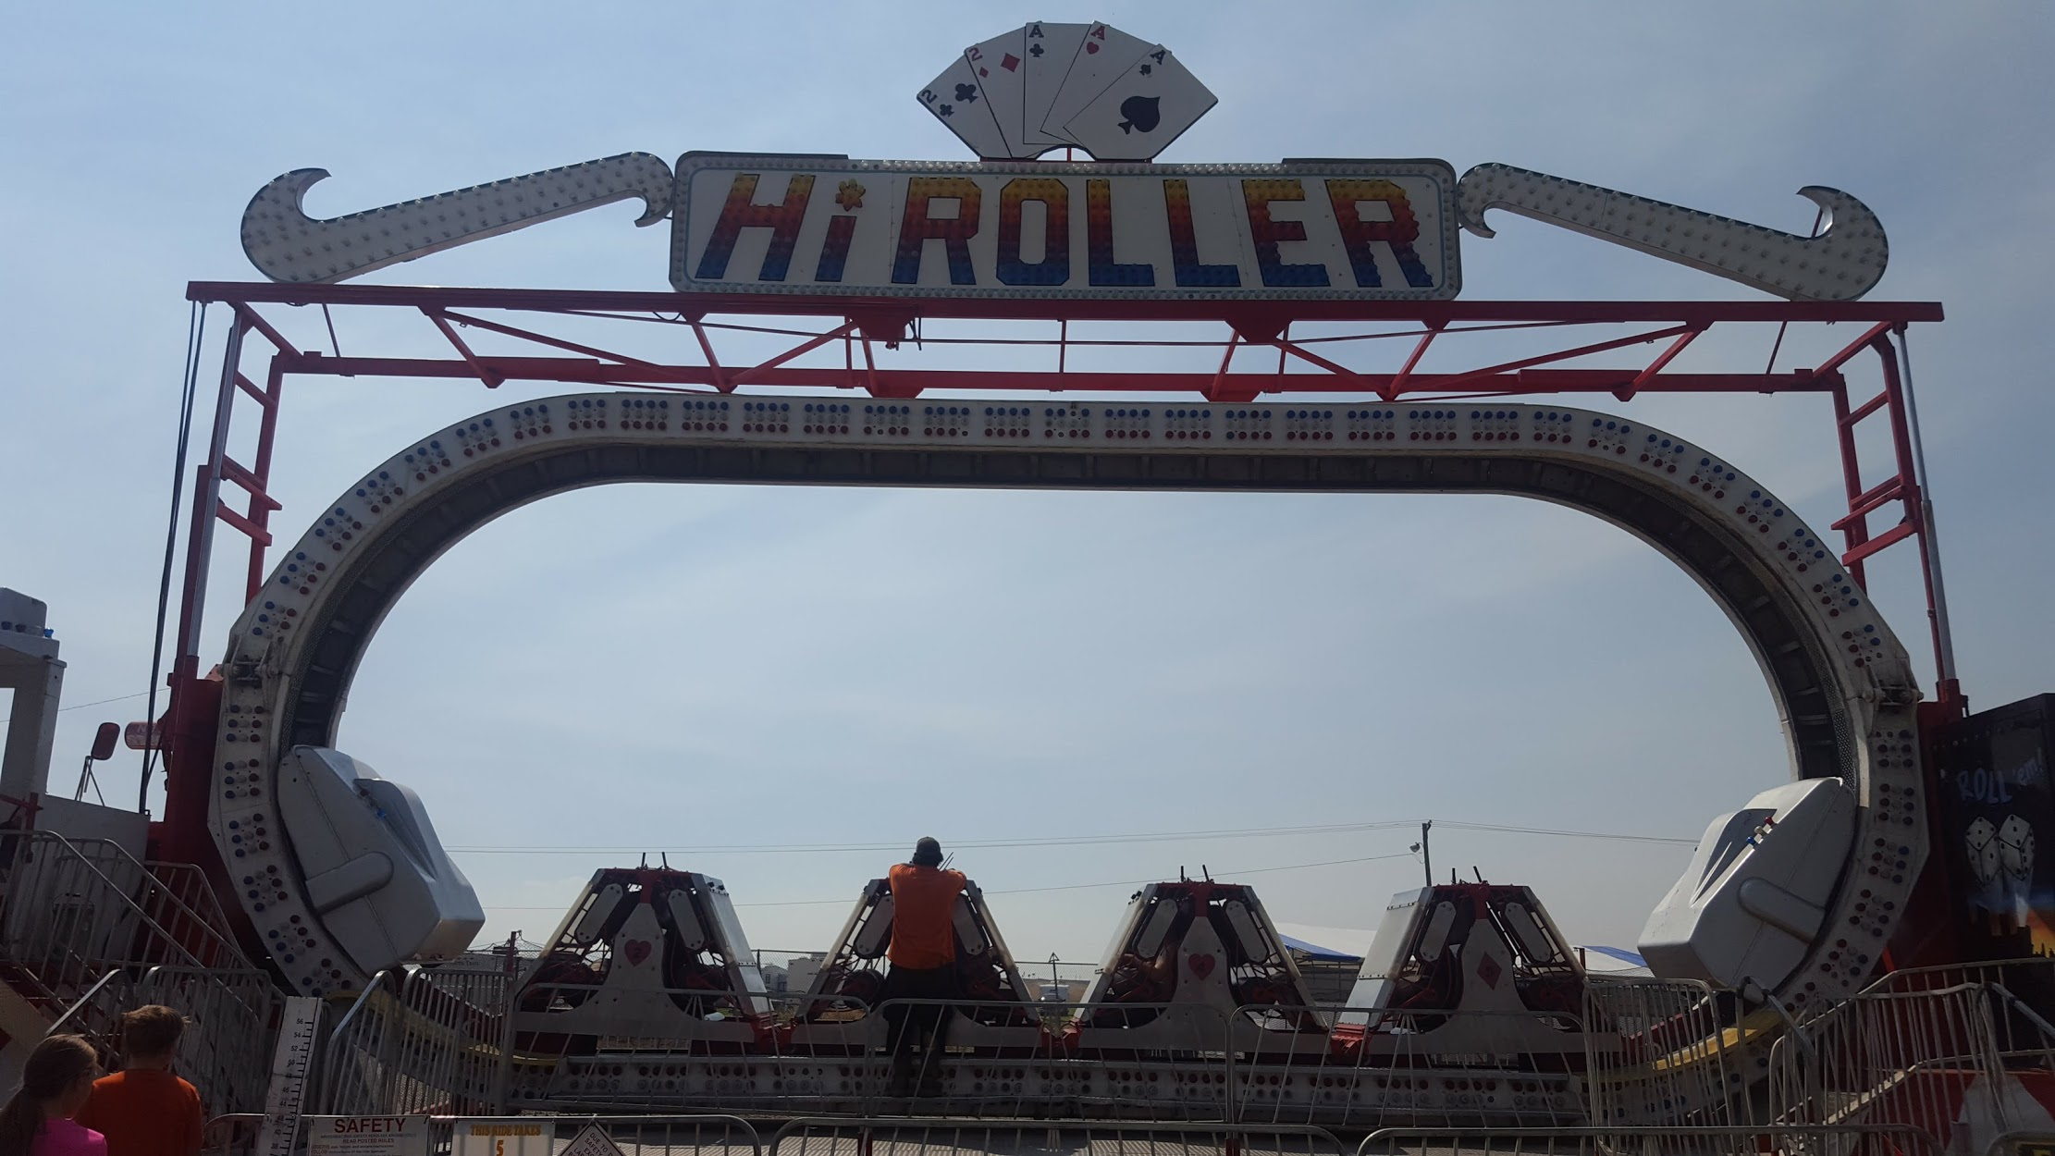

Riders sit in a train that goes around an oval shaped track. While the train moves along the track, the track rotates in a circle! Riders get to go around the circle and even upside down!
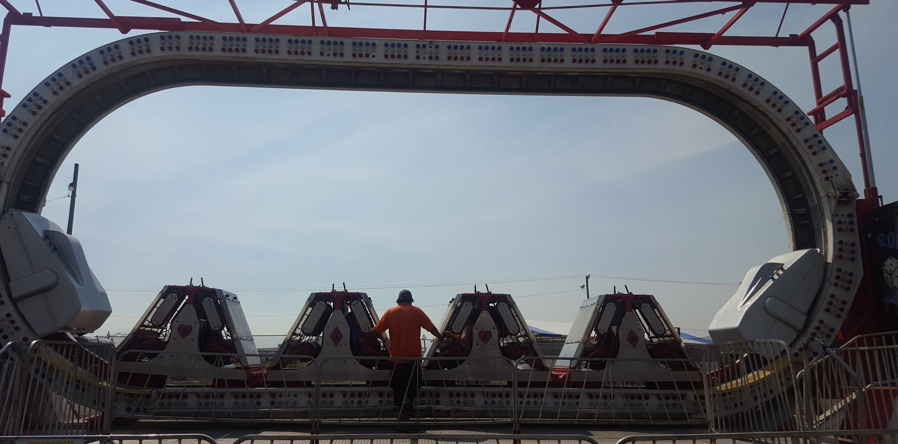

RIDER REQUIREMENTS
Minimum Height- 48”

HEIGHT
42’

WIDTH
39’

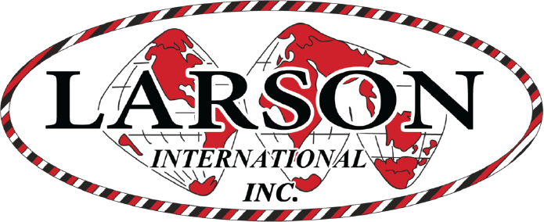
PASSENGER
20

MANUFACTURE
Larson International
High Roller

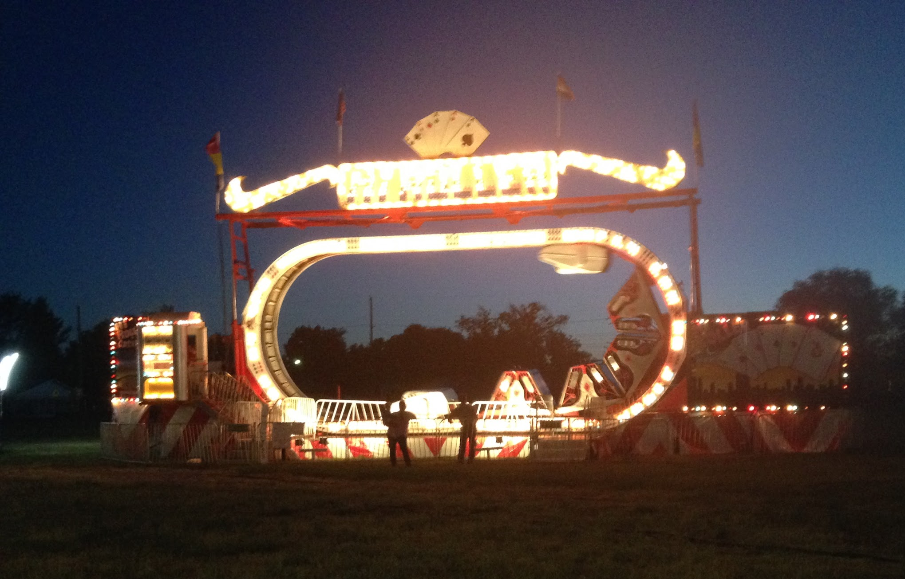

DREAMLAND CARNIVAL COMPANY
bRIDGER, MT

