MARDI GRAS
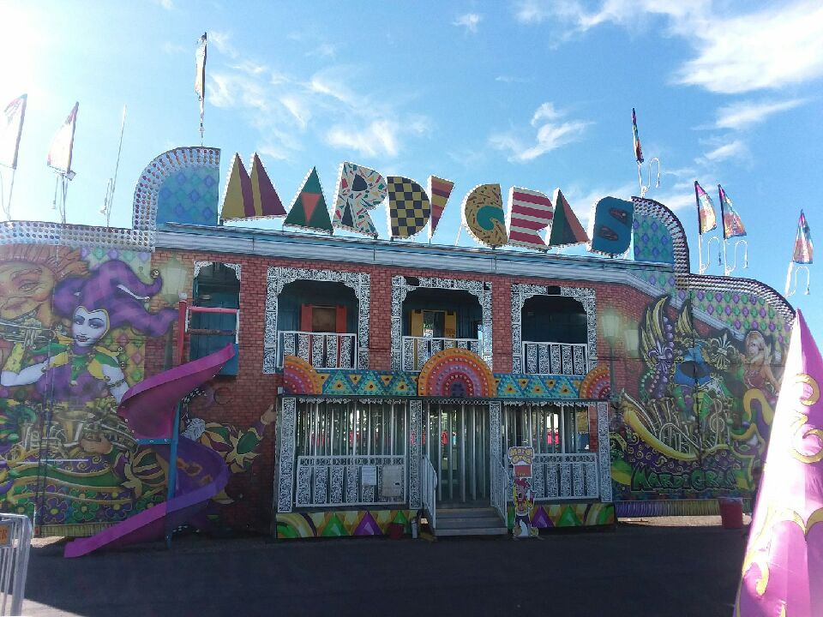

The Mardi Gras Funhouse is a two story fun house that has great tricks and interactive features including a spiral slide at the end. The Mardi Gras funhouse is a mirror maze! This funhouse is sure to be a hit with all the kids!

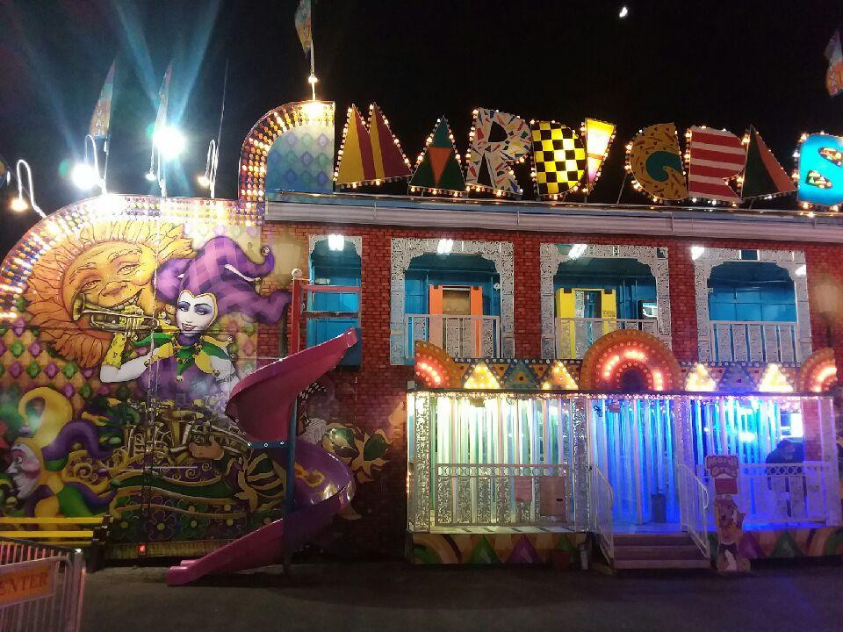
PARTICIPANT REQUIREMENTS
Minimum Height- With Adult Supervision
Minimum Height Without Supervision- 42”
TRANSPORT
1 Trailer

LENGTH
48 Feet

MANUFACTURE
Owens Trailers



Mardi Gras

DREAMLAND CARNIVAL COMPANY
bRIDGER, MT

