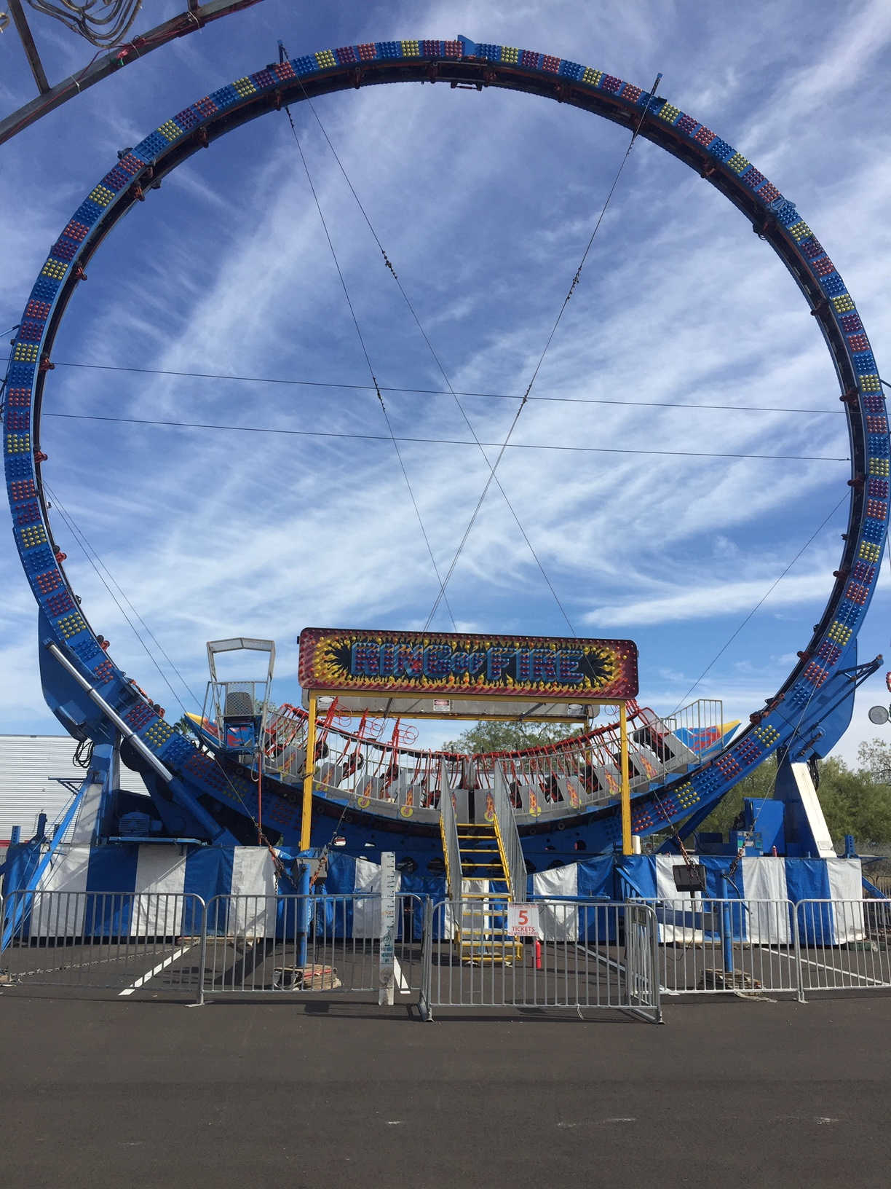
RING OF FIRE

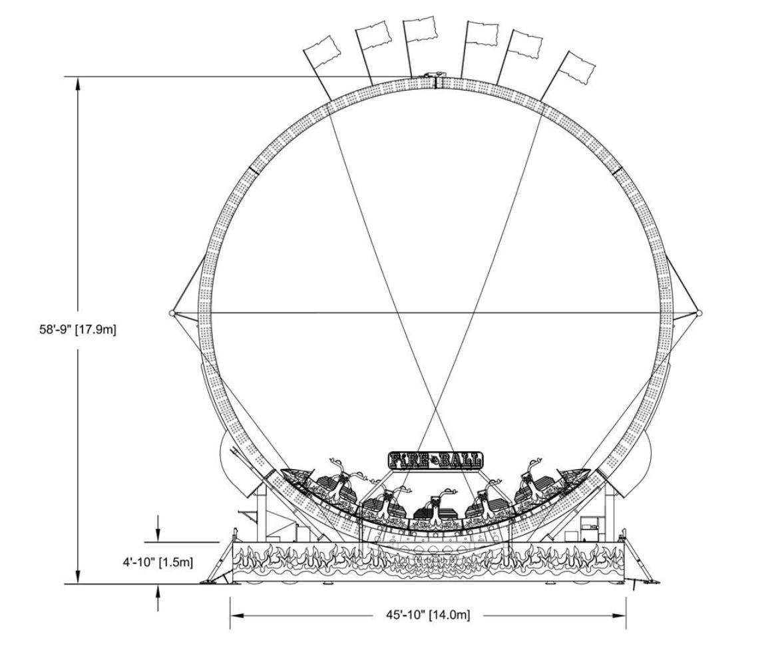
The Ring of Fire is a compact looping – reversing roller coaster. No lift hill or large space is required for this proven thrill ride. Customers will be thrilled with the rocking anticipation of going higher and higher until the train gathers enough momentum to go over the top. Once you experience full speed revolutions, the ride then stops upside down momentarily and reverses direction.

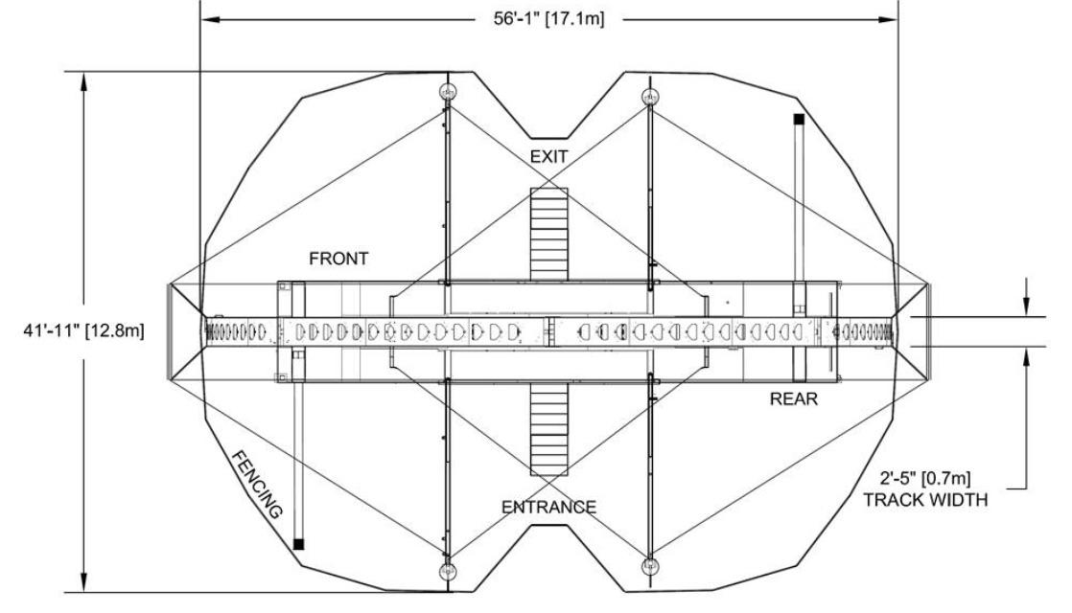
RIDER REQUIREMENTS
Minimum Height- 42”

HEIGHT
59’

WIDTH
39’

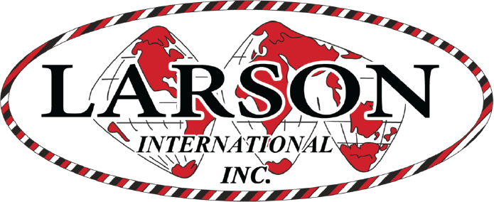
LENGTH
58’

MANUFACTURE
Larson International
Ring of Fire
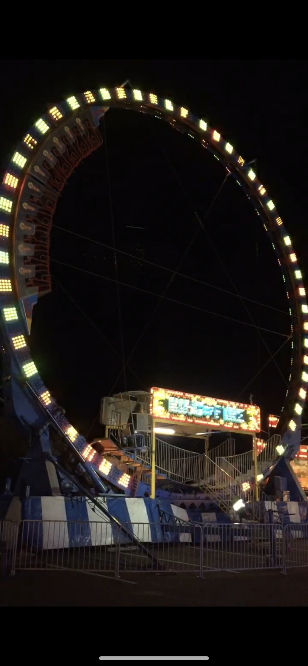
DREAMLAND CARNIVAL COMPANY
bRIDGER, MT

