SUPER TILT
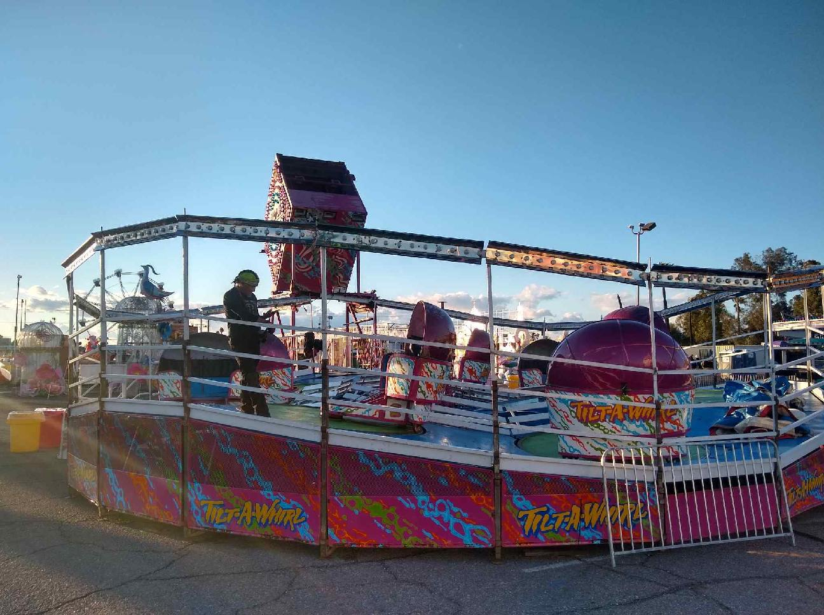

The Super Tilt is a classic amusement ride in which passenger tubs rotate around a circular track as the platform moves through hills and valleys. Each vehicle spins on its own axis and depending on the weight location of each guest every thrilling ride is unique.

RIDER REQUIREMENTS
Minimum Height- 38”
Minimum Height Without Supervision- 46”
Maximum Weight Per Car- 600 lbs.

HEIGHT
12’ 4”

DIAMETER
43’

CIRCUMFERENCE
135’

MANUFACTURE
Wisdom Rides
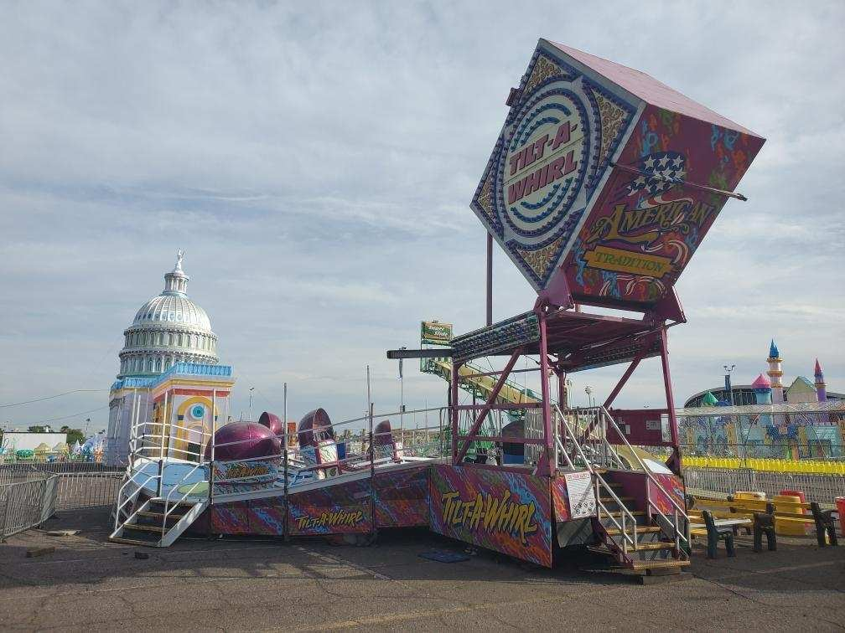
Super Tilt

DREAMLAND CARNIVAL COMPANY
bRIDGER, MT

