WESTERN TRAIN
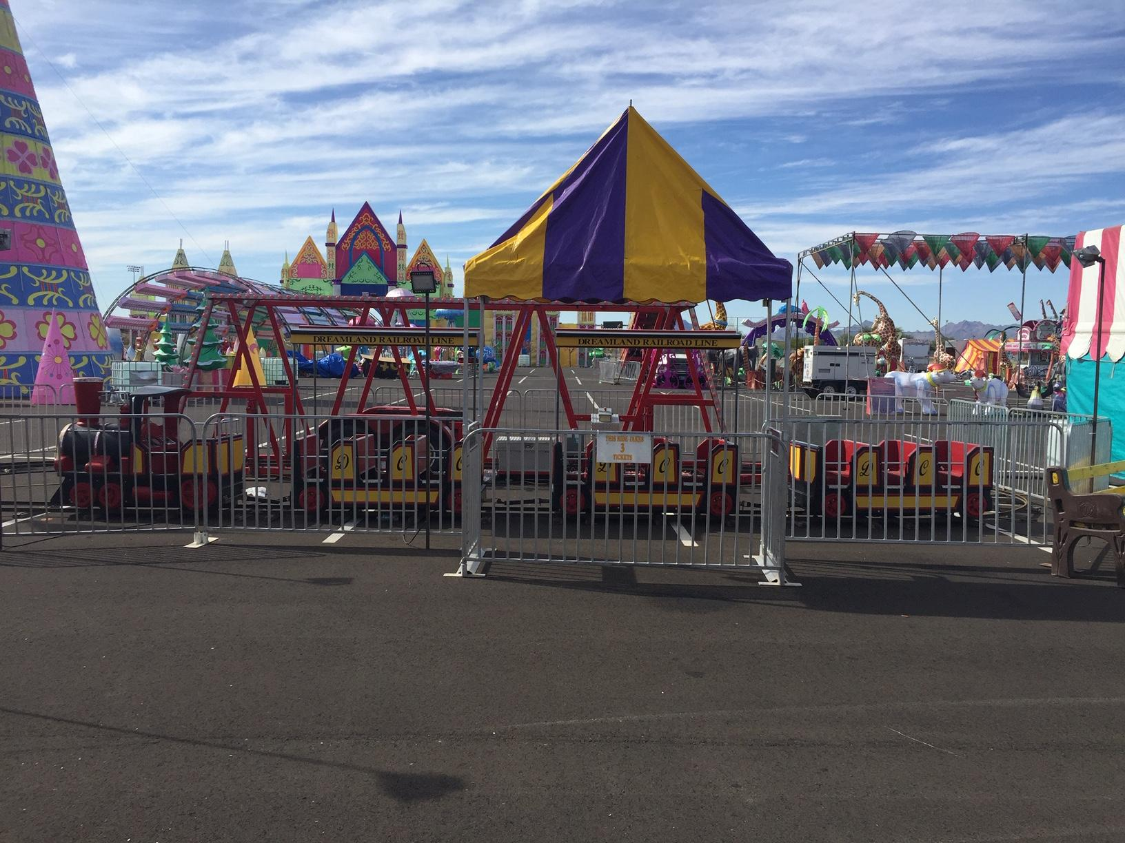

The Western Train is a ride that entertains customers of all ages. Young and old alike get great pleasure from this spectacular ride.

HEIGHT REQUIREMENTS
With Adult Supervision
​Must be 36" Without Adult Supervision
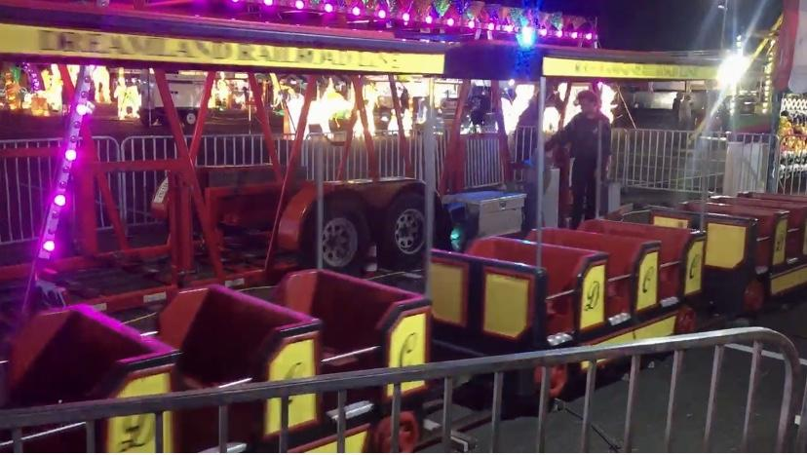
DIMENSIONS
Size: 230x100x190 cm
Engine
Seats / 2
Weight
200 kg
Wagon
Seats / 4
Weight
170 kg

Western Train

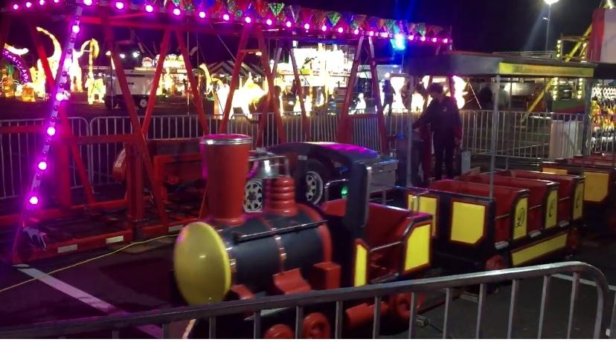
DREAMLAND CARNIVAL COMPANY
bRIDGER, MT

