WESTERN WILD SLIDE
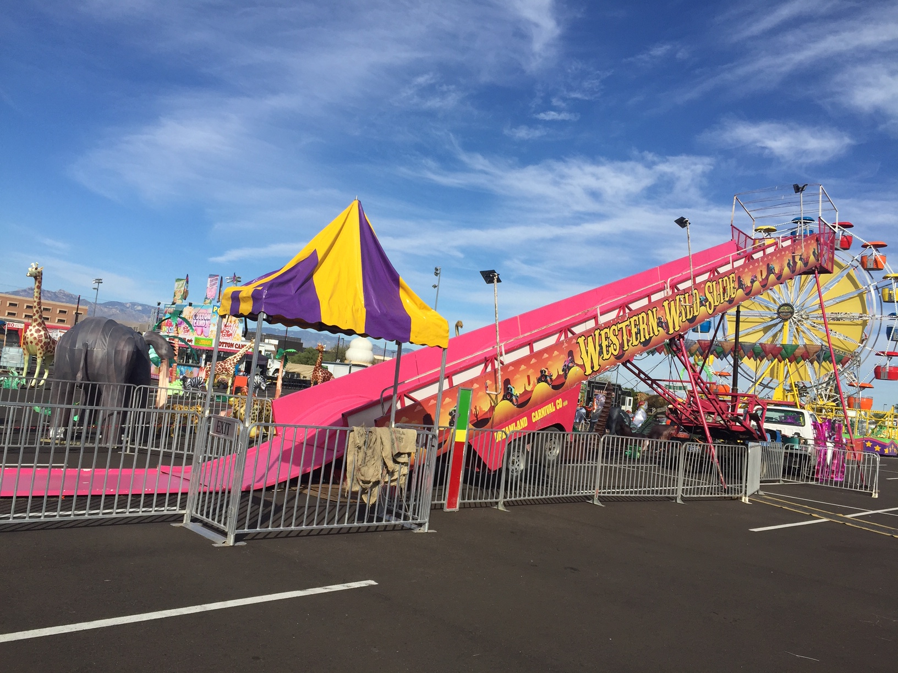

This is not your traditional playground slide! Our slide has three lanes and is over 90ft long! All kids enjoy this massive slide!

RIDER REQUIREMENTS
Minimum Height- With Adult Supervision
Minimum Height Without Supervision- 42”

HEIGHT
90’

WIDTH
16’

HEIGHT
32’

WEIGHT
9,000 lbs

MANUFACTURE
Kalinski

Western Wild Slide

DREAMLAND CARNIVAL COMPANY
bRIDGER, MT

