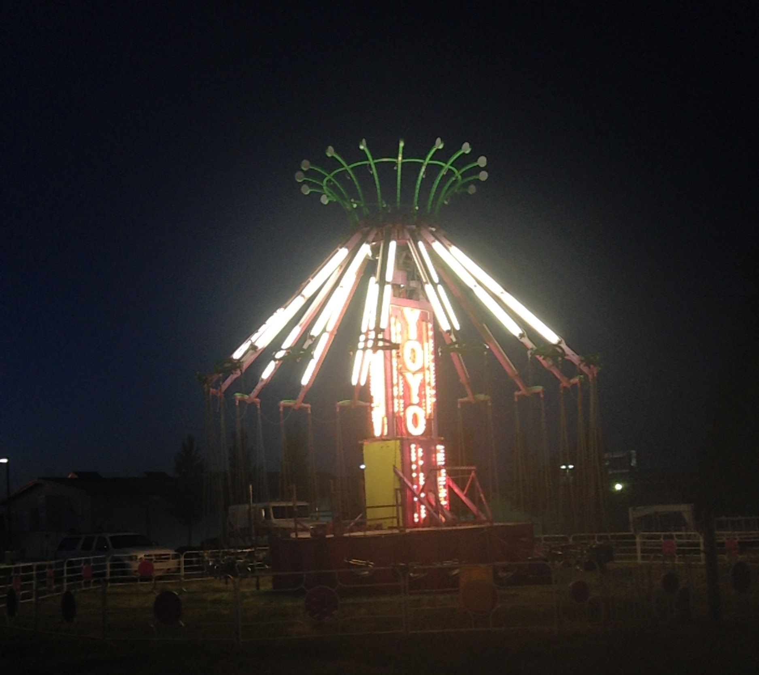
YO YO

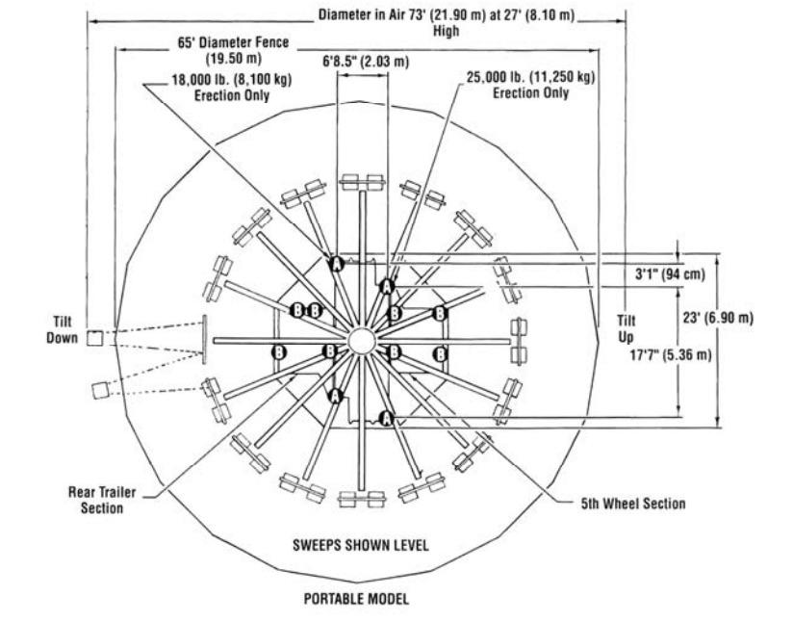
Like the fanciful flight of a whirlwind, the Yo-Yo spins riders through the sky, creating a delightful feeling of freedom. This fun ride dangles riders in 32 self-loading swings for high-flying action. Its high visibility entices both kids and adults.

RIDER REQUIREMENTS
Minimum Height- 42”
Average Weight Per Seat- 170 lbs.

RIDE SPEED
10 RPM

WEIGHT
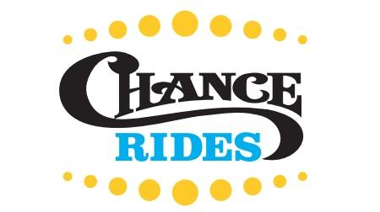
43,000 lbs

MANUFACTURE
Chance Rides

Yo Yo
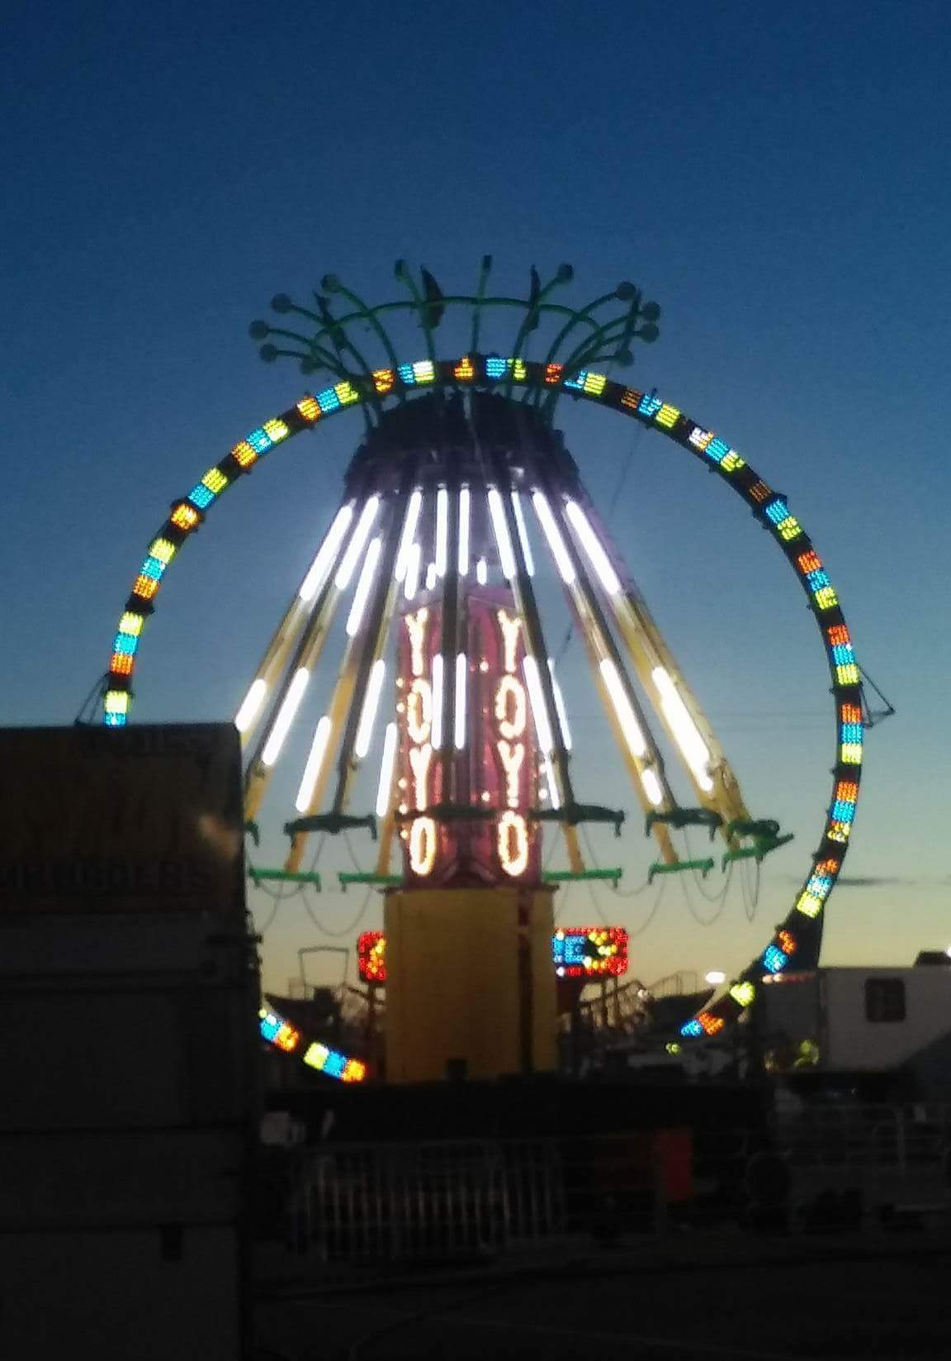
DREAMLAND CARNIVAL COMPANY
bRIDGER, MT

