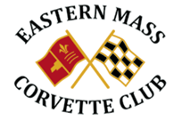

January 2019 Events

1/18 Barrett Jackson Night at Ed Forsberg’s house, 6:00pm – 10:00PM 360 High Street Walpole 508-668-4202, BYOB, $20 each, pizza, snacks Friday

1/19 NE Auto Show, Boston Convention Center, contact Frank 508-509-0267 frankf@comcast.net Saturday

1/28 Board Meeting 5:30pm Conrad’s

2/4 Membership Meeting 7:00pm Conrad’s

