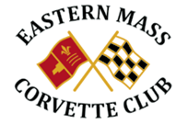

April 2019 Events

4/1 Membership Meeting 7:00pm Conrad’s

4/7 Best Chevy: Techs, Corvettes, Coffee 8:00 – 11:00am

4/11 Bass Pro Opening Day 3:00 – Dusk.

4/25 Bass Pro

4/27 Wash N Shine Pinch’s Garage 1420 Main Street, Rte. 109 Millis, 9:00 – Noon. Coffee, donuts, snacks.

4/29 Board meeting Conrad’s 5:30pm.

April starts static cruises, King Street Café Franklin. 4 – Dusk.

