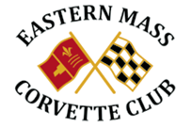

**May 2019 Events**

**5/2 Open cruise**

**5/4 Blessing of the Vettes 10 – 2:00 Corvette Mikes**

**5/6 Membership Meeting 7:00pm Conrad’s**

**5/7 Static Cruise Tuesday, King Street Café, Franklin**

**5/9 Bass Pro 3:00 – Dusk.**

**5/14 Pizza Static Cruise Tuesday around 4:30pm**

**5/16 Ice Cream Machine leave Lake Pearl 6:00pm**

**5/23 Bass Pro**

**5/27 Board meeting Conrad’s 5:30pm.**

**5/30 Firepit at Steve Wilson house 4:00 bring apps. 15 Lantern Lane, Wrentham**

**6/3 Membership Meeting 7:00pm Conrad’s**