JANUARY, 2019  AS A THANK YOU FOR BEING A LOYAL CUSTOMER WE WOULD LIKE TO OFFER YOU $20 OFF YOUR NEXT SERVICE CALL! JUST MENTION NEWS20 WHEN YOU SCHEDULE YOUR APPOINTMENT.  SAVINGS  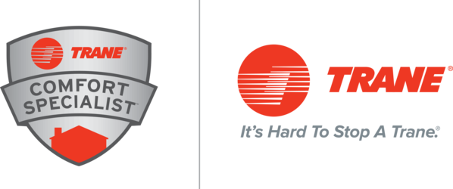 | 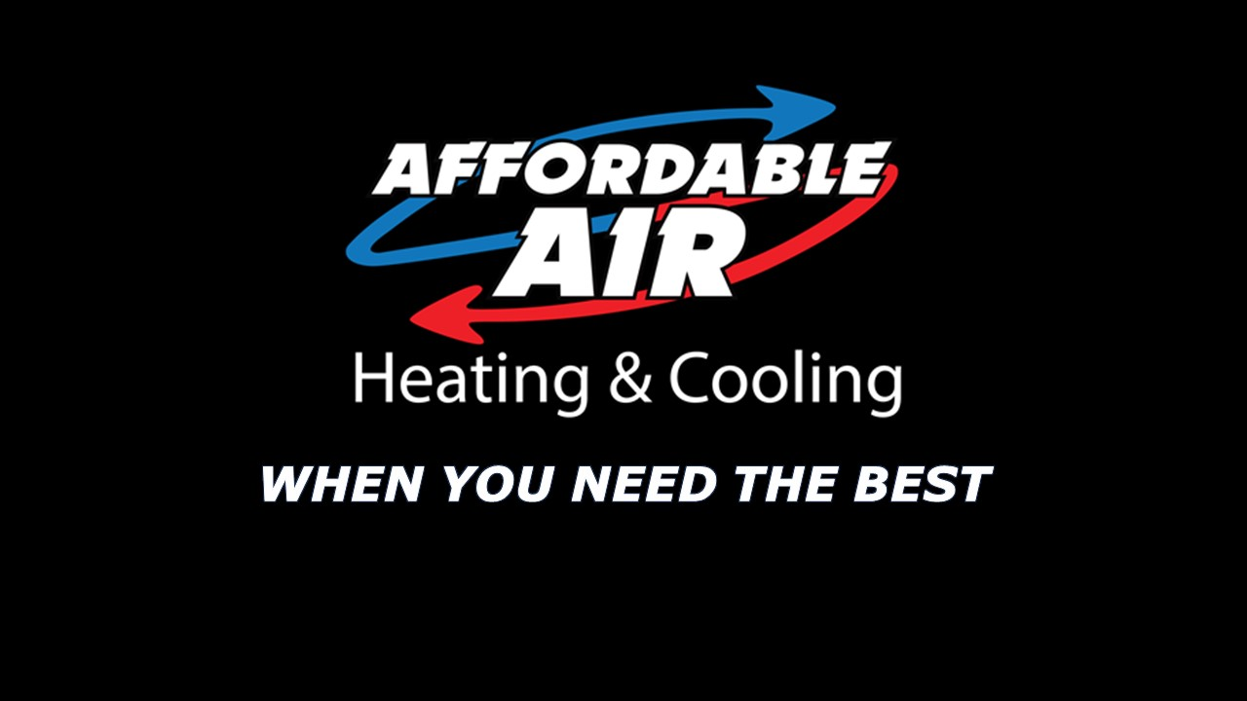  NEWS…  WELCOME 2019!  Where did 2018 go? It was a fantastic year here at Affordable Air, and we hope you had a fantastic year as well. We had a record-breaking year here and are working toward growing even more in 2019. We look forward to working with all of you again. Thank you for being loyal customers and we can’t wait to see you again!

- Contact Us  AFFORDABLE AIR HEATING & COOLING  949 E. MAIN STREET  CHILLICOTHE, OH 45601  740-779-0079  www.AffordableAirChillicothe.com  License #46265 | AFFORDABLE AIR CHRISTMAS PARTY  AFFORDABLE AIR IS A FAMILY AND WE LOVE TO CELEBRATE THAT FACT TOGETHER. OUR ANNUAL CHRISTMAS PARTY WAS ONCE AGAIN A HUGE SUCCESS.  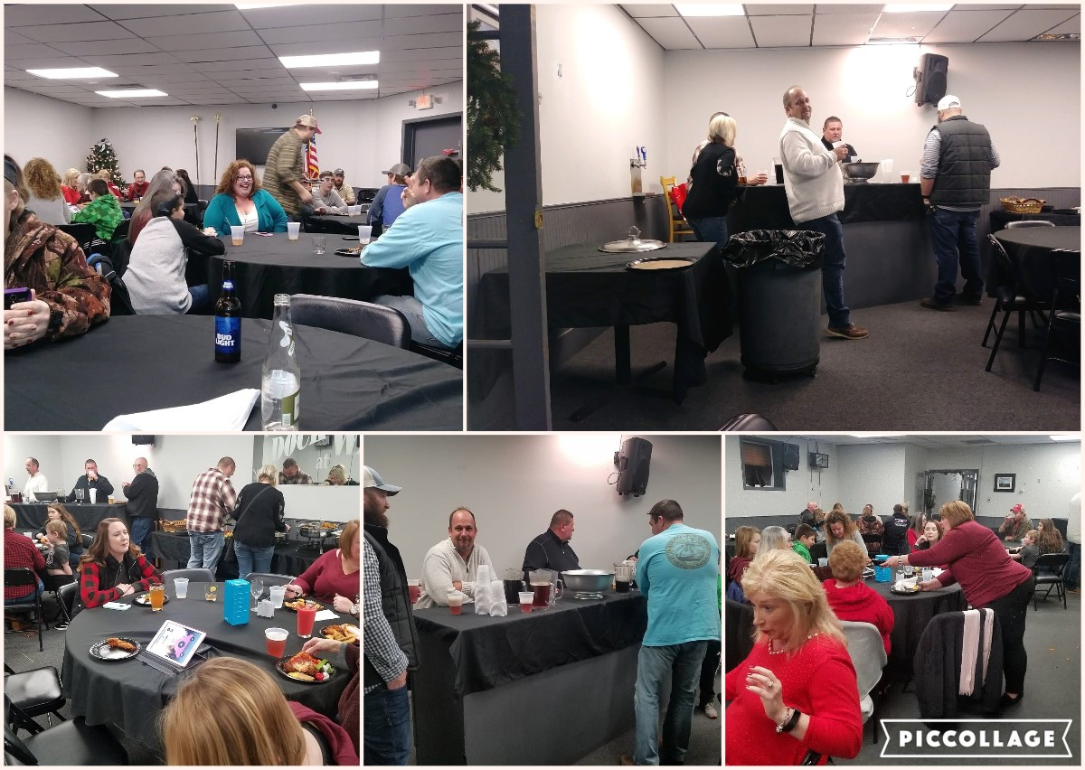  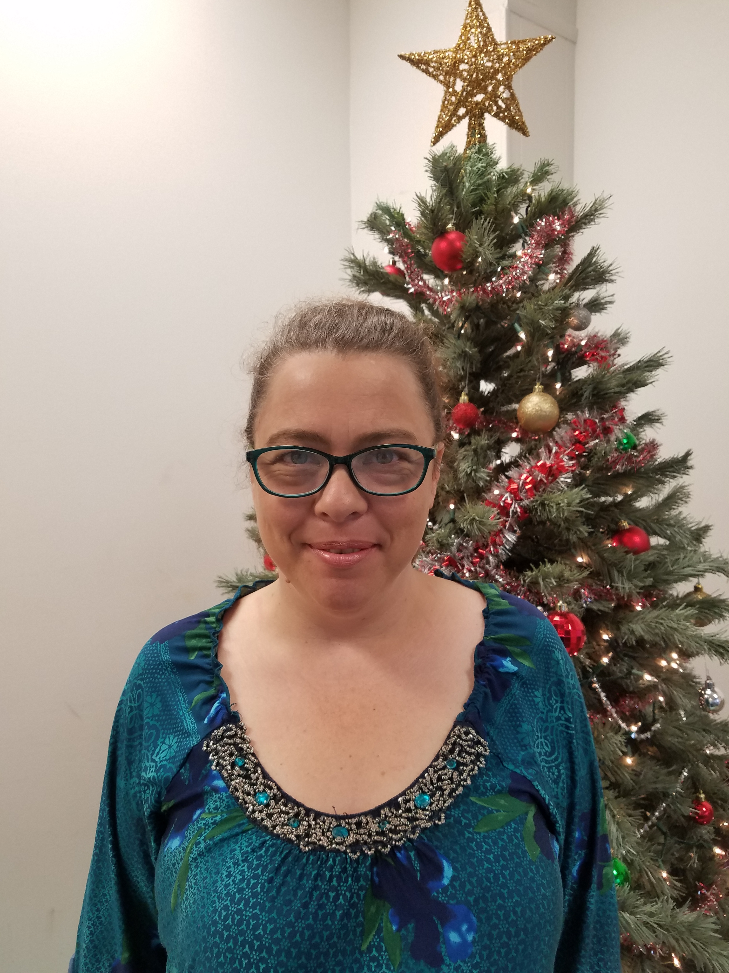  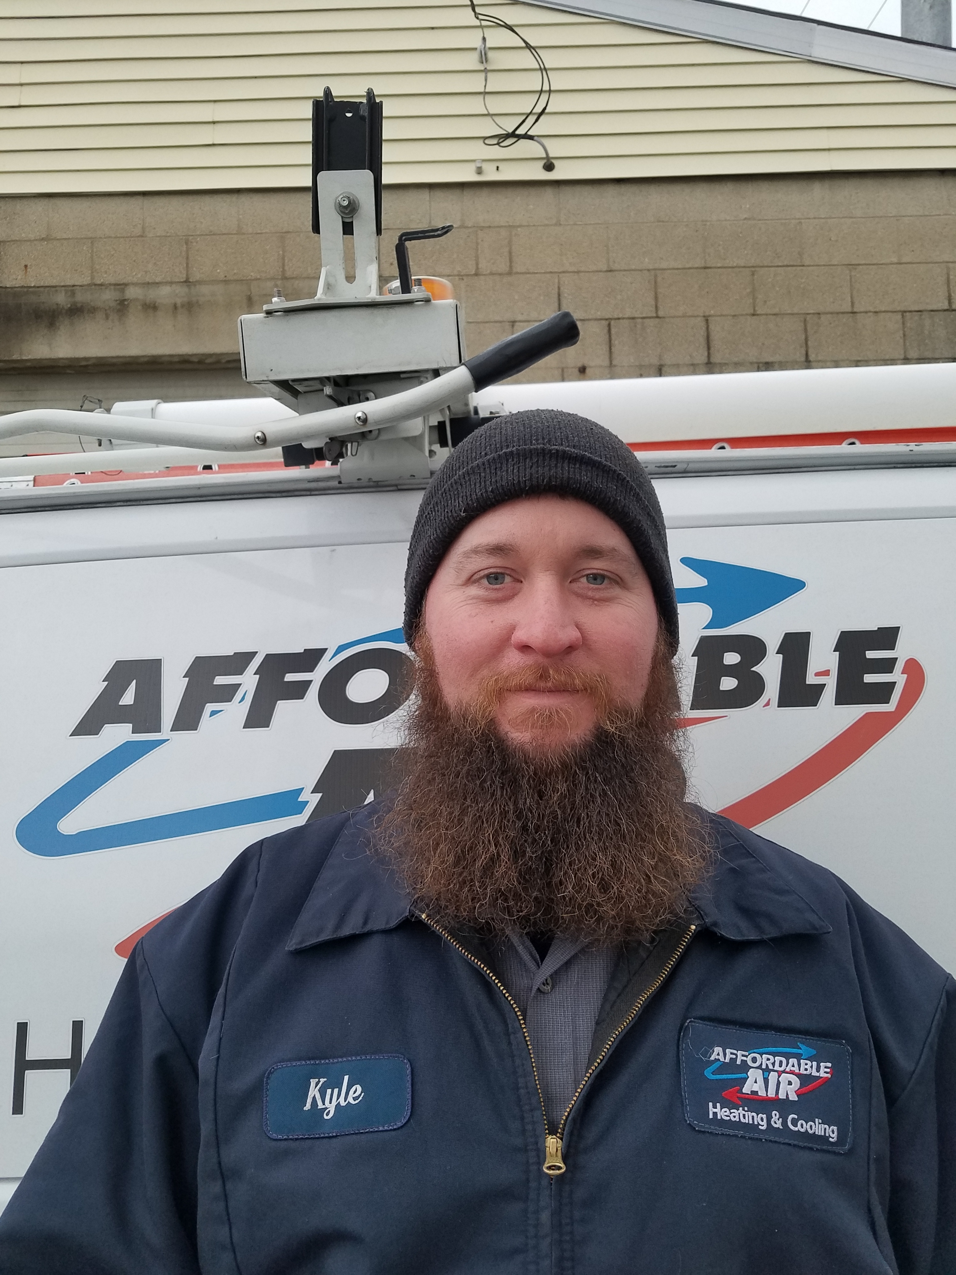  EMPLOYEE SPOTLIGHT  Jennifer Downey, Dispatcher/Billing  Jennifer started with Affordable Air in October of 2018. She and her husband, Deryl, have 6 children. Jennifer is active in her church and enjoys gardening, reading and yoga.  Kyle Hatcher, Commercial Service Manager  Kyle has been with Affordable Air for 3 years. He and his wife, Autumn, have a total of 4 children. Kyle enjoys metal working, and anything mechanical in his spare time.  SAFETY TIP!  If your water heater is 8 years or older, consider having it checked. The thermostat and heat element can deteriorate with age and cause a flash fire.  Affordable Air Love!  N Z J P X C S E Q U E N C E R G A  B C D A R I N F R A Z I E R N P I  X L K T R A N S F O R M E R O N R  E R O P L R G R H Y D R S R I R C  X E O W D W H C S H N F O Q T O O  B G X X E E E R H A S W I B A T N  S N D R H R C A I Y K D L T L C D  Q A F E H E W I W G F S B R L A I  S H U S L D A H V W U G U S A T T  H C R I O U E T E R R Z R O T N I  A X N D D C P J P E E W N T S O O  N E A E Y T D X J U L S E J N C N  E T C N A B B A I E M H R W I S E  S A E T L O B J R T X P H U A R R  H E L I E A A V P E U L F M O Z N  A H O A R R G Y U Y C M H X Y H J  W O A L B D P C O M M E R C I A L  blower wheel heat exchanger transformer  sequencer relay contactor  oil burner flue duct board  installation air conditioner heat pump  furnace commercial service  residential Darin Frazier Shane Shaw

