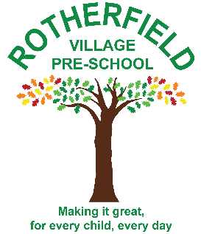
Rotherfield Village Pre-school
Rotherfield Recreation Ground
North Street
Rotherfield
TN6 3LX

Permissions

In order to provide your child with the best possible care and to offer them a range of activities during their time at pre-school, we require parental/ primary carer permission for the listed items below. These cover both your child’s health and wellbeing, their safety whilst they are in our care, and your personal preferences with regards to e-Safety, publicity, and religion.

Do we have your consent for the following? Please circle as necessary.

Your child’s health and wellbeing:

To obtain the appropriate medical assistance in the case of an emergency. Yes / No*

To apply sunscreen to your child and sponge down if we suspect your child of suffering from
Sunstroke Yes/ No
To give your child 2.5ml (1mg) of Piriton in the case of an unexpected allergic reaction Yes / No*

Has your child had chicken pox? Yes / No*

E-safety, publicity, religious occasions and face painting:

To video, photograph, and make written observations of your child to support
their development through the Early Years Foundation Stage Framework. Yes / No*

To use your child’s photograph (digital or printed) as part of a display
(including the Cleartouch interactive screen) within the pre-school. Yes/No*
To use your child’s photograph when pre-school events are reported in local newspapers. Yes / No*

To allow your child to participate in the Pre-School Harvest
Celebrations and Christmas Nativity in the village church? Yes / No*

To allow your child to appear in photographs or videos taken
by other parents at school events throughout the school year. Yes / No*

To use face paints on your child’s face or arm. Yes / No*

Outings and activities:

To take your child on outings by foot. Yes / No*

To use the playground equipment at the Rotherfield playground (not the big slide) Yes / No*

To take part in forest school type activities in the designated area below the bottom playing
field. Yes / No*

P.T.O
I the parent/ primary carer of , give my consent (having circled Yes) for the above statements pertaining to my child’s health, wellbeing, use of digital images/ publicity, and participation in any activities that they may engage in during the time they are in the care of Rotherfield Village Pre-school. I understand that if I have declined permission for any of the above, Rotherfield Village Pre-school will work with me and my child in order to accommodate this, and if required, find an alternative solution.

We will adhere to the principles of the General Data Protection Regulations 2018 when collecting and processing information about you and your child. We explain how your data is processed, collected, kept up-to-date in our Privacy notice which is given to you at the point of registration.

